SAMPLE Lucy Movie Storyboard “General Awareness Video”

Introduction: Each LUCY Video is split up in different scenes / animations. This video script covers the awareness video

If you want only a few selected scenes to be altered choose the according scene and provide us with the customized text and a draft of the desired animation. Within the field “animation description” you can specify the details of the animation.

Price calculation: A modification costs about around 100 USD per scene (depends on the complexity of the desired animation). So, if you only want to change the logo at the beginning and the end with the intro voice change it will cost 200 USD. The creation of a customized new video of about 2 mins length with a voice of your choice starts from USD 2’000 (includes voice & image/animation design).

# | Voice-over | Animation Plan | Storyboard
1 | This is a LUCY awareness video | - Logo and contact animation | 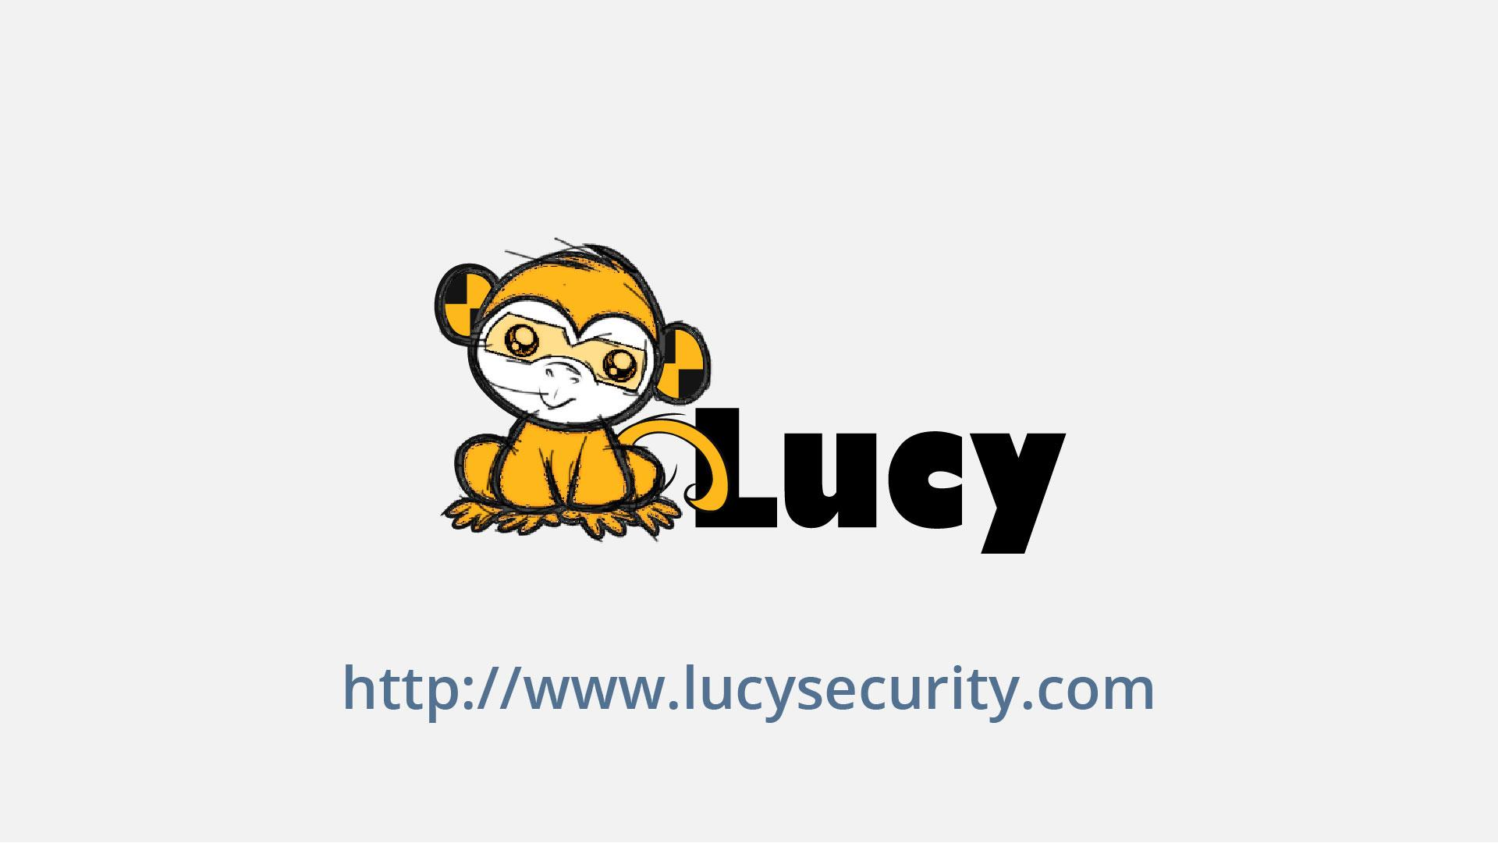
2 | In this short security  awareness video, we will give you a few tips  on how you can help  us stay secure. | - Screen appears  - Text animation  - Lock on the screen appears | 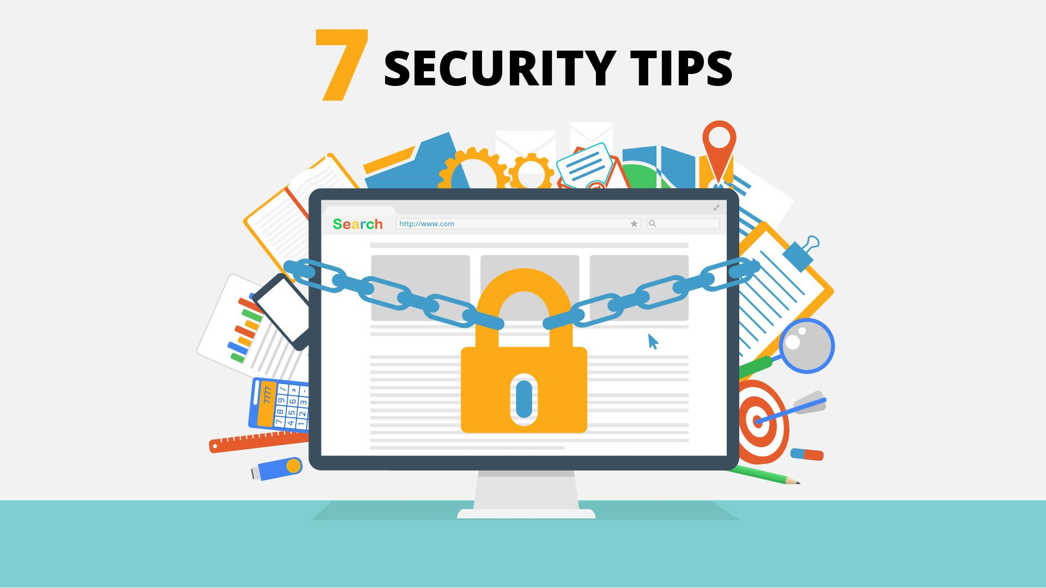
3 | Tip Nr 1: Follow a clean Desk Policy | - Sticker appears  - Text animation | 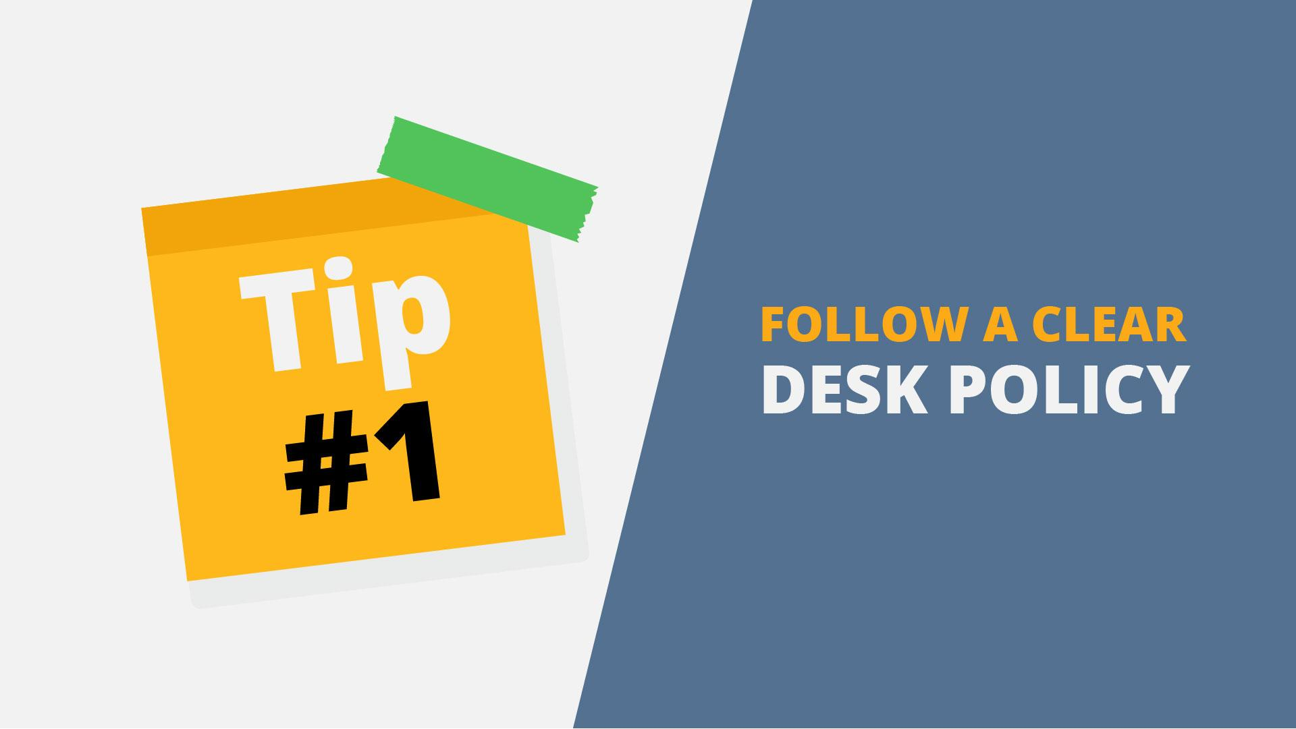
4 | Following a clean desk policy will help us reduce the risk of information theft,  fraud, or a security breach caused by sensitive information being left in  plain view. | - PC monitor appears  - Stickers with login and passwords appear on it  - Block signs appear  - Stickers disappear | 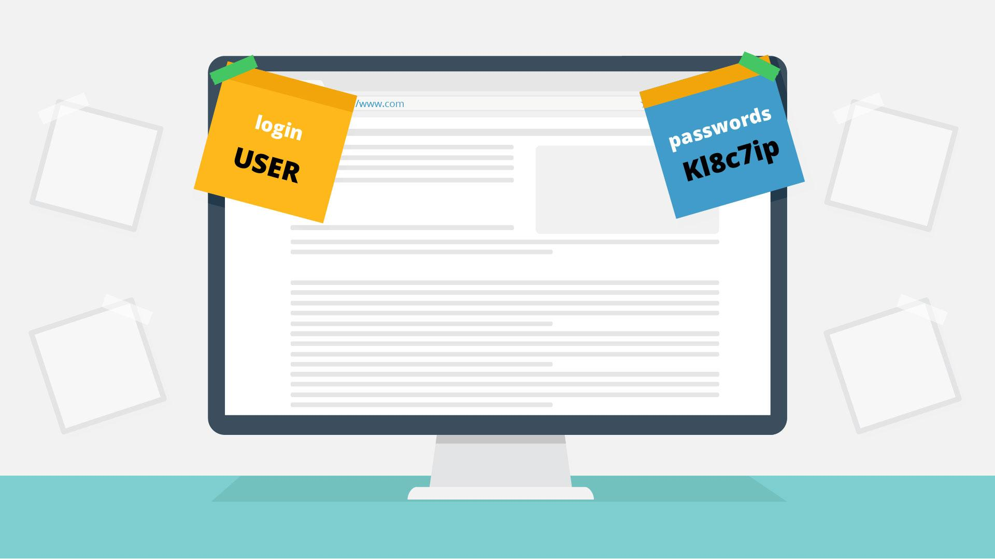  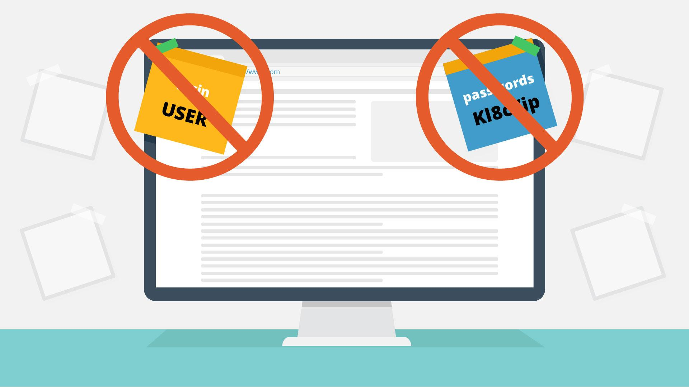
5 | When leaving your desk, be sure to lock your computer  and put away sensitive documents | - Work desk with PC appears  - Character appears near cooler  - Lock and thumbs up icon appears on the PC screen | 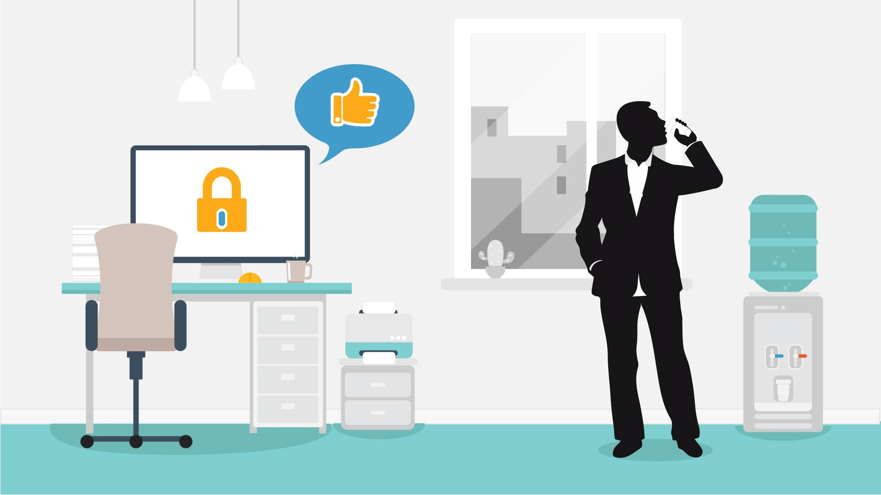
6 | Tip Nr 2:  Be aware when creating or disposing of paper documents | - Sticker appears  - Text animation | 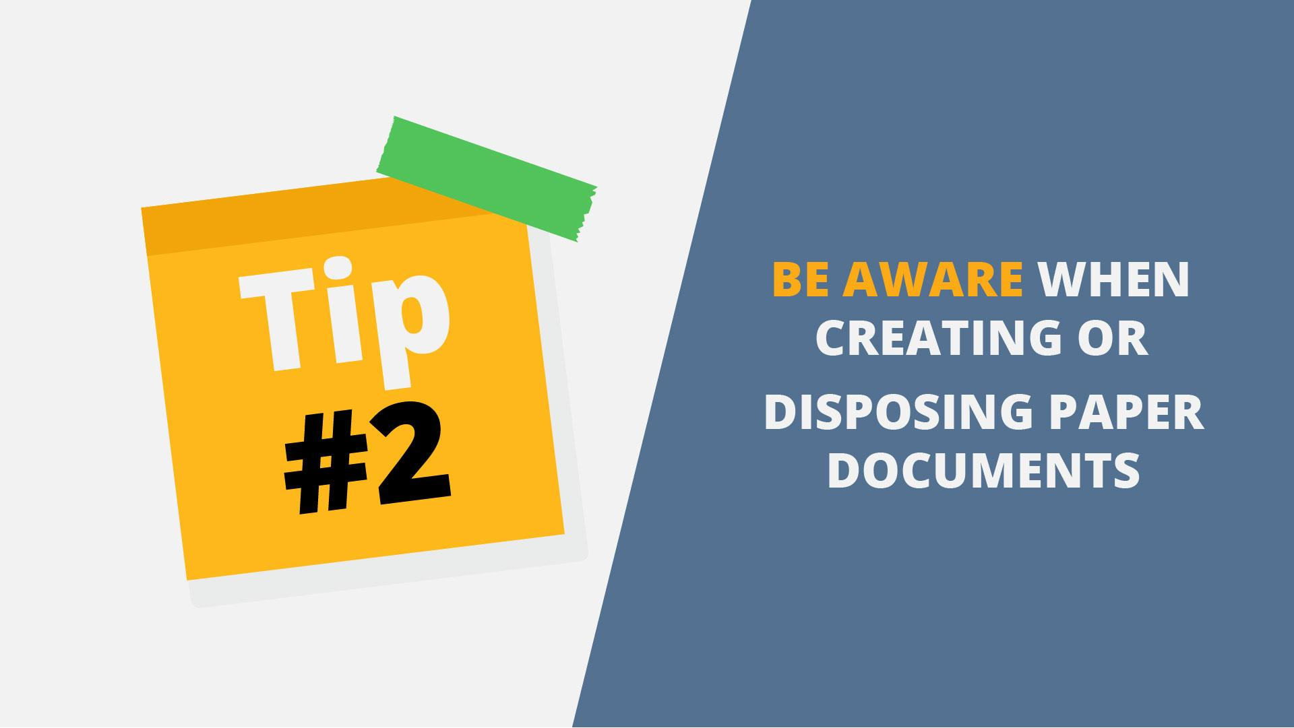
7 | Sometimes an attacker might look through your trash hoping to discover  useful information that may allow access to your network. | - Trash bin appears  - One hand appears and throws the documents into the trash bin  - Criminal hand appear and pull the documents out of the bin | 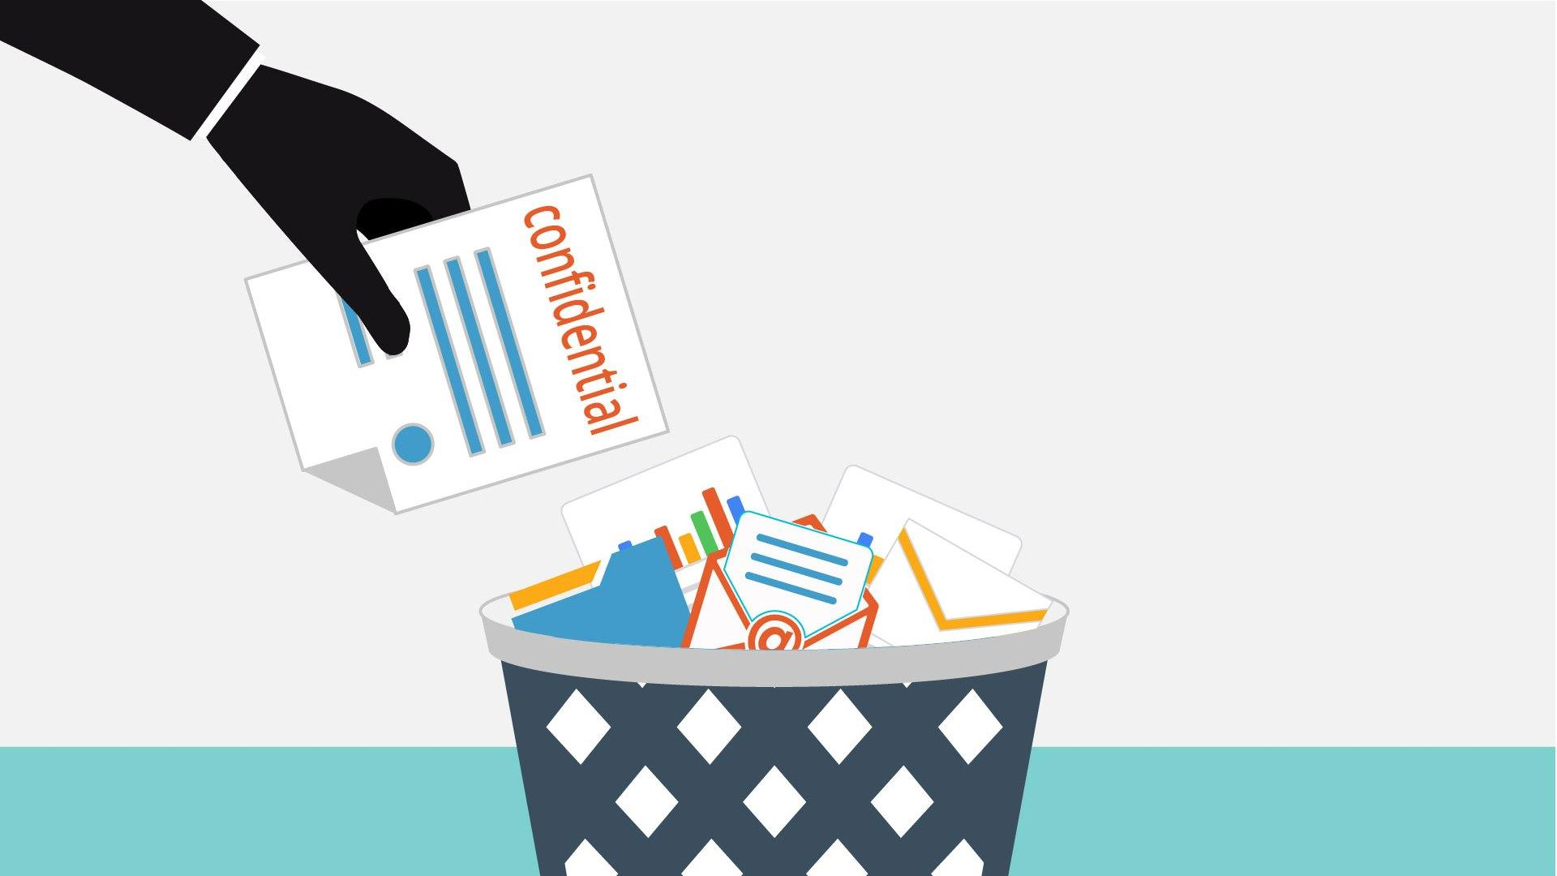  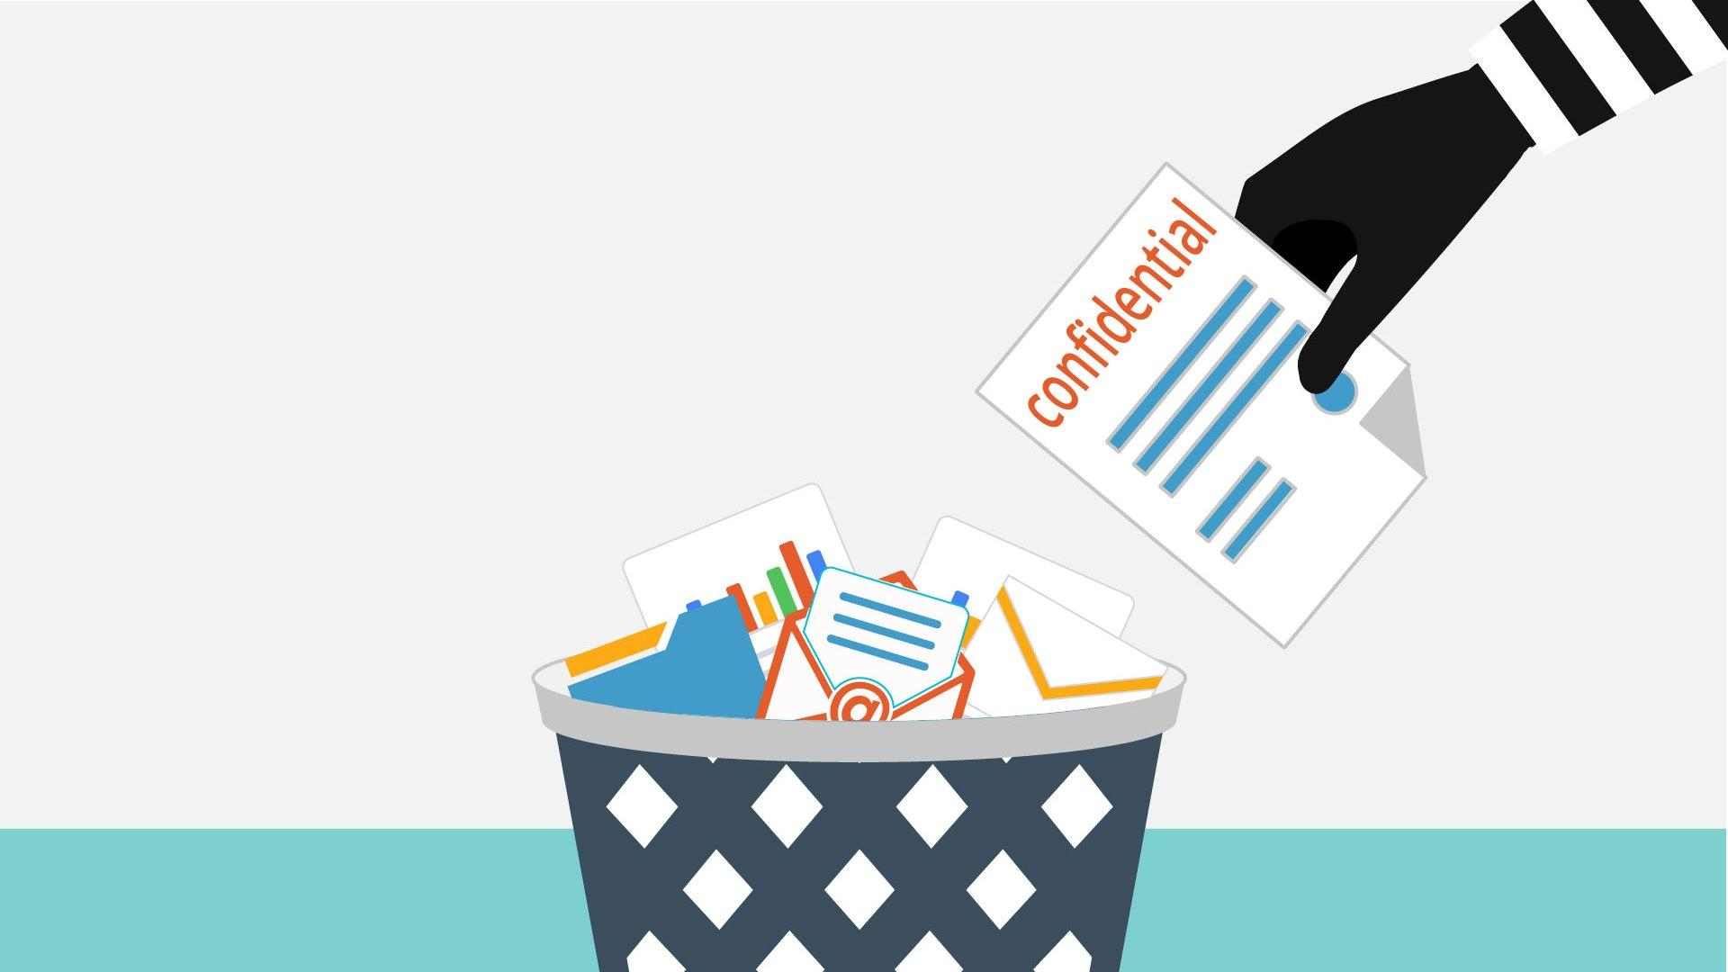
8 | Sensitive documents must never be disposed in the  wastepaper basket.  Also, don’t forget:  If you print a document, you should always pick up the  printouts. | - Bin appears  - Document labeled “secret info” appears on the floor near the bin  - Printer appears  - Stack of papers appear labeled top secret appear on it | 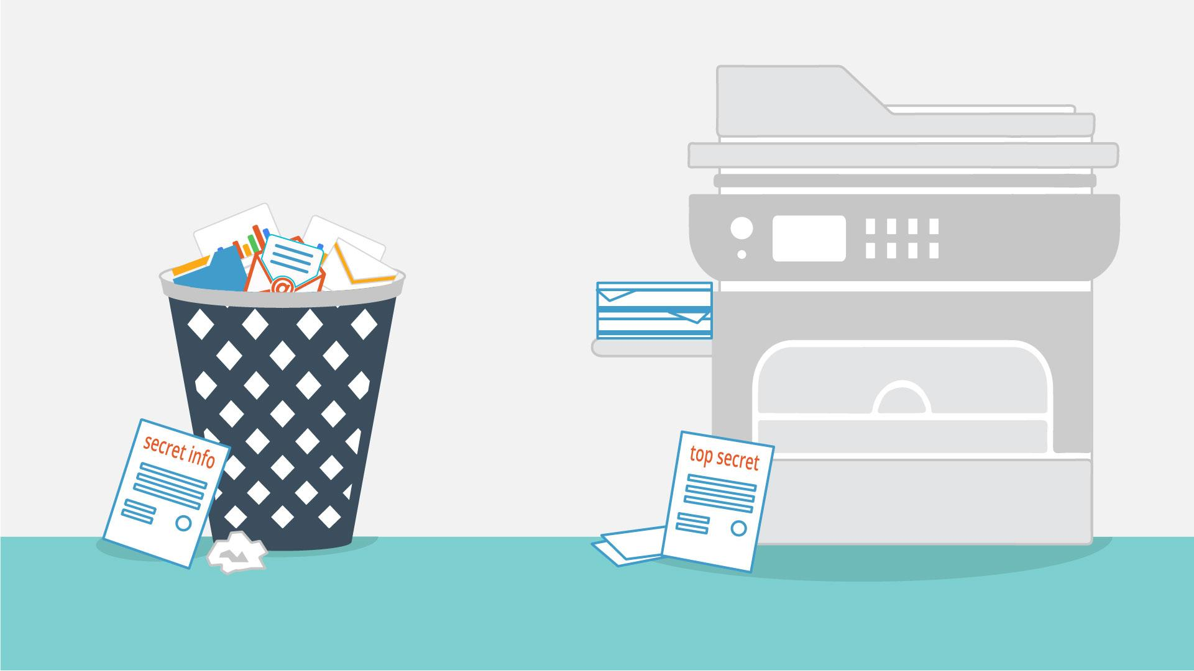
9 | Tip Nr 3: Consider carefully what information you put out there | - Sticker appears  - Text animation | 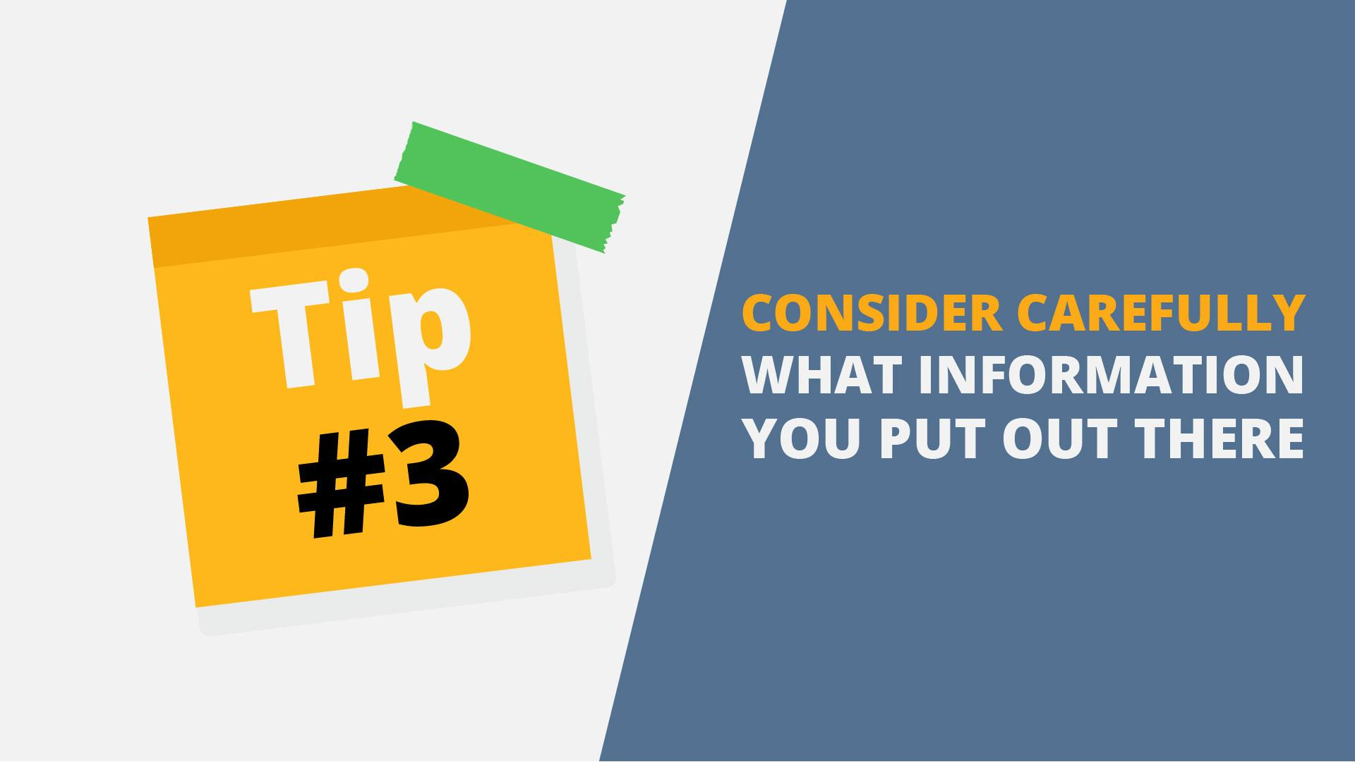
10 | Practically anything you have ever posted  on the internet, can be discovered by cybercriminals. | - Desk with PC appears  - Information goes out of the PC  - Hacker appears | 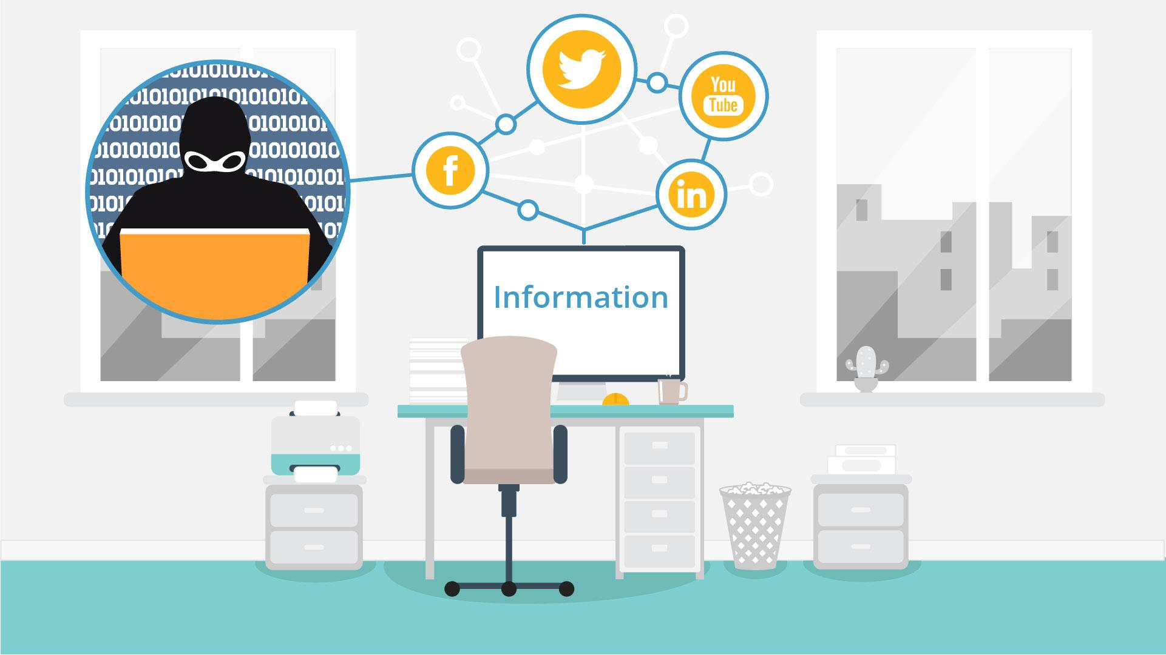
11 | What might seem like a harmless post, could help an attacker prepare a targeted attack against you. | - Worker at the desk appears  - Social media image appears | 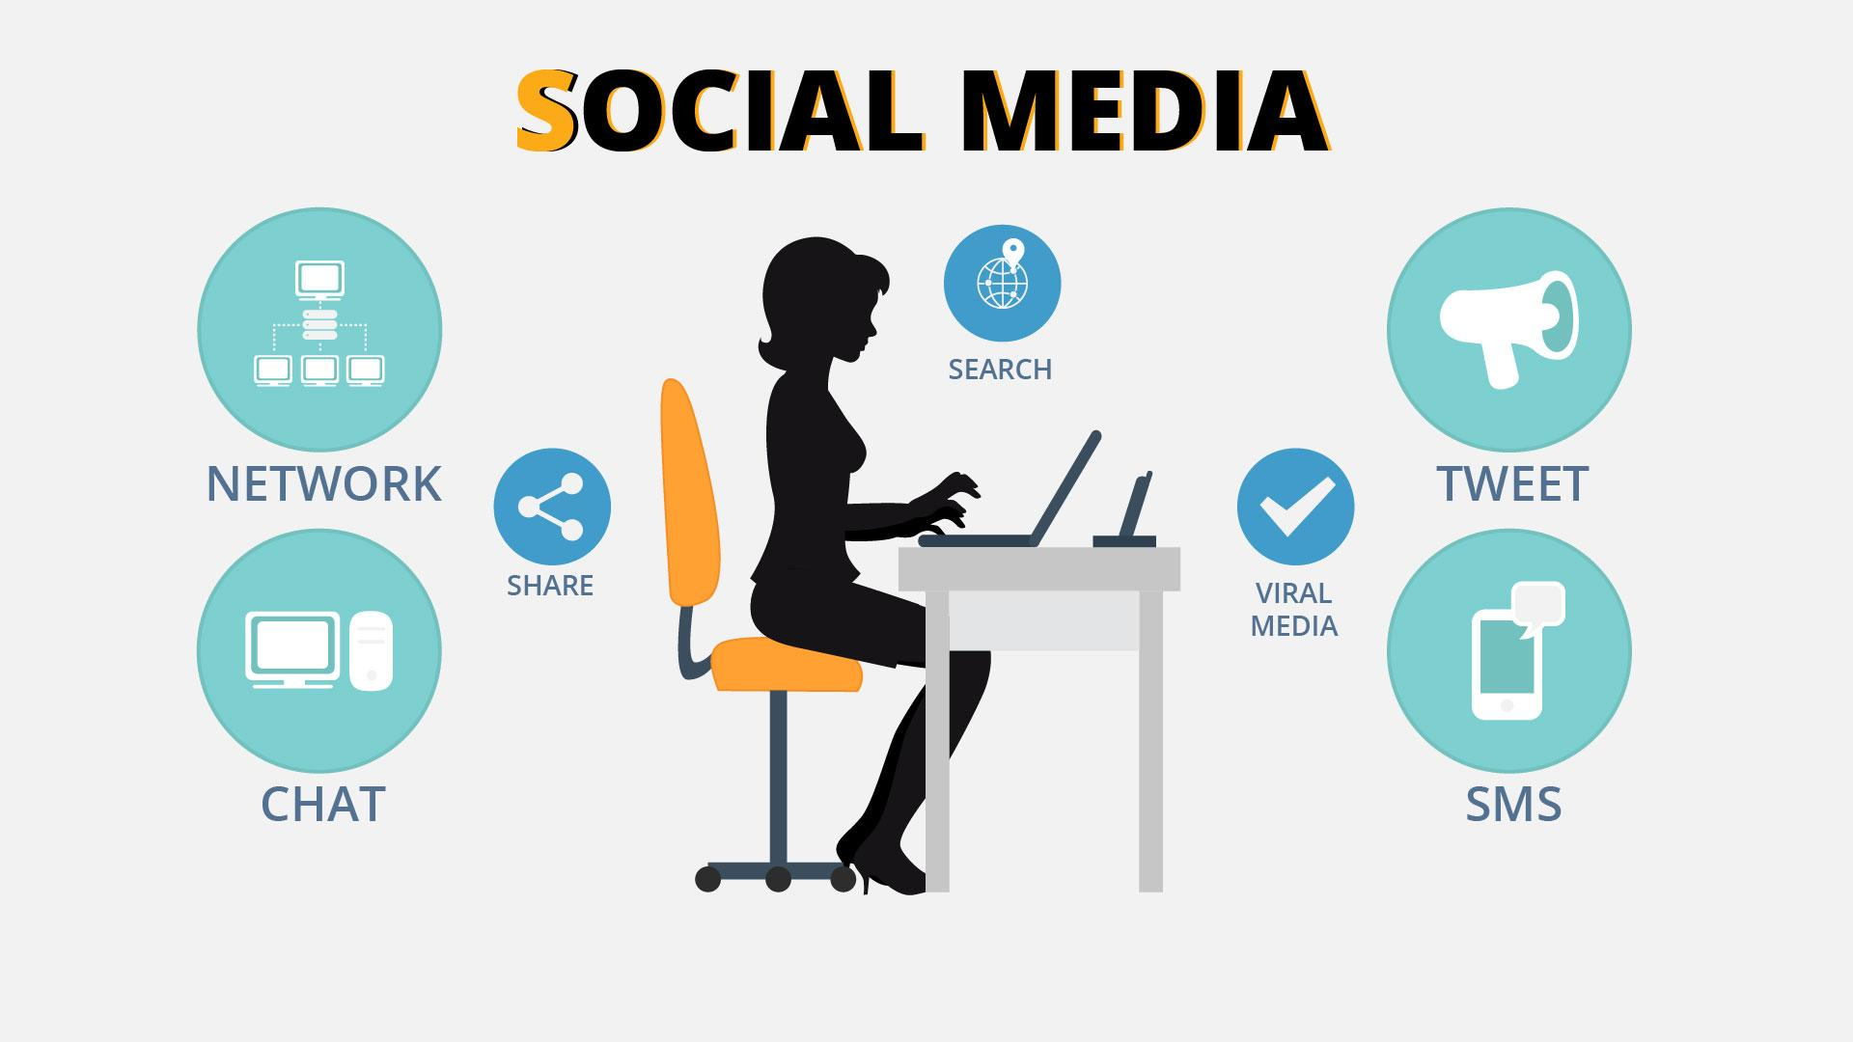
12 | Tip Nr 4: Prevent  unauthorized people  accessing your company | - Sticker appears  - Text animation | 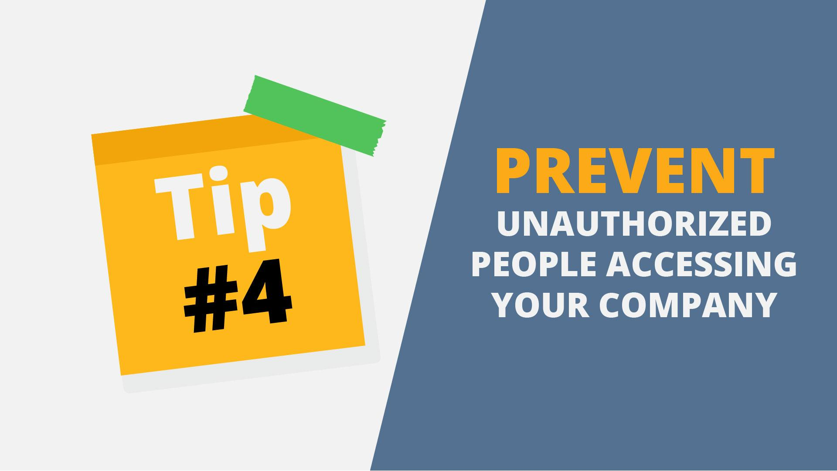
13 | An attacker may try gain access to the building by pretending to be an employee, visitor or service personnel. | - Security guard appears near building entrance  - Second character appears near to him  - Security guard shows stop  - Block sign appears | 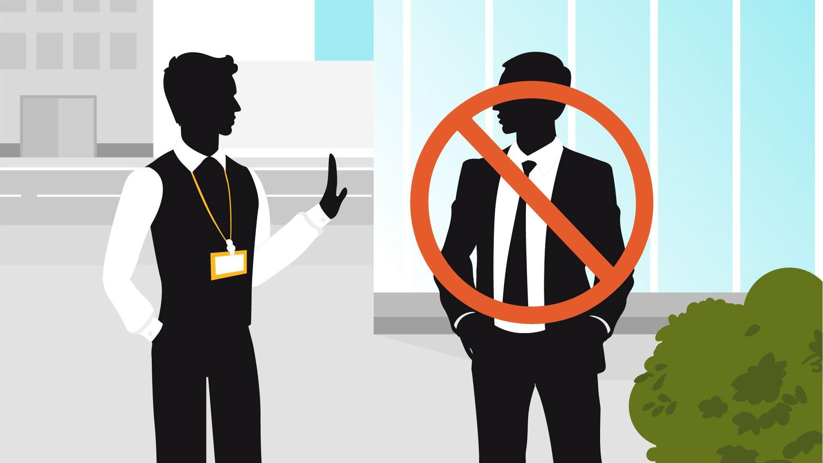
14 | If you see a someone you don’t know without a badge  don’t be shy to approach them. Ask for their contact  person so that you may verify their identify. | - 2 characters appear in the office. One has a badge, other - without it  - Talking bubble with question marks appears | 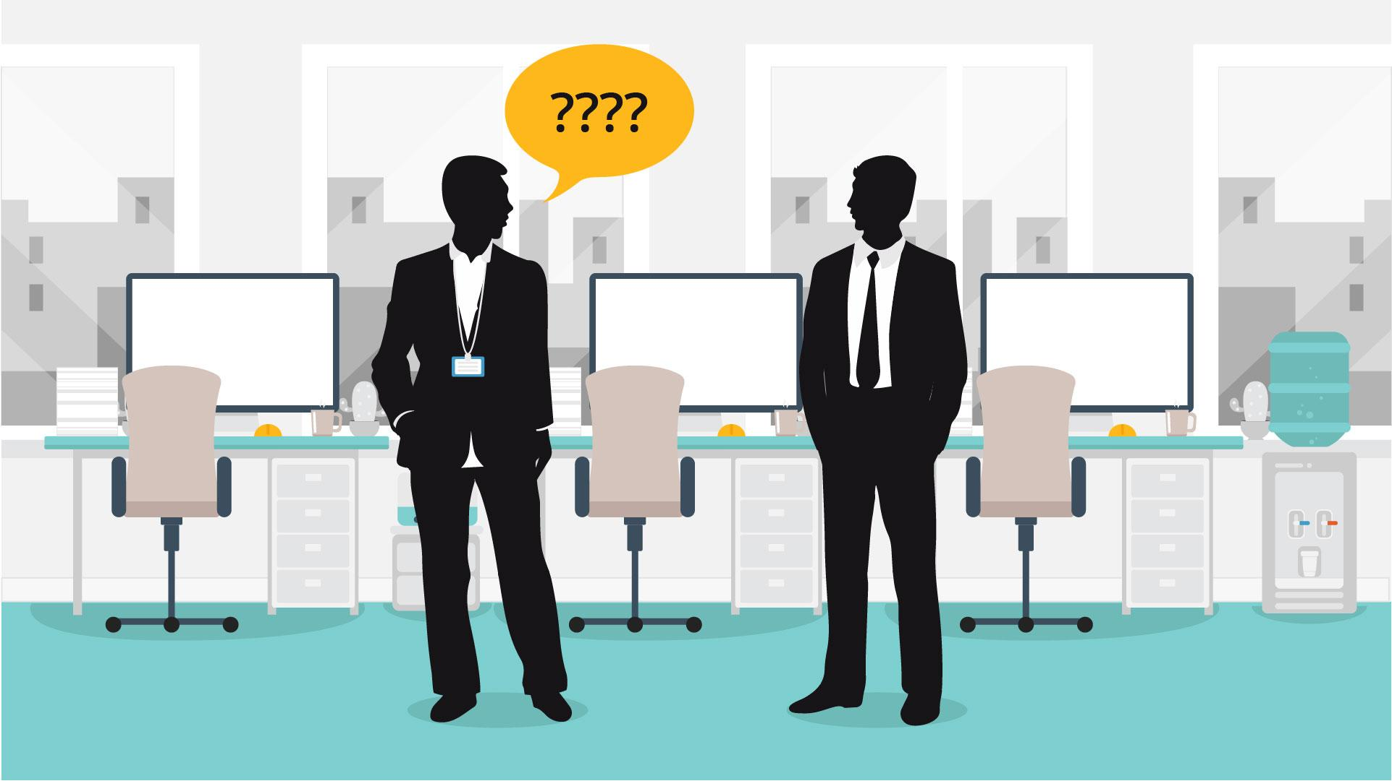
15 | Tip Nr 5: Just because they know you, doesn’t mean, you know them! | - Sticker appears  - Text animation | 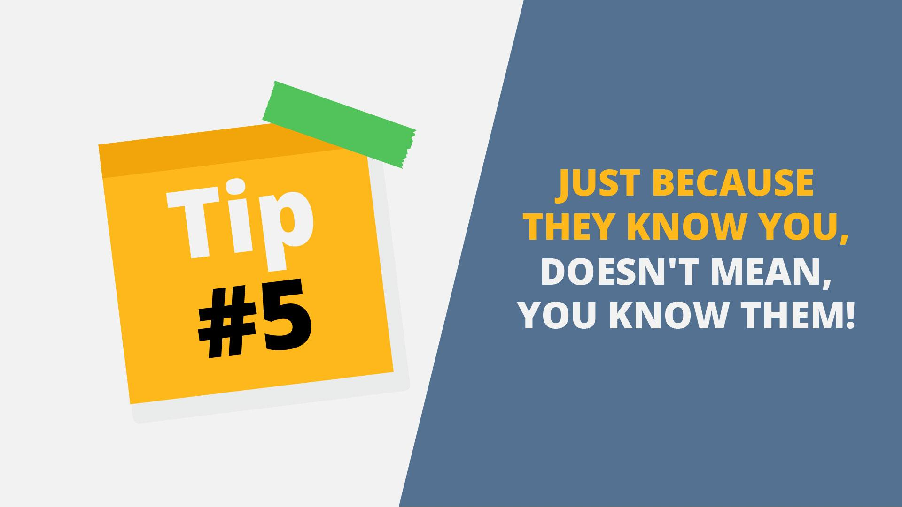
16 | Voice phishing occurs when trained fraudsters trick  unsuspecting people into giving out sensitive info over  the telephone | - Image appears  - Person in the bubble changes to criminal | 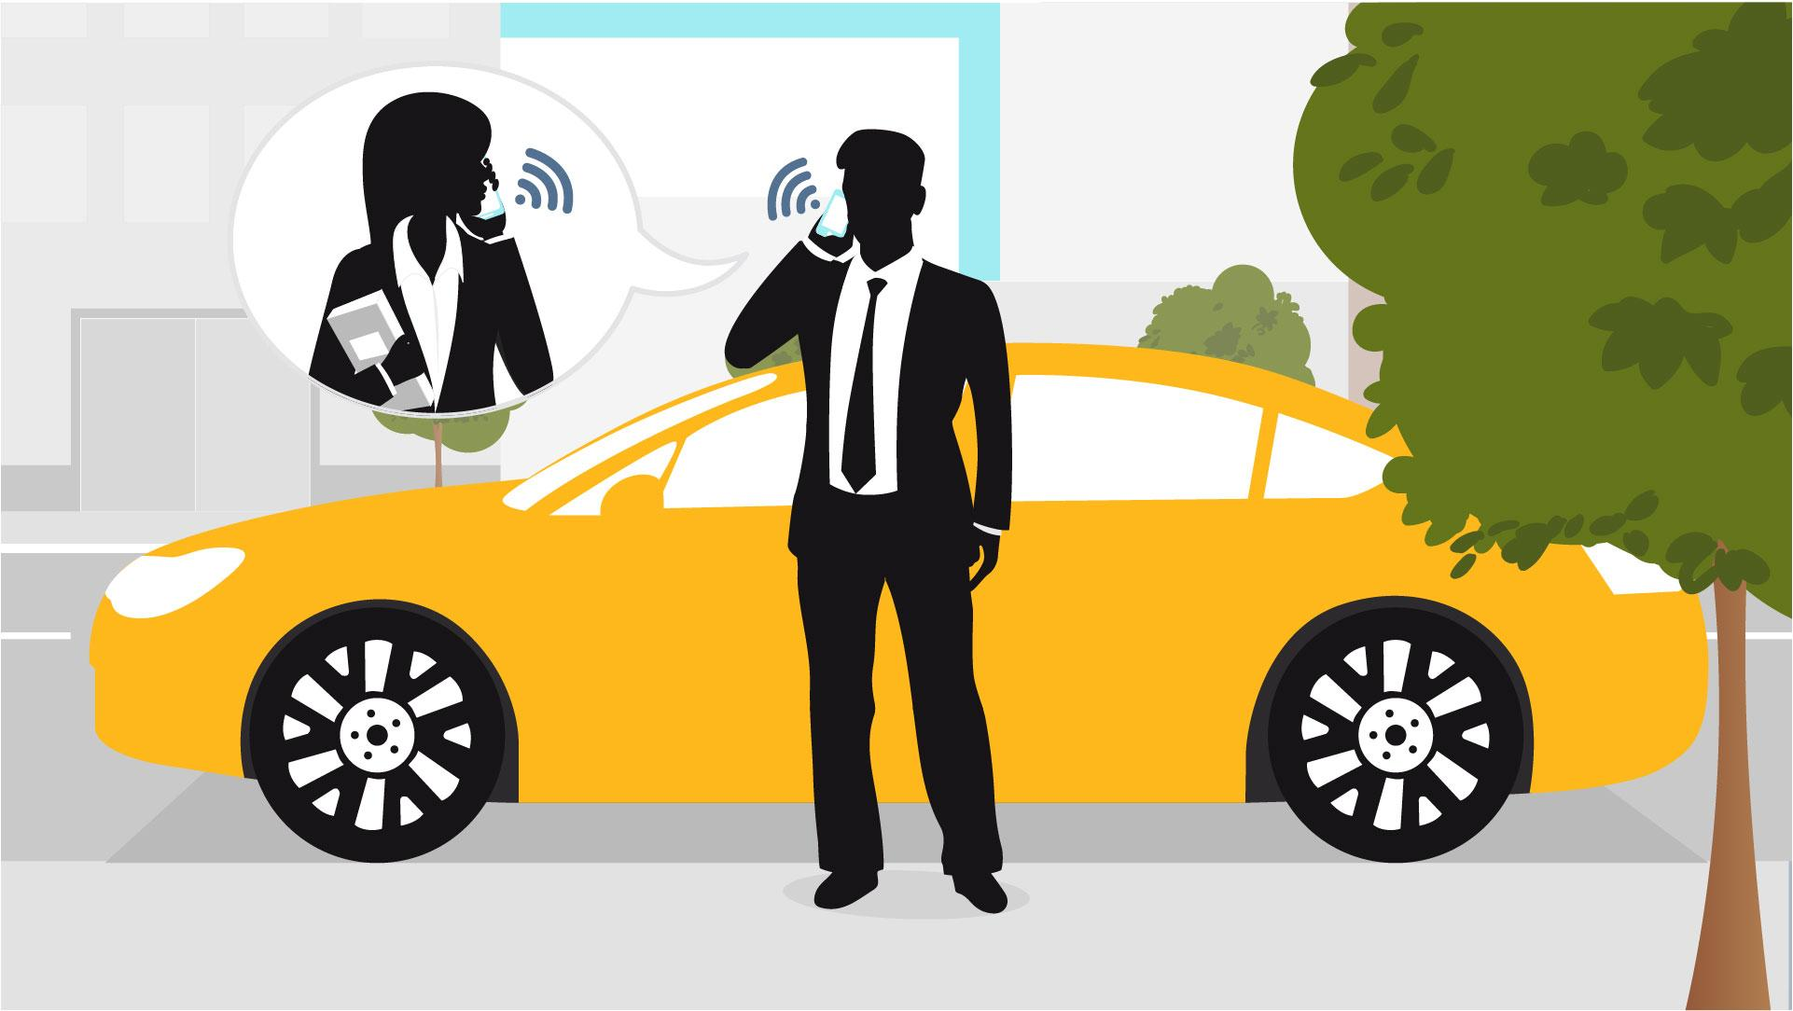  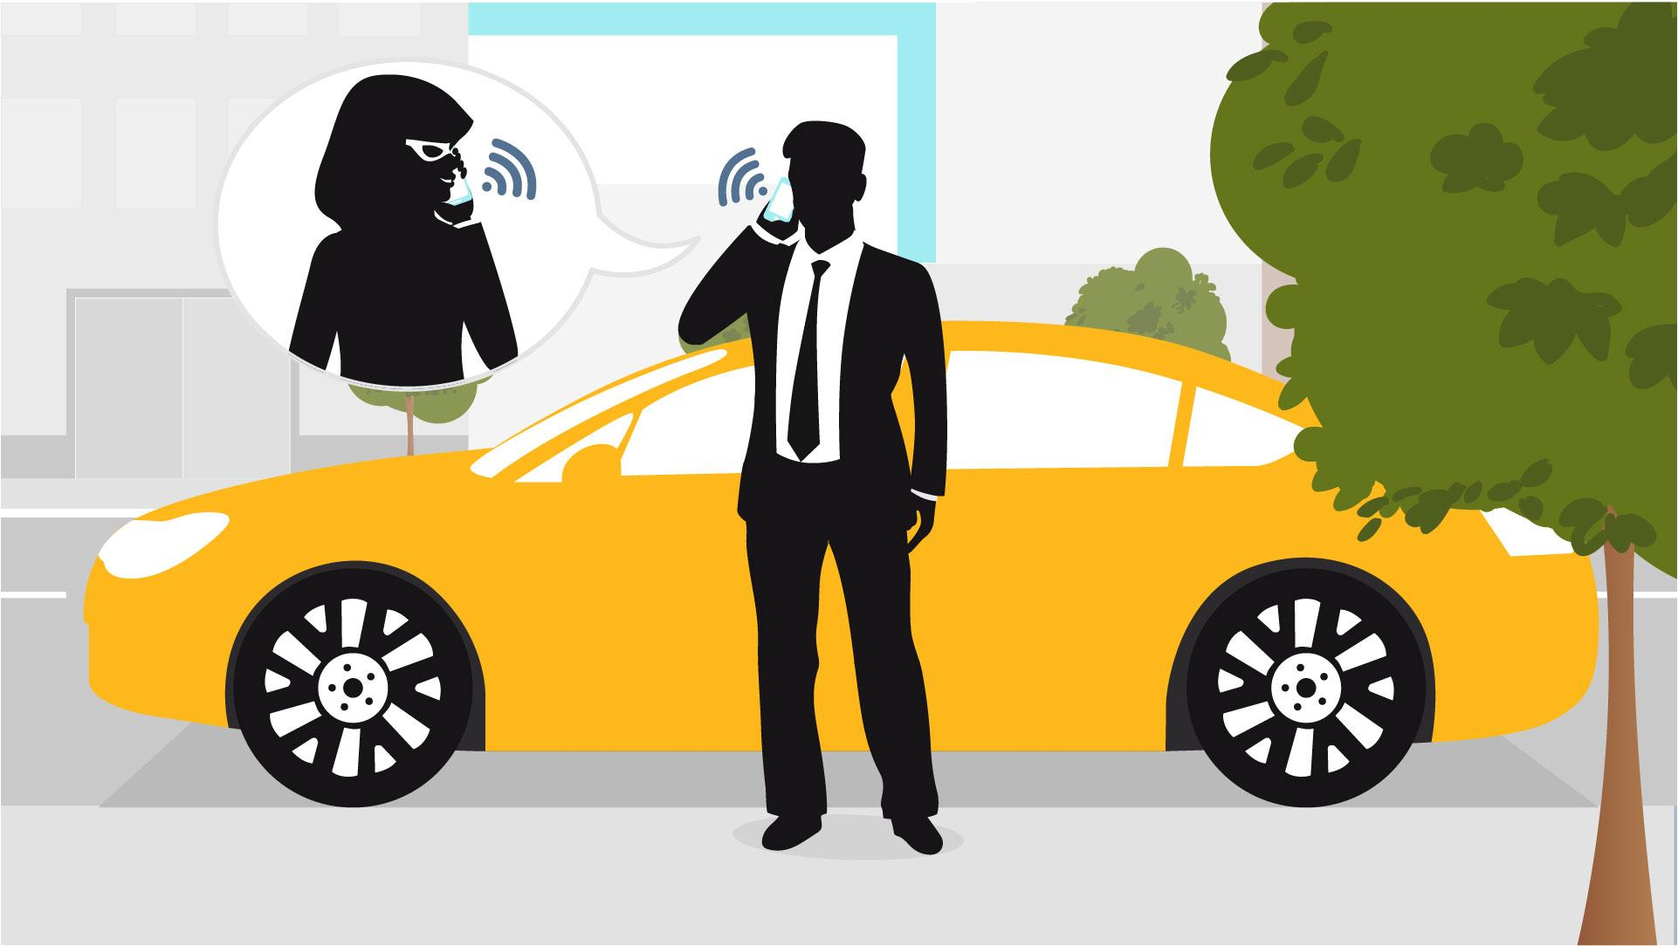
17 | Tip Nr 6: Phishing Scams: don’t bite | - Sticker appears  - Text animation | 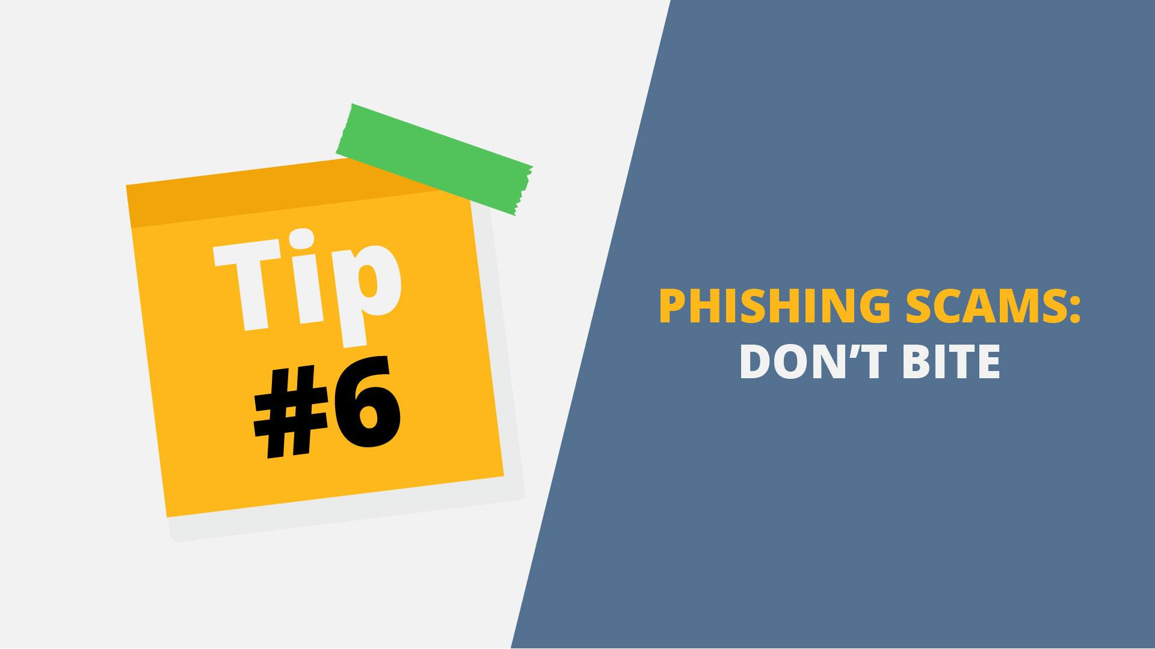
18 | Through phishing, potential hackers might try to acquire  information such as  Usernames, passwords or get you to download malware. | - PC screen with web form appears  - Login and password are typed in  - Hook appears from the top and steals data | 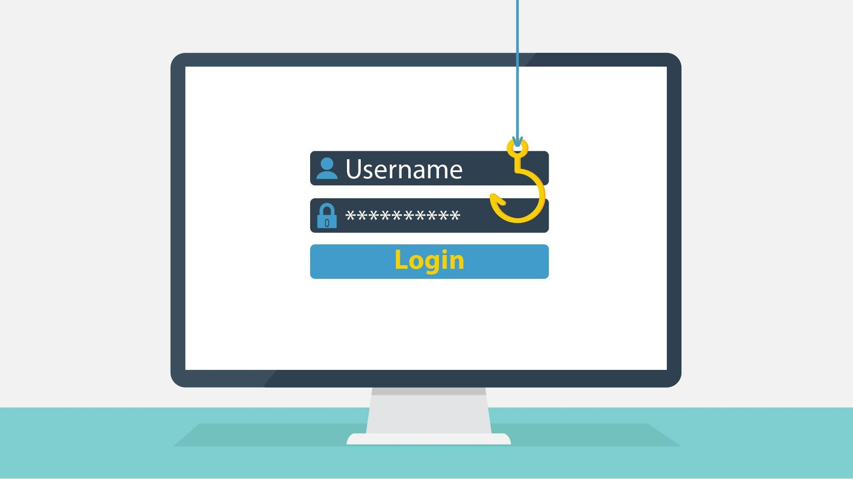  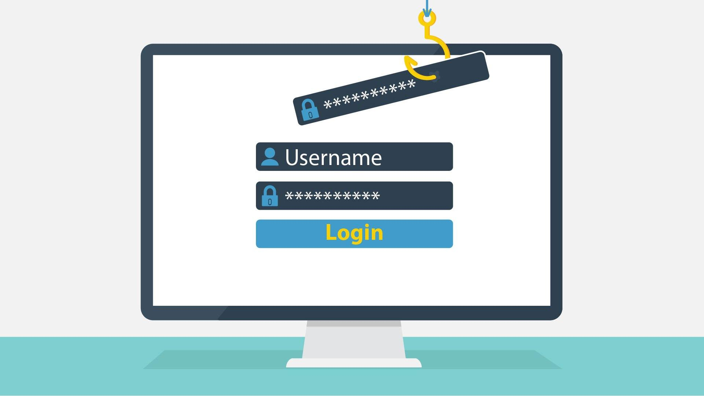
19 | Be especially cautious of emails that come from unrecognized senders. Never confirm personal or  financial information over the Internet. | - PC screen appears  - Email appears  - Cursor click the text | 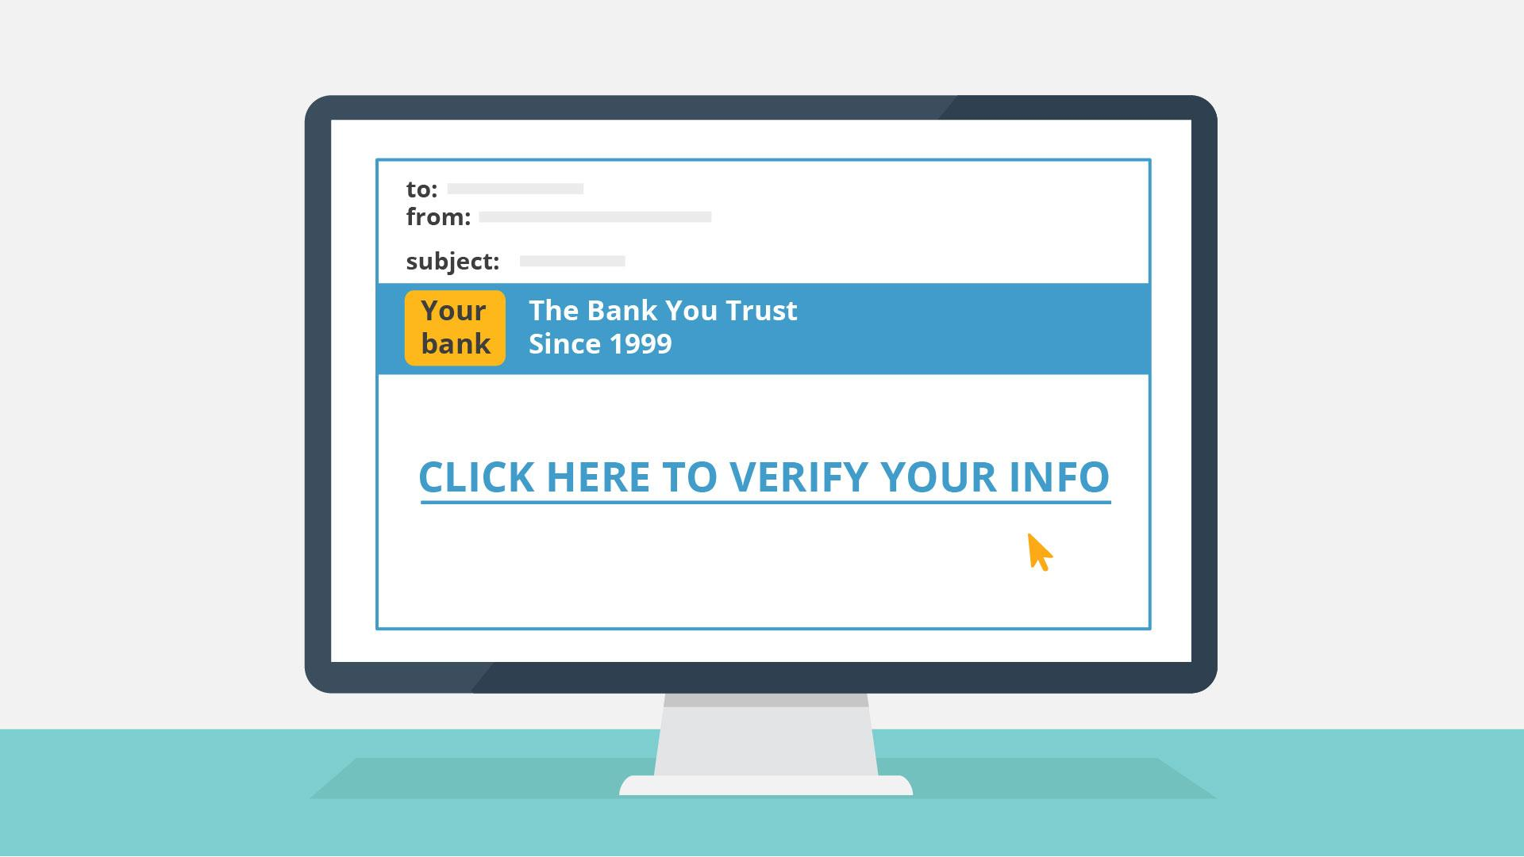
20 | If you get a suspicious mail, do not open it. Forward it immediately to your IT security department. | - Worker and IT specialist appear  - Bubbles appear above | 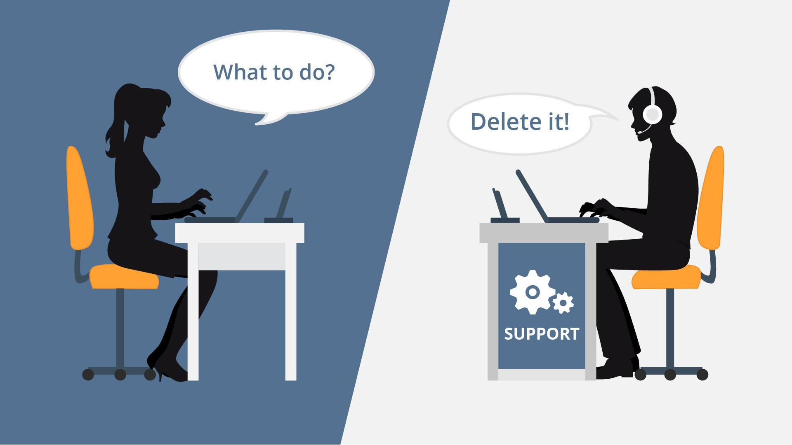
21 | Tip Nr 7: Prevent damage  from malware | - Sticker appears  - Text animation | 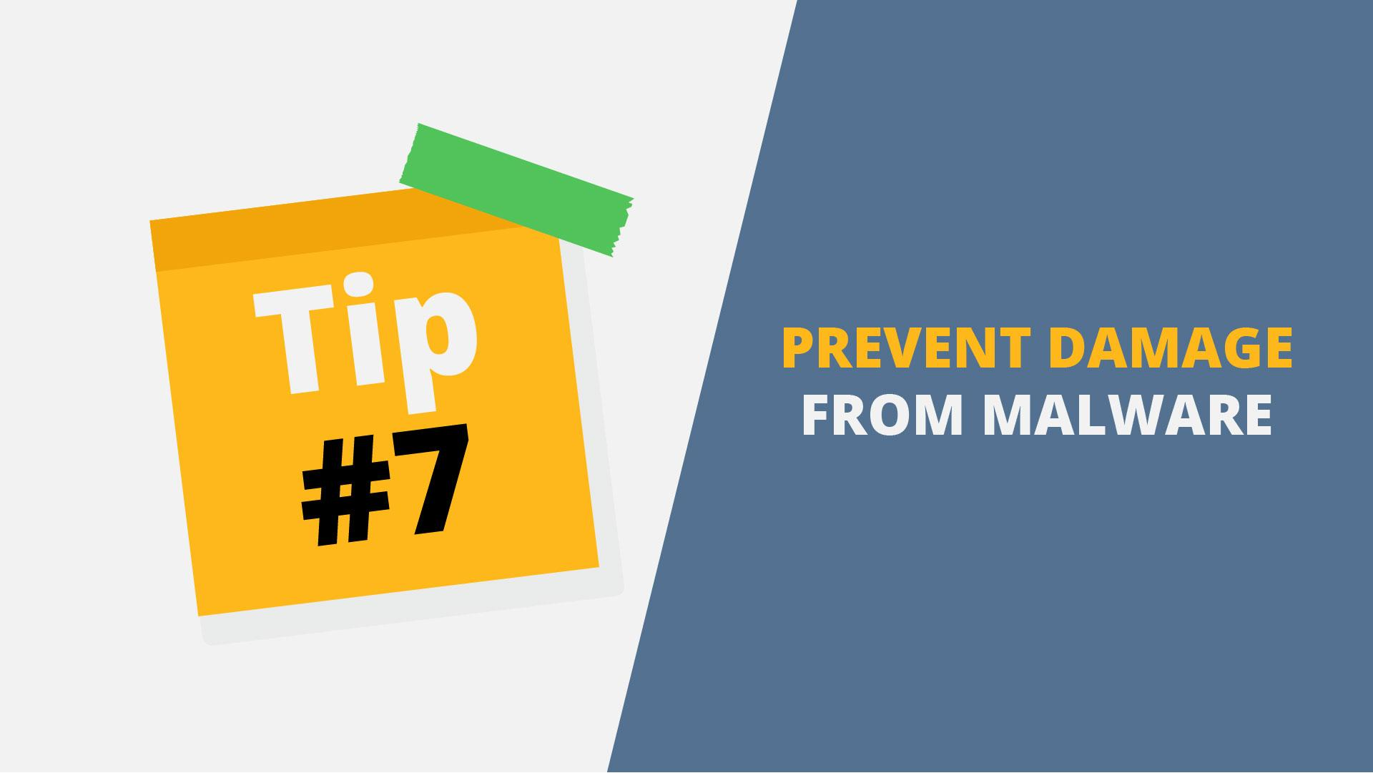
22 | When you don’t know or trust the sender:  ...do not open mail  attachments... | - We see inbox letter with attachment  - Attachment is blinking and attracting the attention | 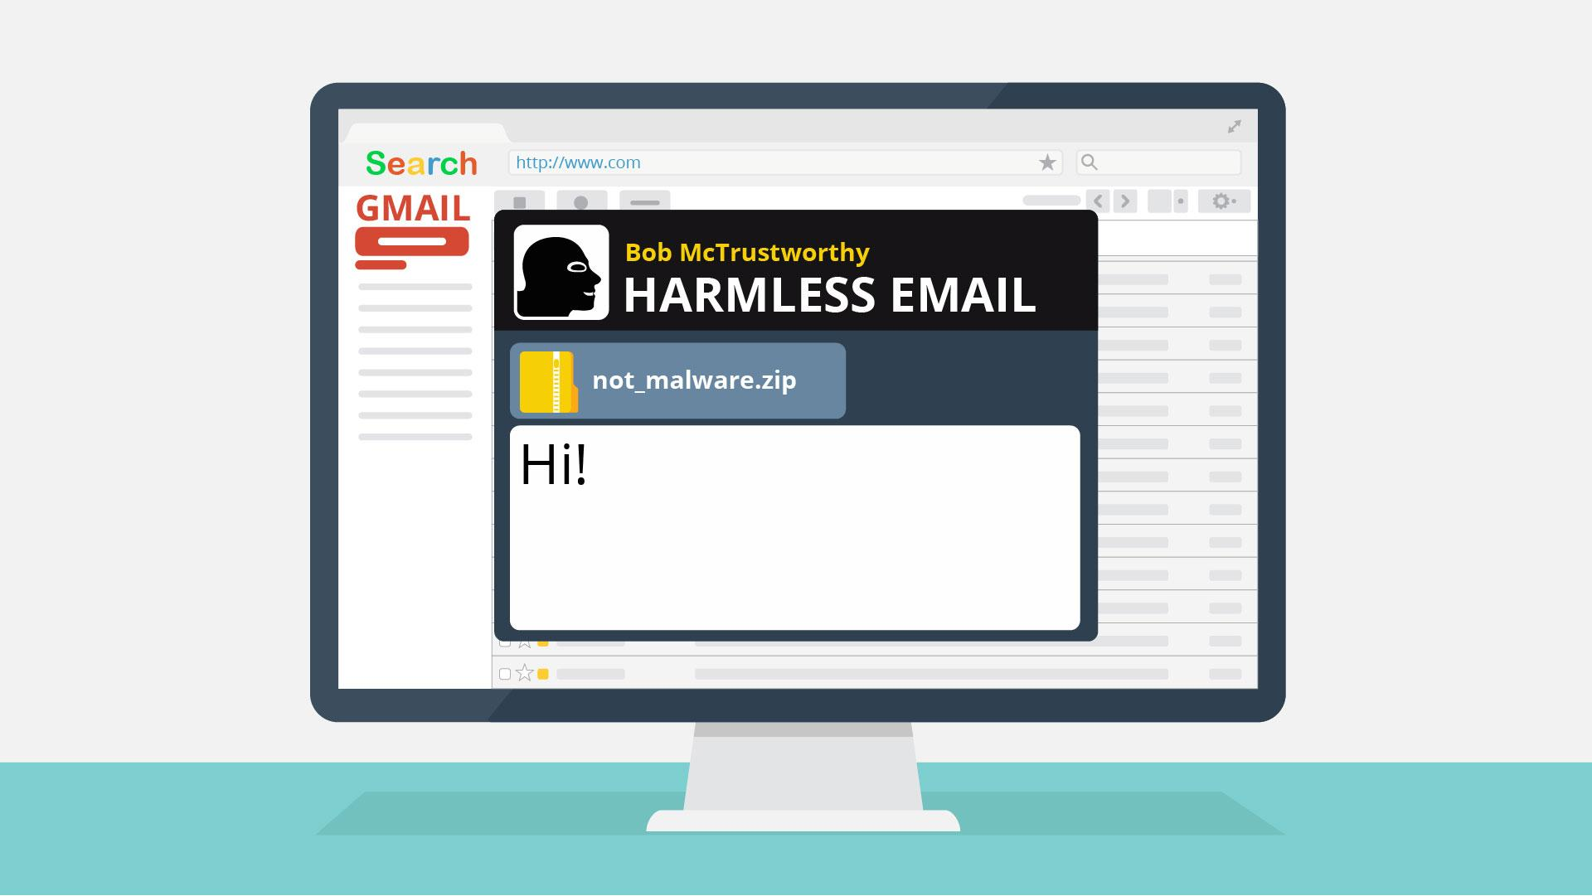
23 | Same goes for macros in  office documents... | - We show a document  - Macros appear  - Bloc signs appear | 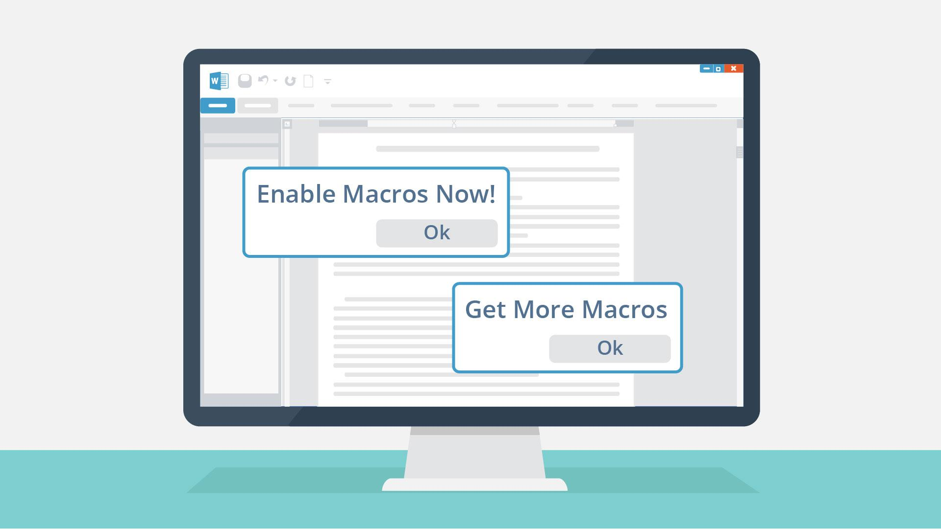  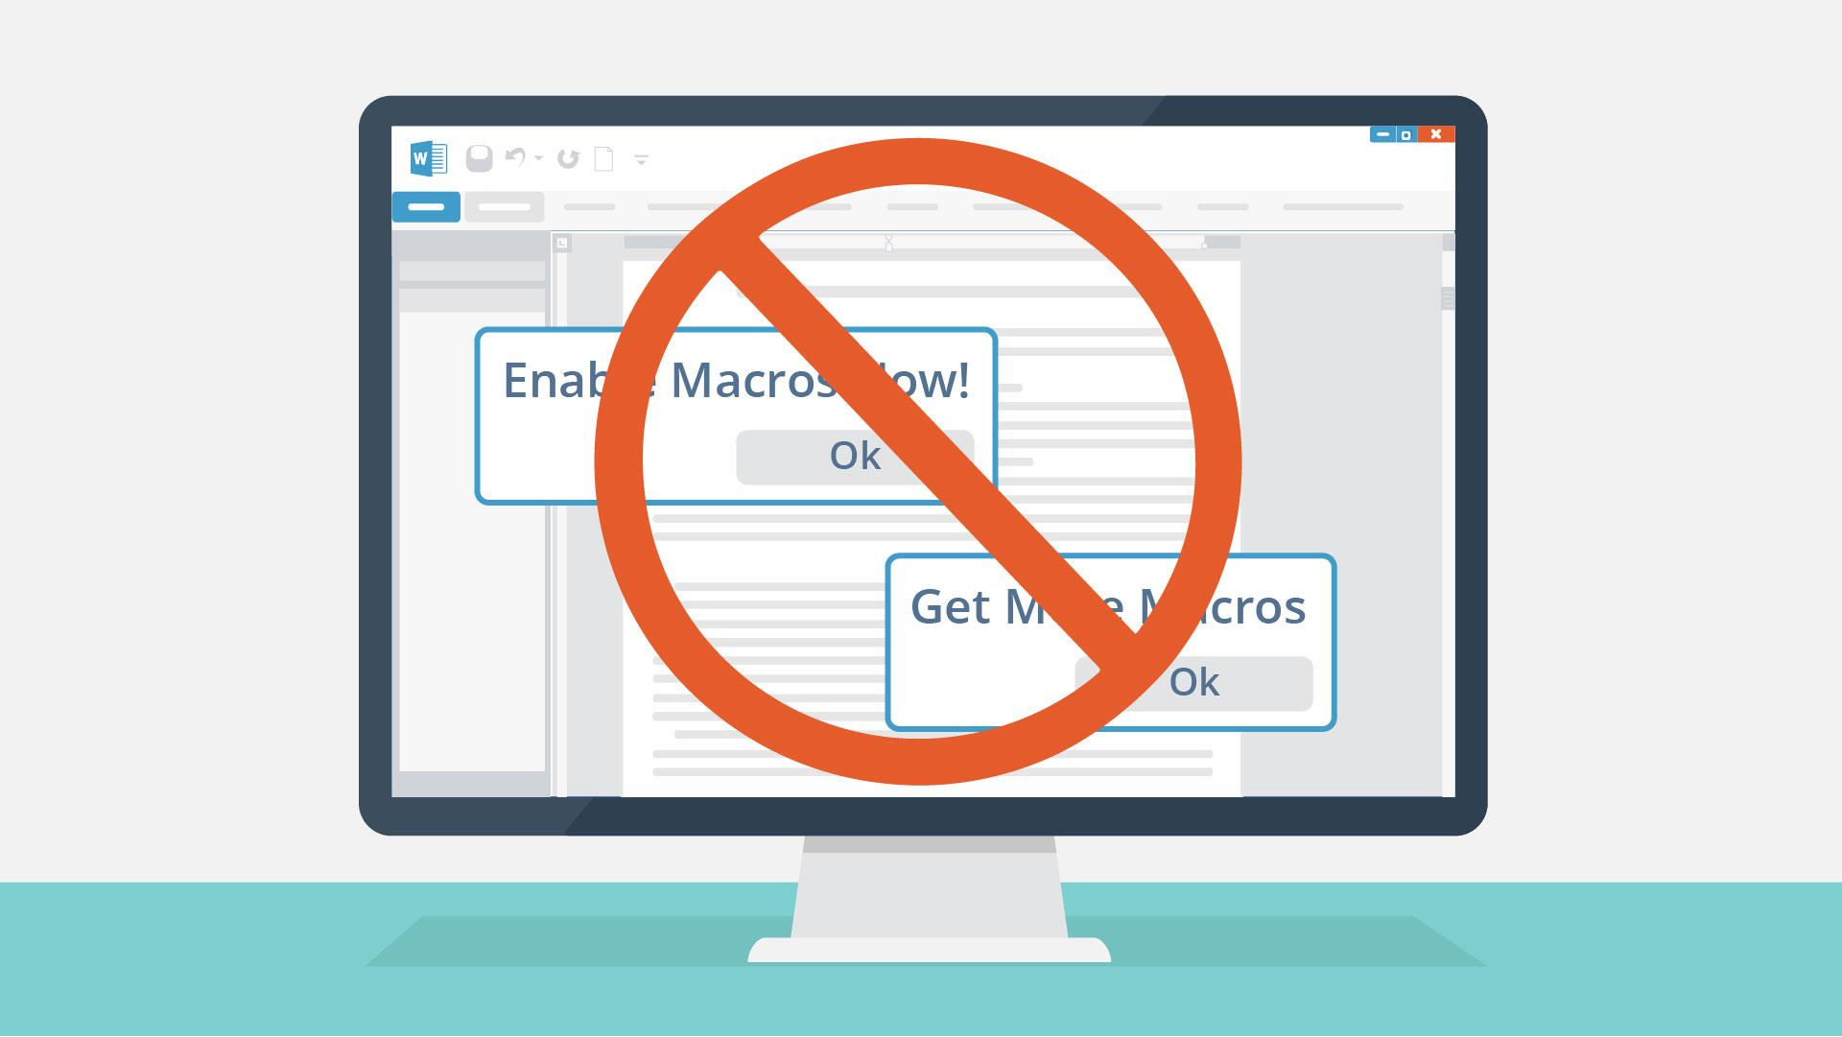
24 | Never plug in USB devices from untrusted sources. | - USB is connected | 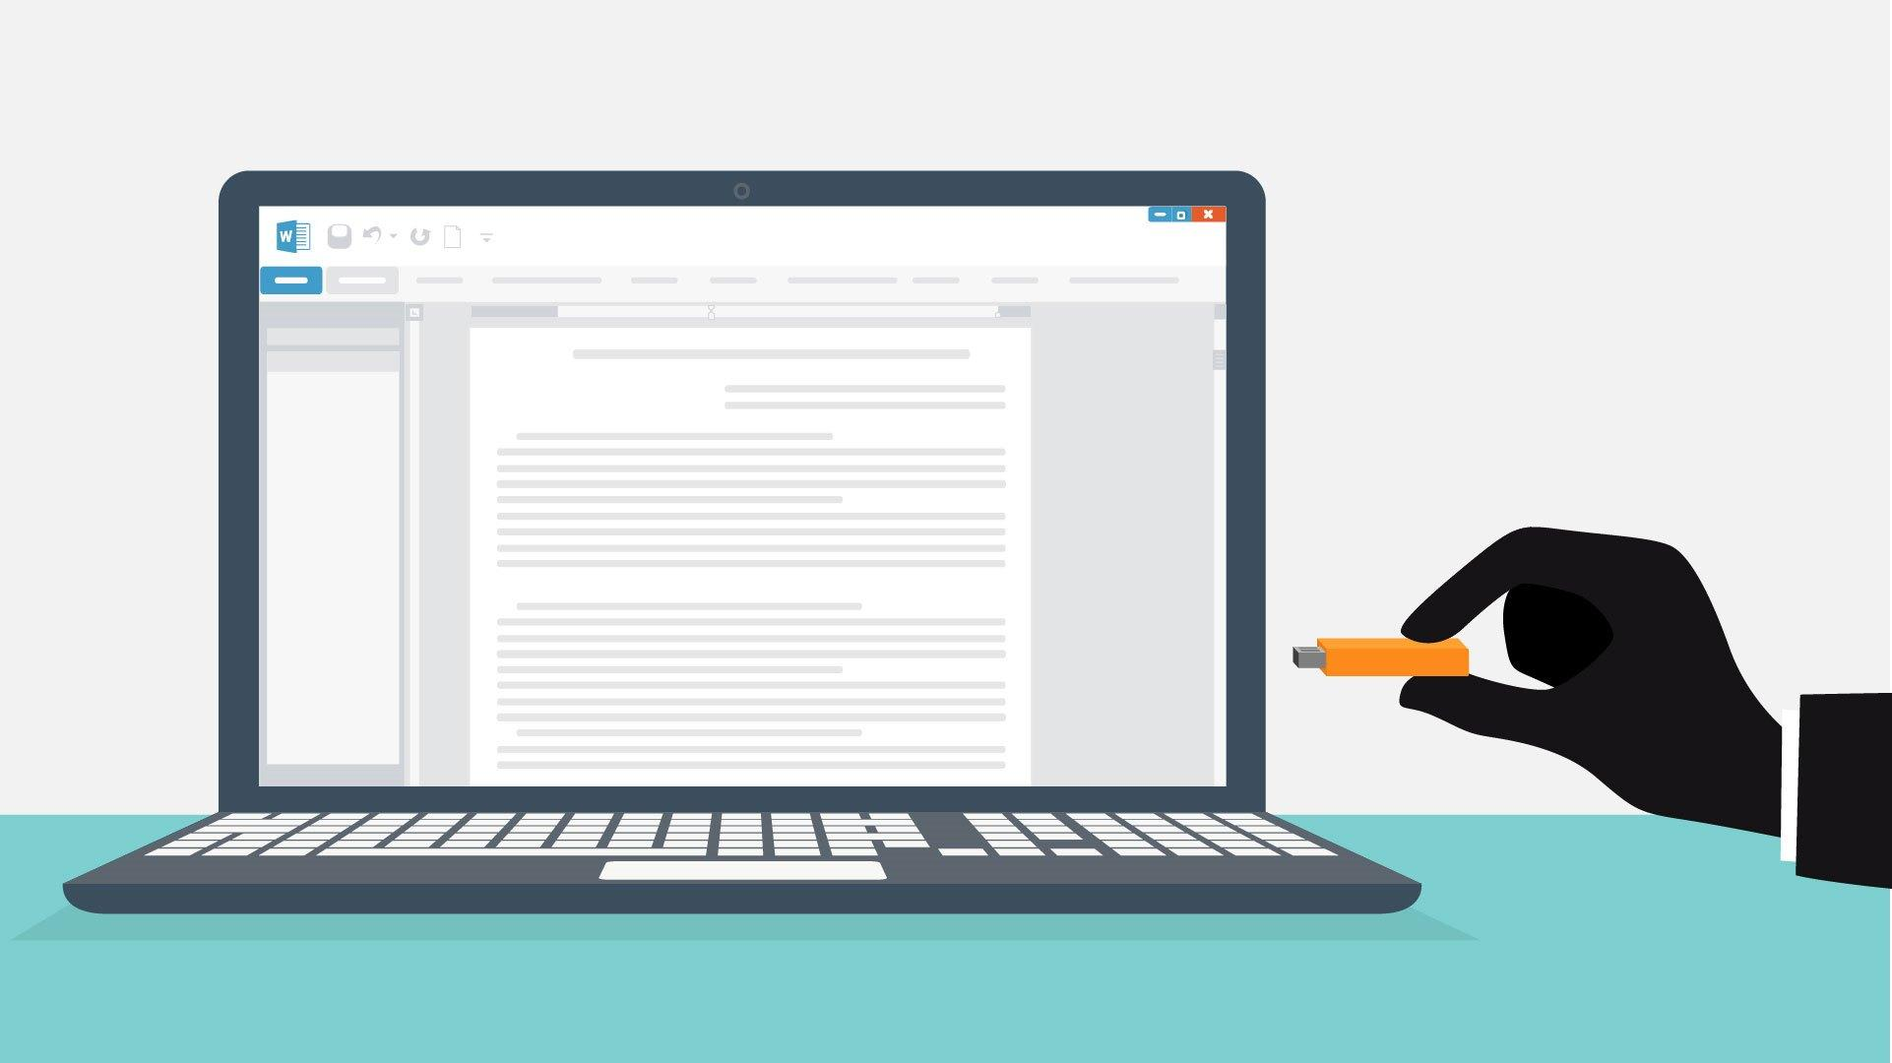  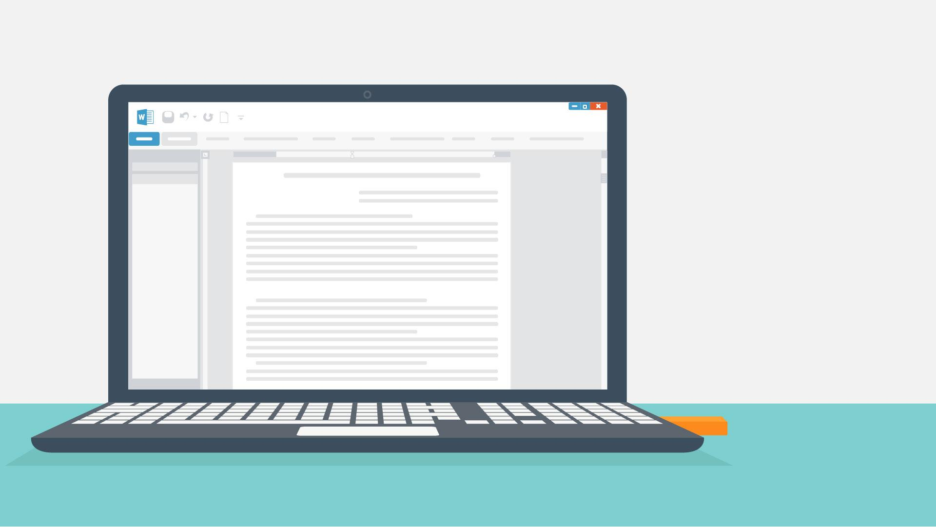
25 | If you follow these  safeguards and report  anything suspicious to your it department right away... | - Worker and IT specialist appear  - Mail flies from the worker towards IT | 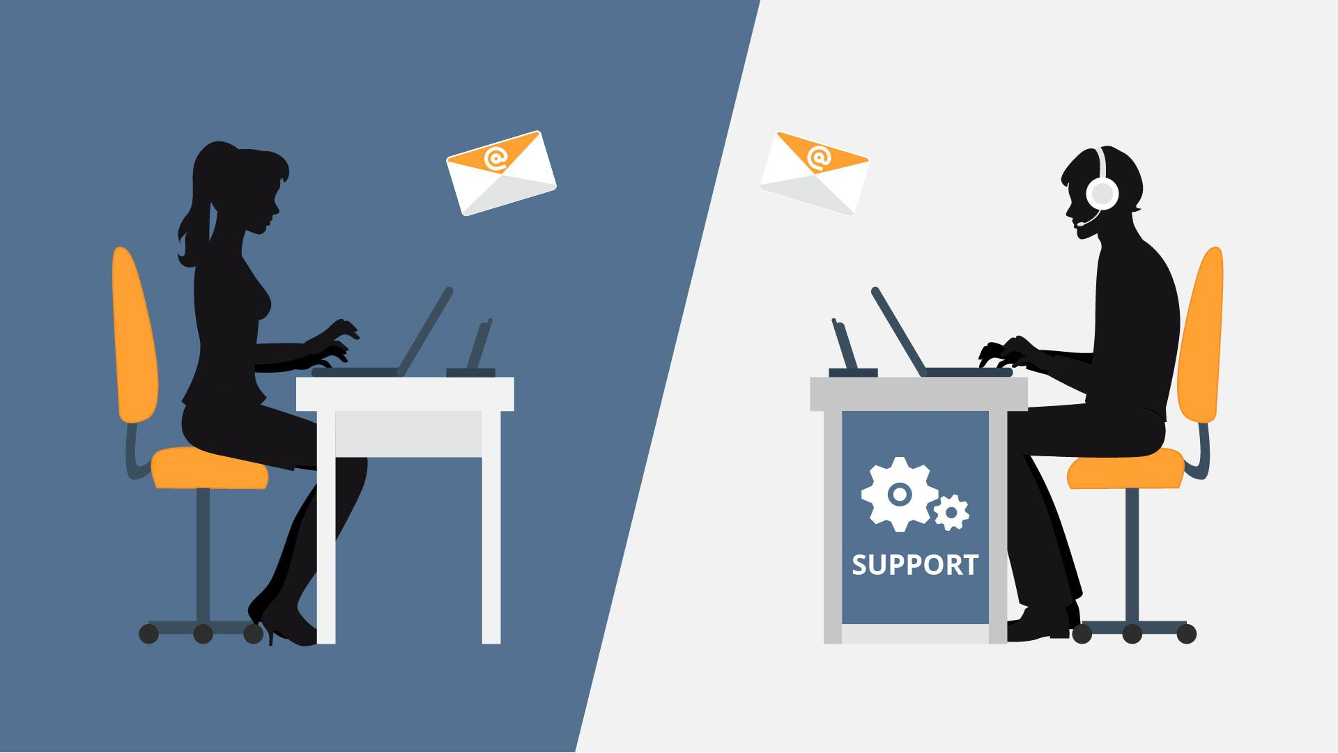
26 | YOU do your part to  protect US from  cyberthreats! | - Image appears  - Character shows thumbs up. | 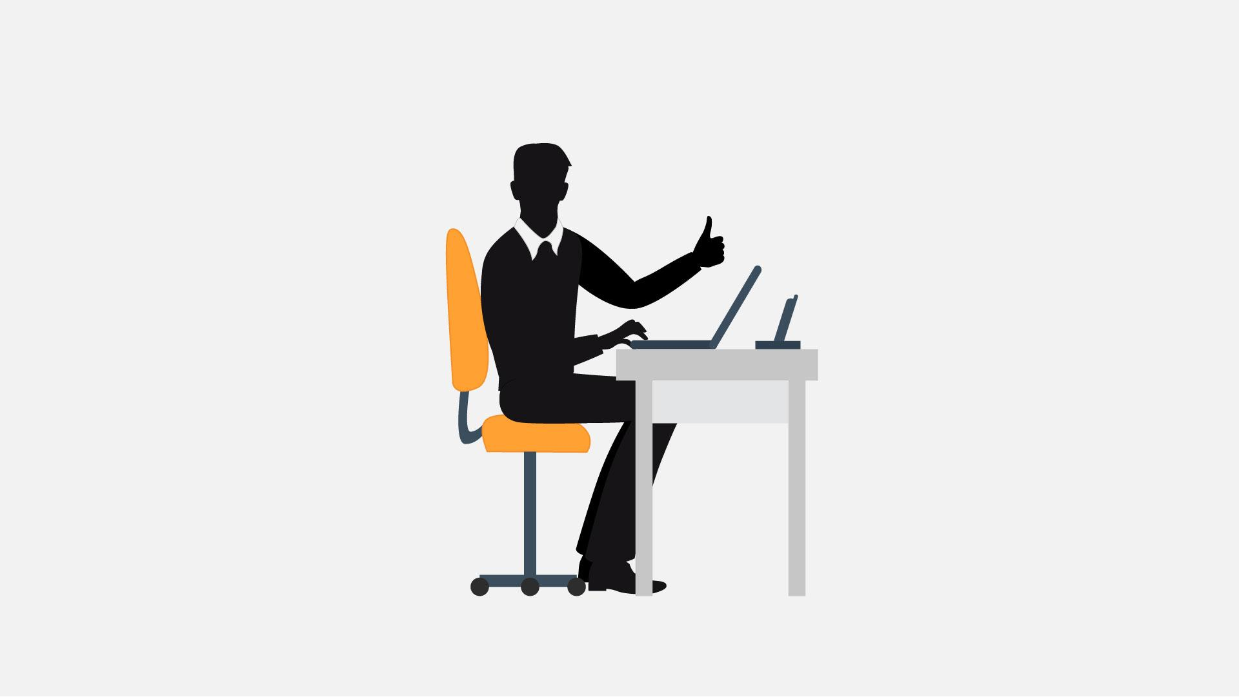
27 | Thank you and be safe! | - Logo animation

