Movie Storyboard “Physcical Security Awareness Video”

Introduction: Each LUCY Video is split up in different scenes / animations. This video script covers the awareness video under:

https://www.youtube.com/watch?v=ORS9DPKJlks

If you want only a few selected scenes to be altered choose the according scene and provide us with the customized text and a draft of the desired animation. Within the field “animation description” you can specify the details of the animation.

Price calculation: A modification costs about around 100 USD per scene (depends on the complexity of the desired animation). So if you only want to change the logo at the beginning and the end with the intro voice change it will cost 200 USD. The creation of a customized new video of about 2 mins length with a voice of your choice starts from USD 2’000 (includes voice & image/animation design).

# | Voice-over | Animation | Storyboard
1 | This is a LUCY  Physical security video | - Logo and text animation | 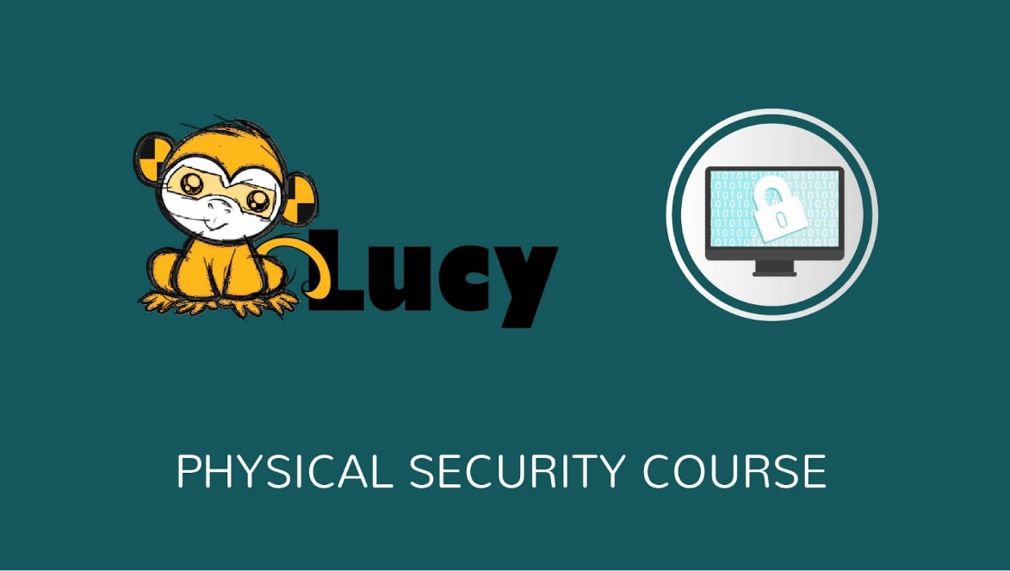
2 | So how exactly can PHYSICAL SECURITY prevent huge thefts from your organization?  Well, network systems aren't the only way that sensitive information can be stolen or used against an organization. Physical security must be implemented correctly to prevent attackers from gaining physical access and taking what they want. | - Notes appears on the right  - Text animated  - 2 person appear on the left  - Employee gives the criminal confidential data  - Block sign appears | 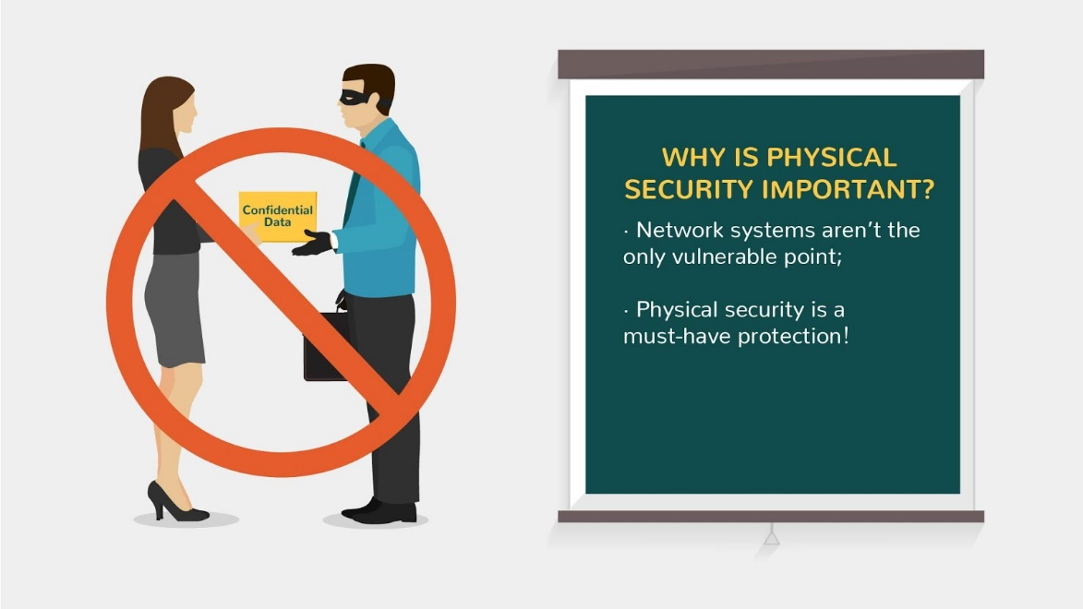
3 | If you need to leave your devices unattended: secure them!  Secure your area before leaving it unattended: take keys out of drawers, close and lock windows, never share your access code, card or key, and don't hold secure doors open for people you don't know. Be sure to lock up equipment and sensitive material before you leave them unattended. | - Text is animated on the note  - Image appears on the left  - Lock appears on the screen and thumb up icon appears | 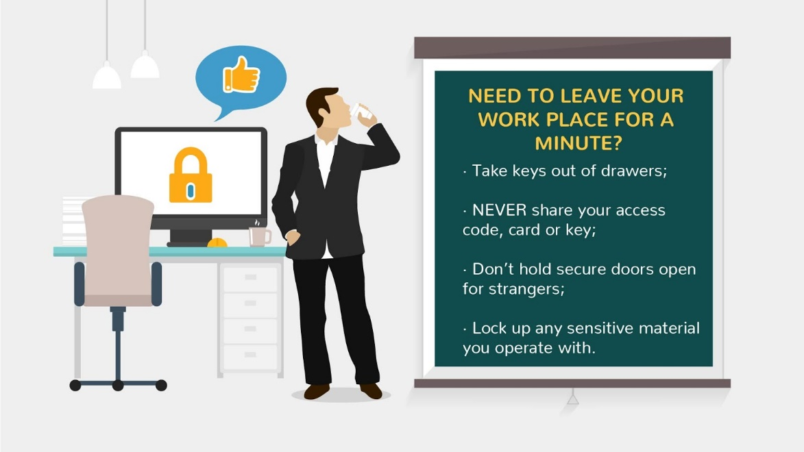
4 | Shoulder surfing is using direct observation techniques, such as looking over someone's shoulder, to get information.  It is an effective way to get information in crowded places because it's relatively easy to stand next to someone and watch as they fill out a form, enter a PIN number at an ATM machine, or use a calling card at a public pay phone. | - Text is animated on the note  - Image appears on the left  - Character looking at the tablet appears  - Criminal appears  - Tablet is changed to ATM and then to phone | 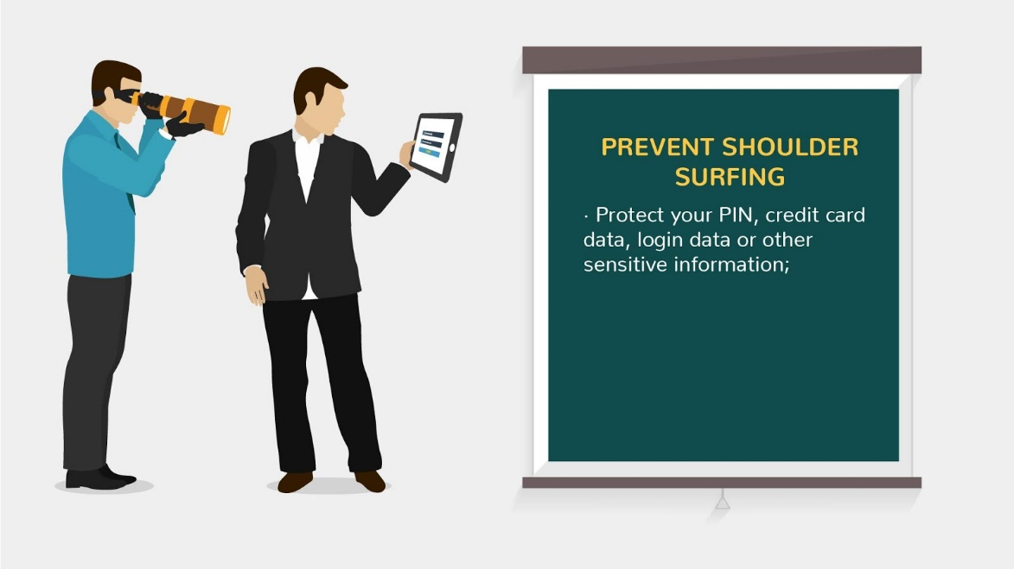  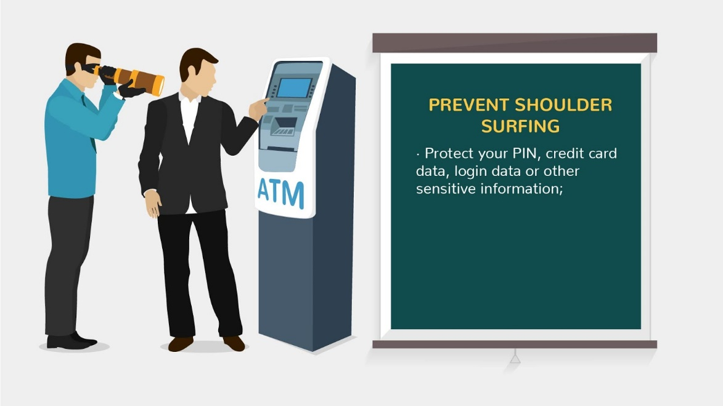  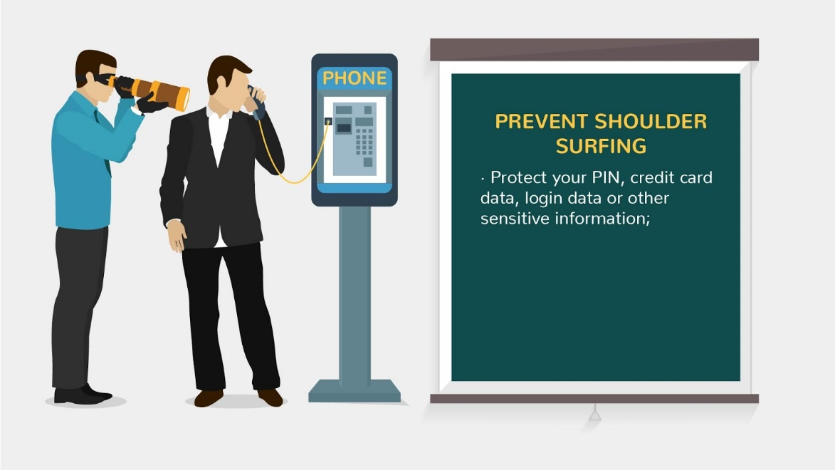
5 | To prevent shoulder surfing, experts recommend that you shield paperwork or your keypad from view by using your body or cupping your hand. | - Character with confidential data appears  - Character is cupping his hands above the confidential data | 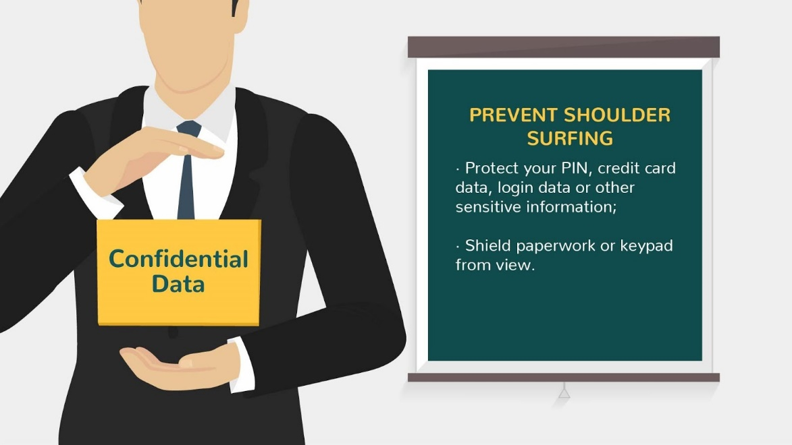
6 | Physically secure laptop computers and mobile devices at all times: keep them with you or lock them up securely before you step away -- even just for a second. And make sure they are locked to or in something permanent. | - Text is animated on the note  - PC appears and lock appears on it | 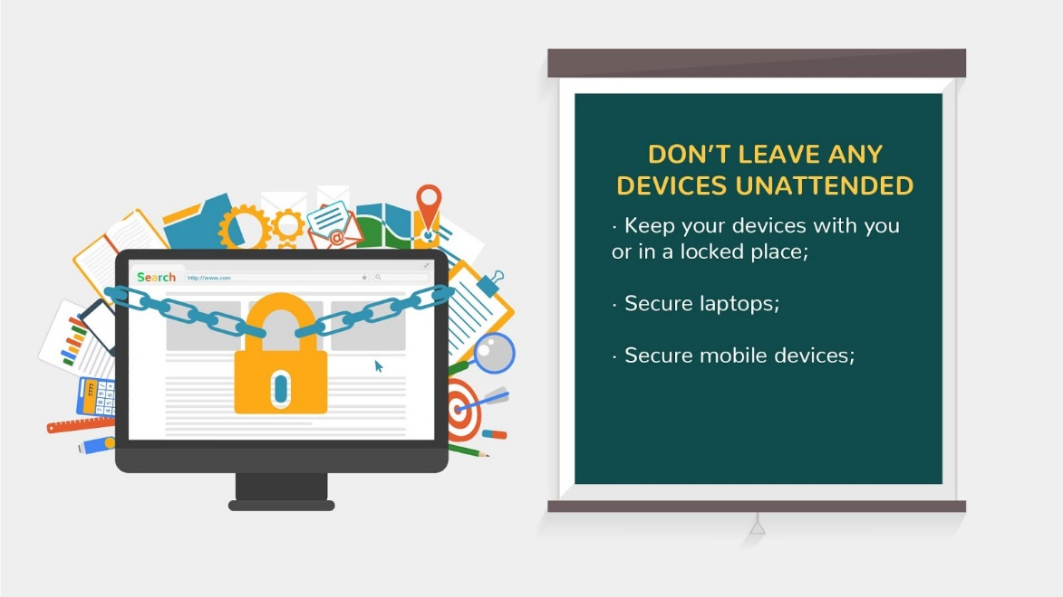
7 | Don't leave mobile devices unattended in public places.  Be especially careful with portable devices (such as laptop computers, mobile phones, memory sticks, CDs/DVDs/floppy disks). These items are extra vulnerable to theft or loss. | - Public place appears  - Icons of devices appear as V\O mentions them | 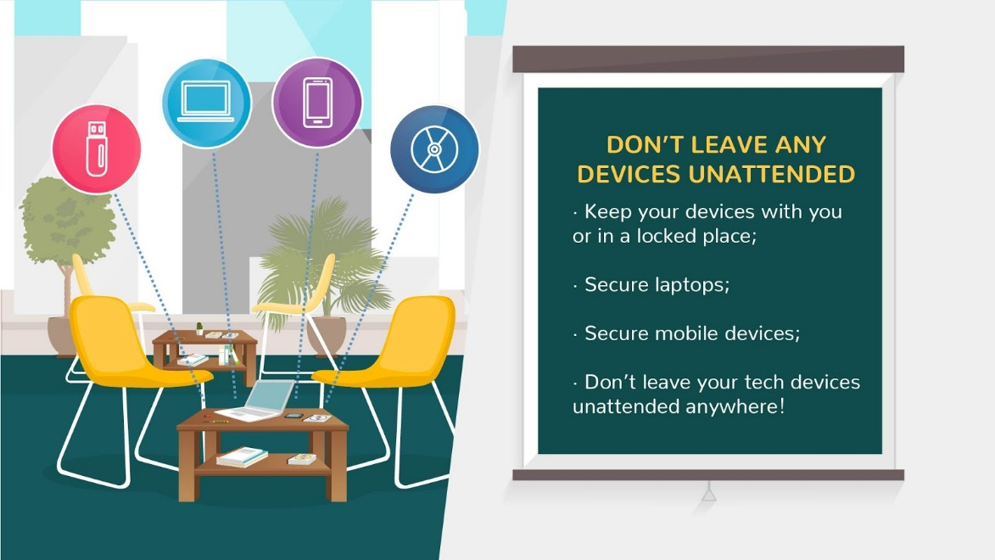
8 | If you find a random USB device lying around, give it to the IT support team.  The IT department can find the owner without putting the system in danger. | - Image appears with the question  - Text appears in the note  - Text is changed in the note | 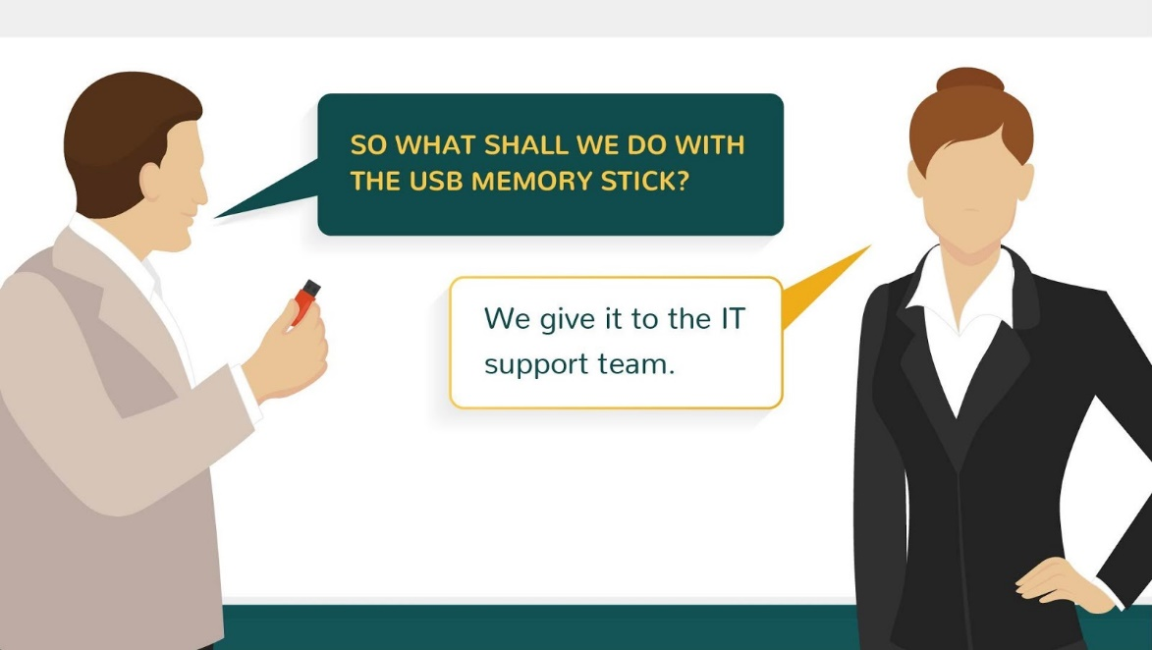  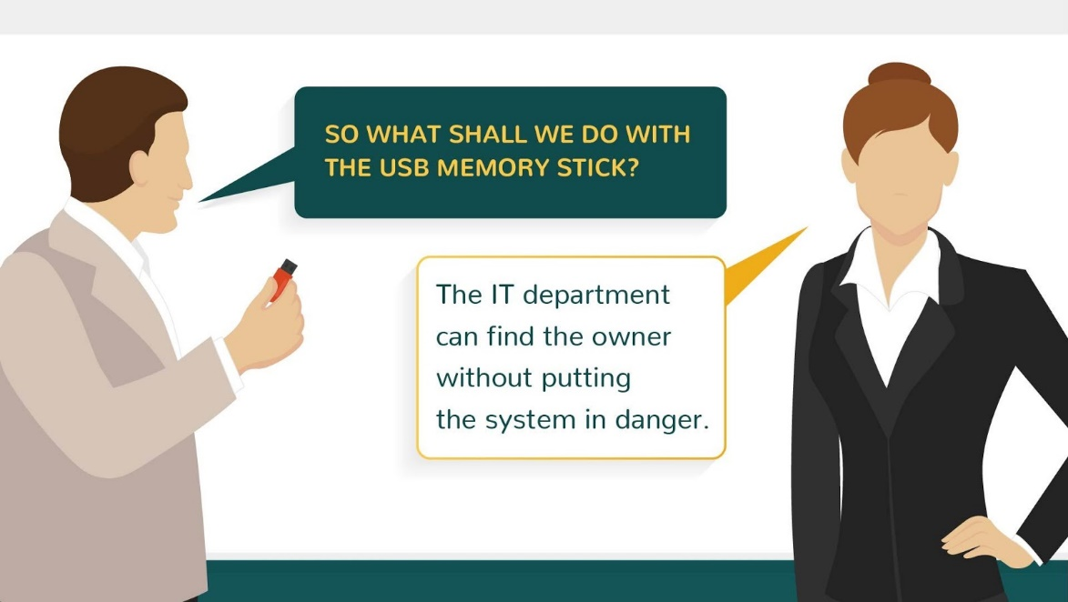
9 | Enable remote wipe  Some devices can be set to be erased remotely, or to erase themselves if the password/PIN is entered incorrectly too many times.  Consider turning these on to protect information in the case of theft or loss. Be sure to back up your device regularly if you enable these features! | - Text is animated in the note  - Animation of wiping data on the phone  - Screen changes and *Create Backup* button is clicked | 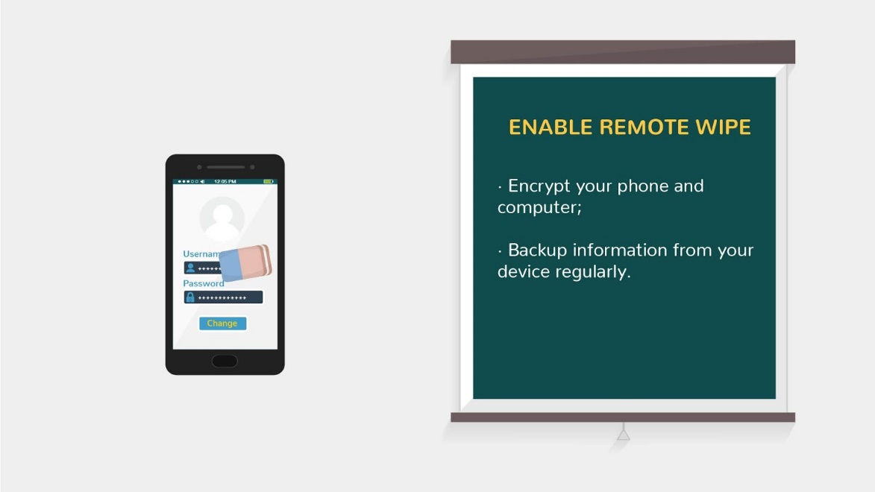  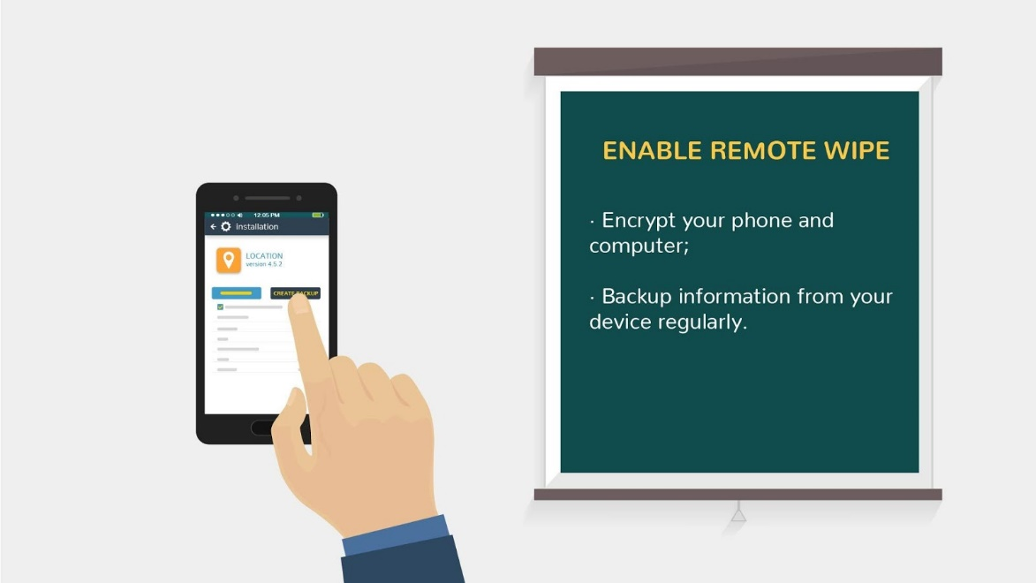
10 | Password-protect all of your devices  Use a complex password and set the device to lock after a short period of inactivity. | - Same animation as in reference | 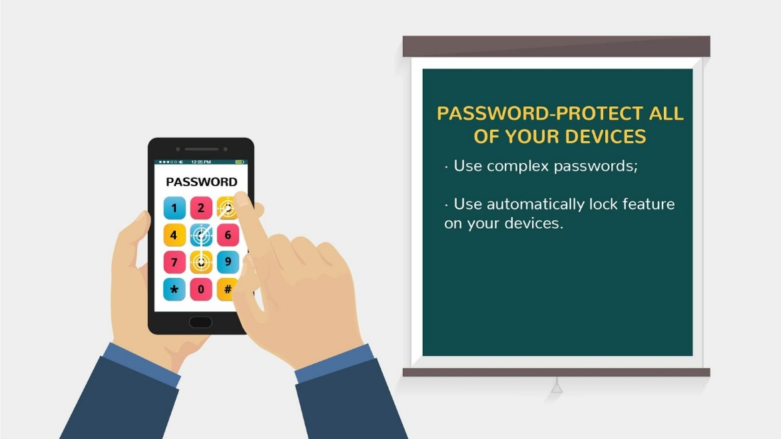
11 | Sensitive documents must never be disposed of in the  wastepaper basket. Also, don’t forget:  If you print a document, you should always pick up the printouts. | - Same animation as in Lucy Awarness V2  - Bin appears  - Document labeled “secret info” appears on the floor near the bin  - Printer appears  - Stack of papers appear labeled top secret appear on it | 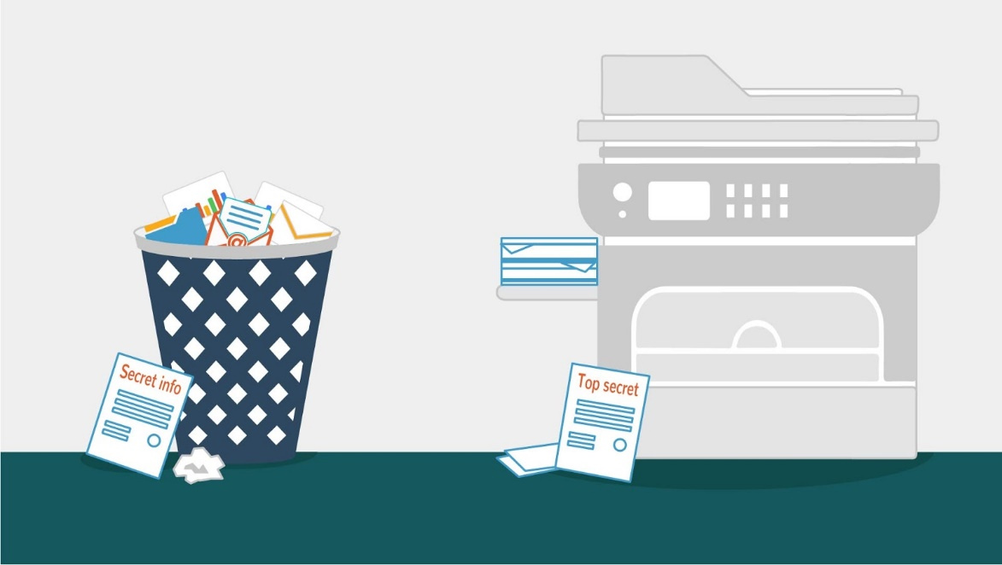
12 | Sometimes an attacker might look through your trash hoping to discover  useful information that may allow access to your network. | - Same animation as in Lucy Awarness V2  - Trash bin appears  - One hand appears and throws the documents into the trash bin  - Criminal hand appear and pull the documents out of the bin | 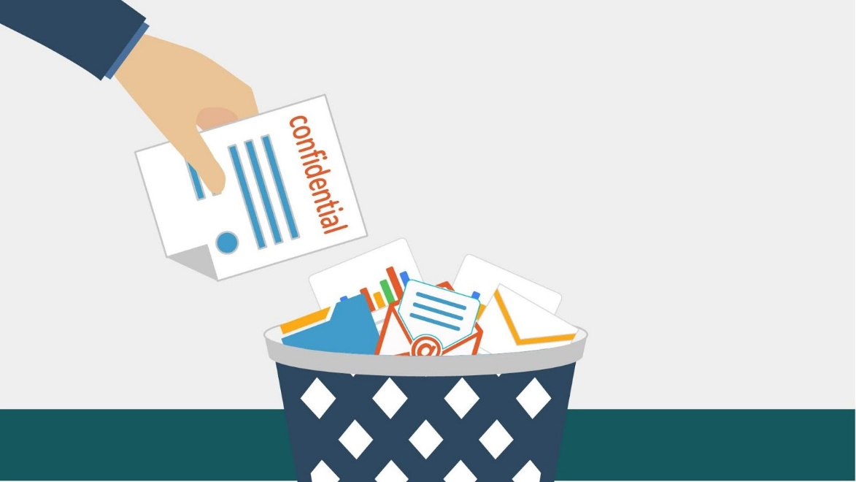  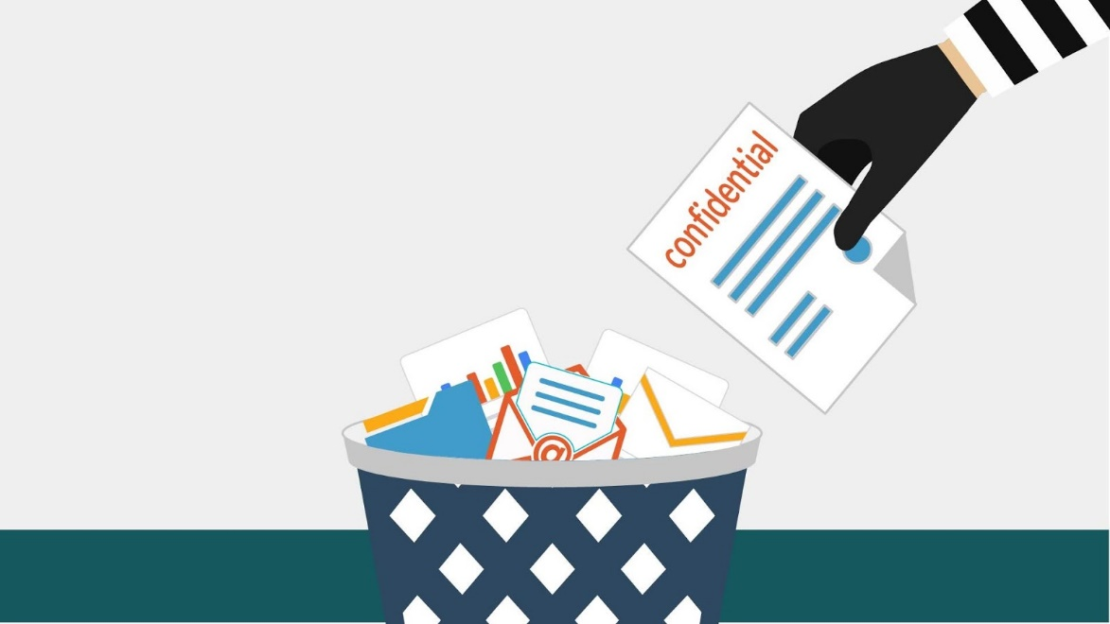
13 | An attacker may try to gain access by pretending to be an employee, visitor or service personnel. | - Security guard appears near building entrance  - Second character appears near to him  - Security guard shows stop  - Block sign appears | 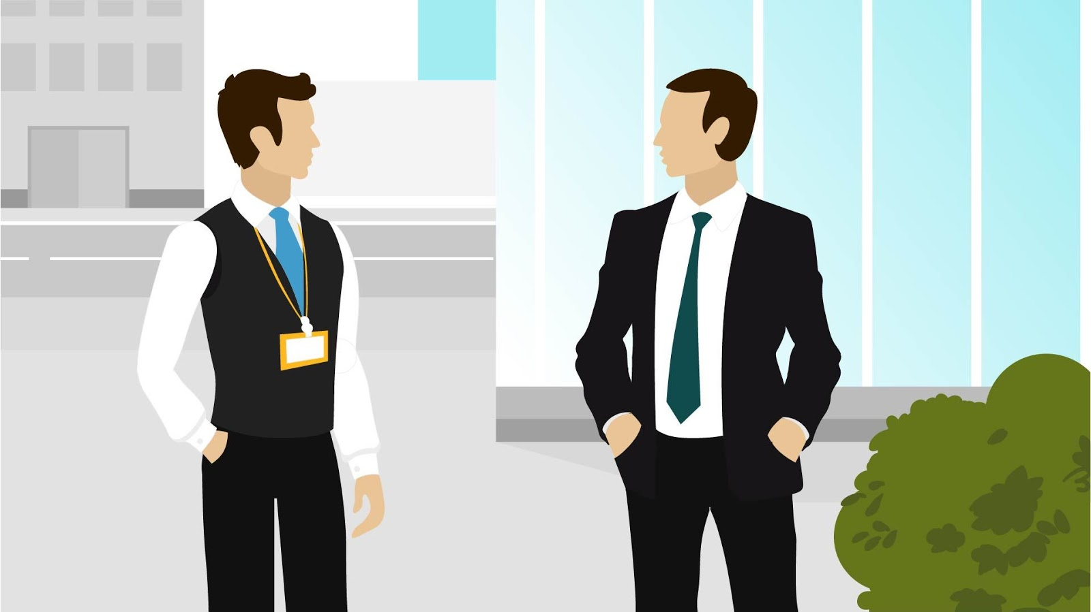  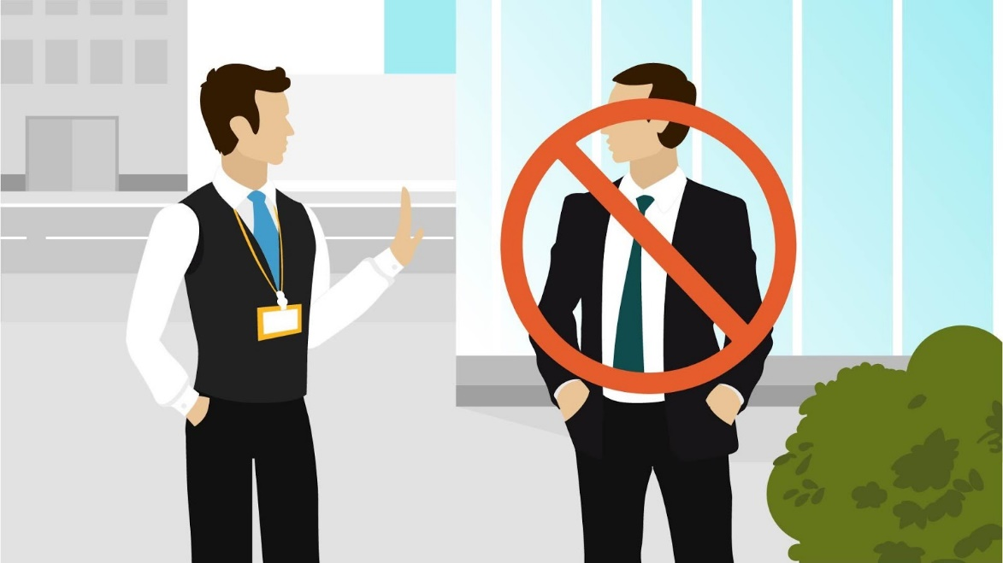
14 | Follow a Clean Desk Policy:  Following a clean desk policy will help us reduce the risk of information theft, fraud, or a security breach caused by sensitive information being left in plain view. | - PC monitor appears  - Stickers with login and passwords appear on it  - Block signs appear  - Stickers disappear | 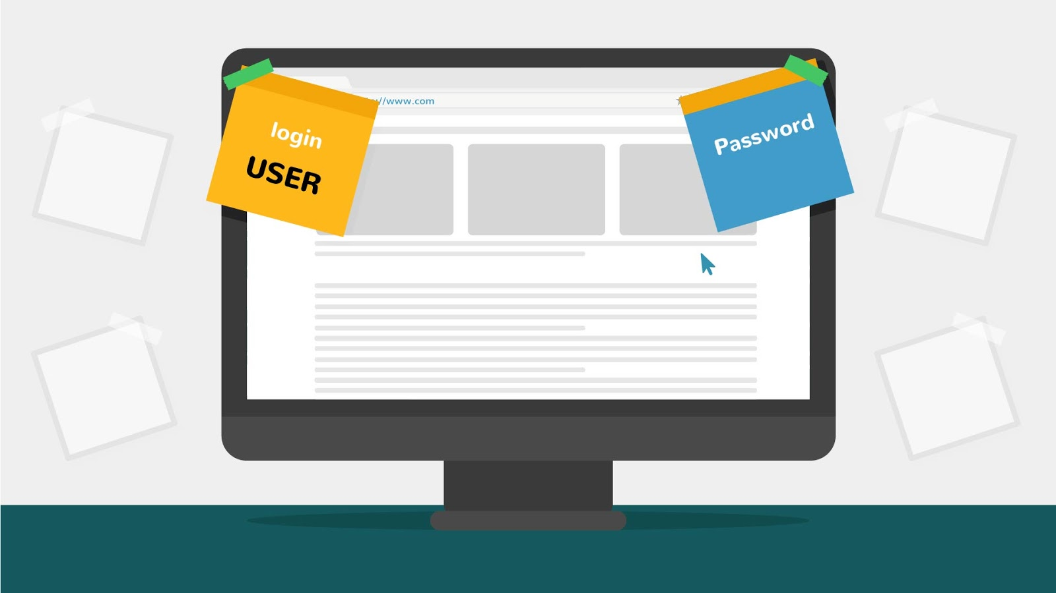  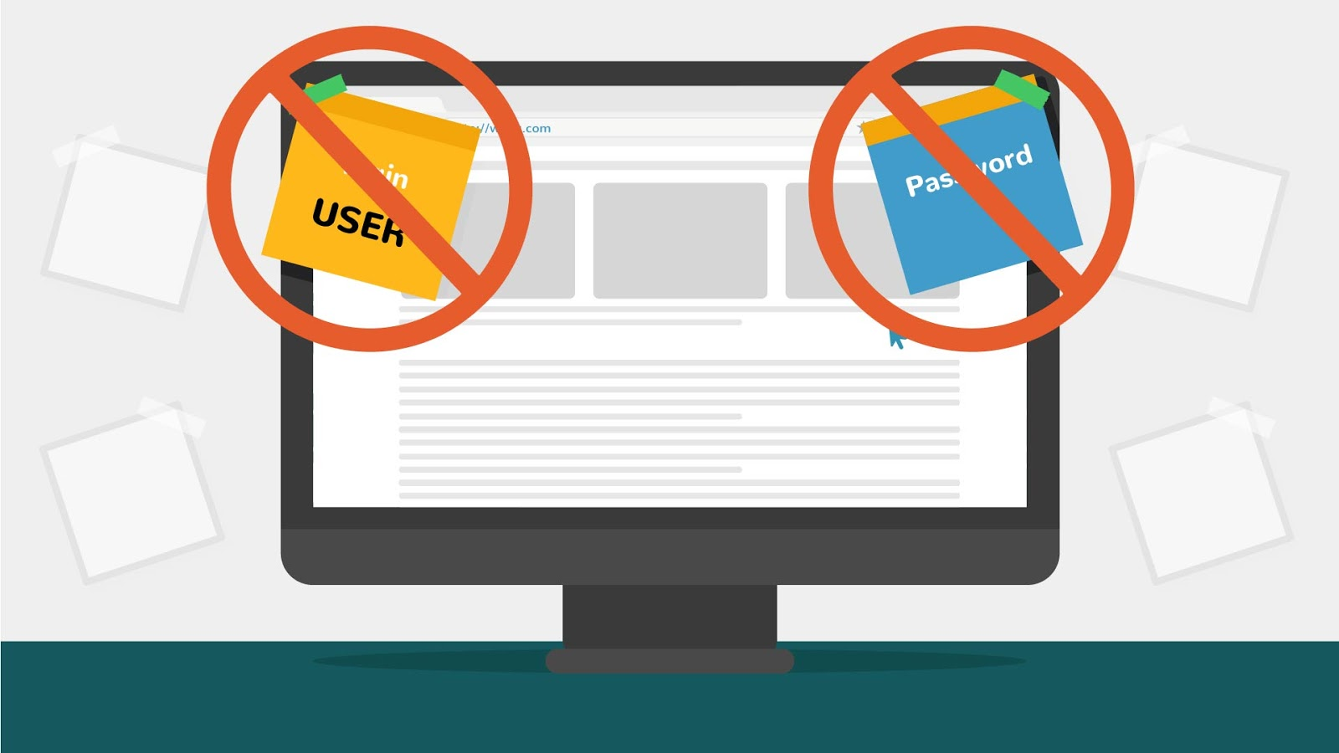
15 | Lost your device? Report lost or stolen devices directly to your it department & notify your supervisor. | - Text is animated  - Images on the left appears as V\O mentions them | 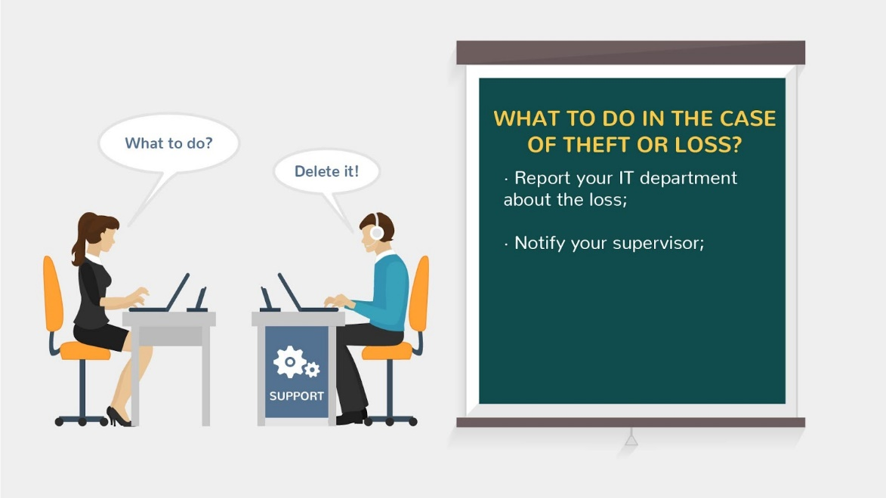
16 | For phones, notify your cellular carrier -- see if they can deactivate the device. | - Text is animated  - Phone appears on the left  - Block sign appears | 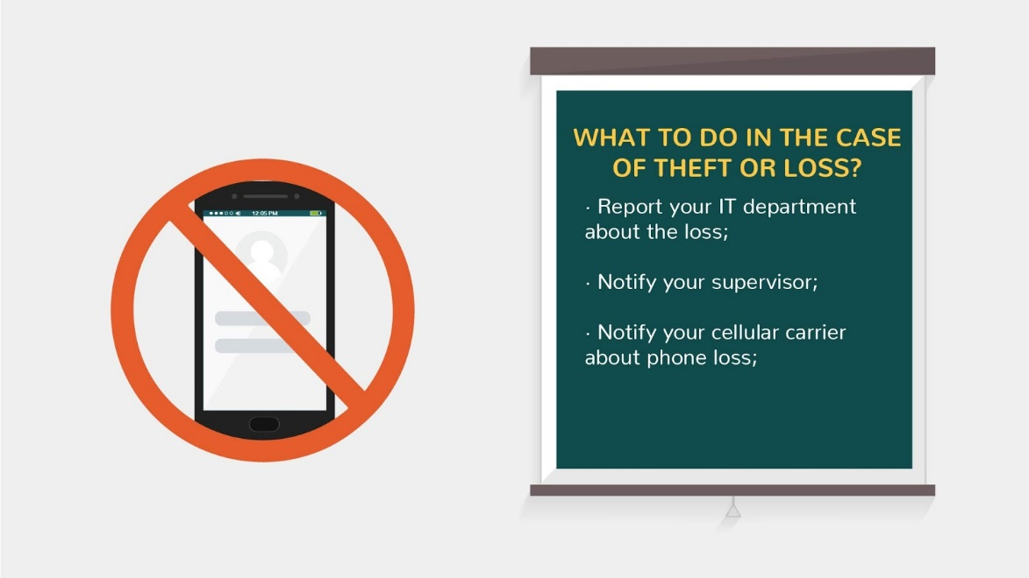
17 | Change all passwords stored or used on the device, including email, Dropbox, banking, etc. | - Text is animated  - Images on the left appears as V\O mentions them | 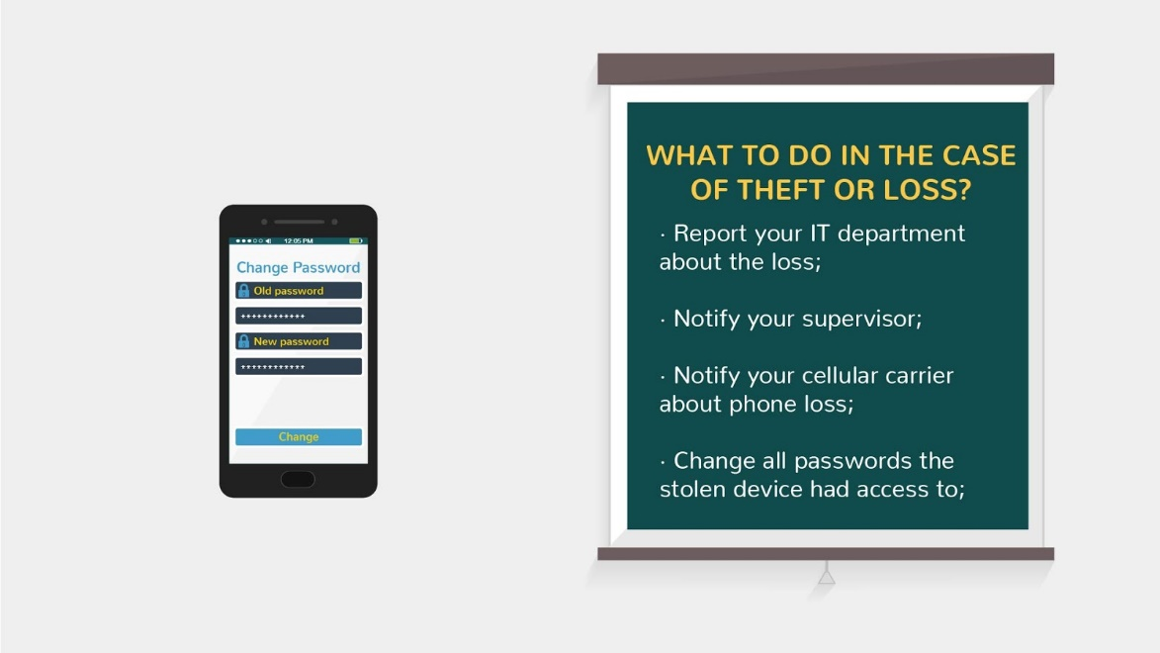
18 | Notify credit card companies and banks if you used the device for shopping or banking. | - Text is animated  - Images on the left appears as V\O mentions them | 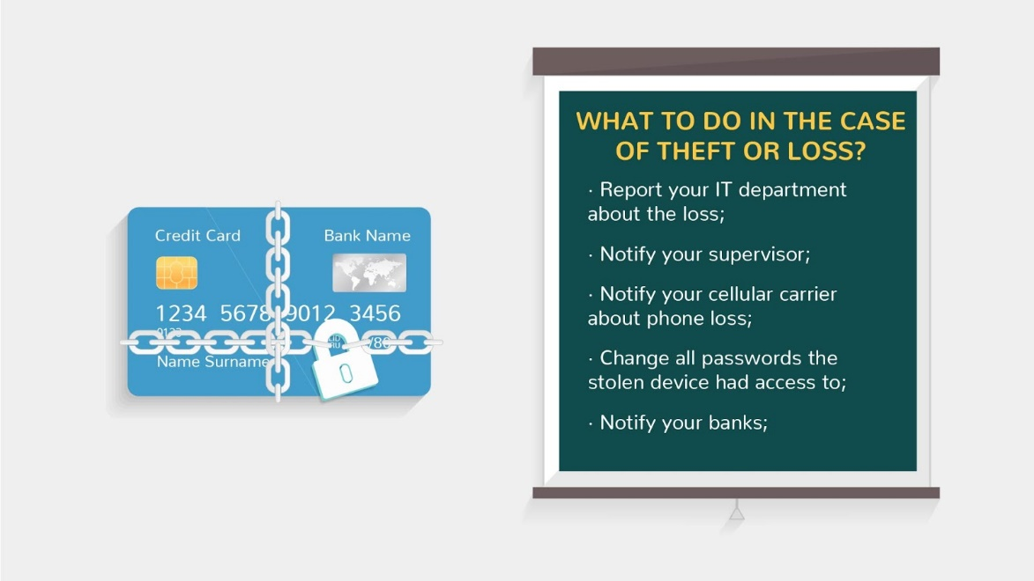
19 | Try to track its location, if possible. | - Text is animated  - Images on the left appears as V\O mentions them | 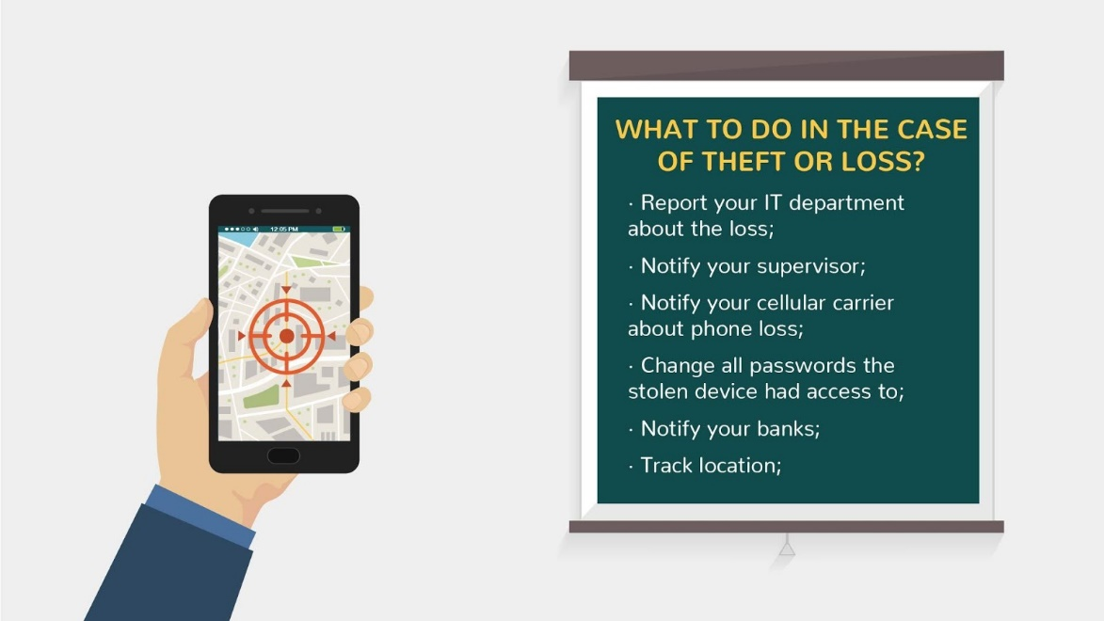
20 | Try remote wipe if sensitive information, passwords, or credit cards were stored. | - Text is animated  - Images on the left appears as V\O mentions them  - We show the wiping process on the screen | 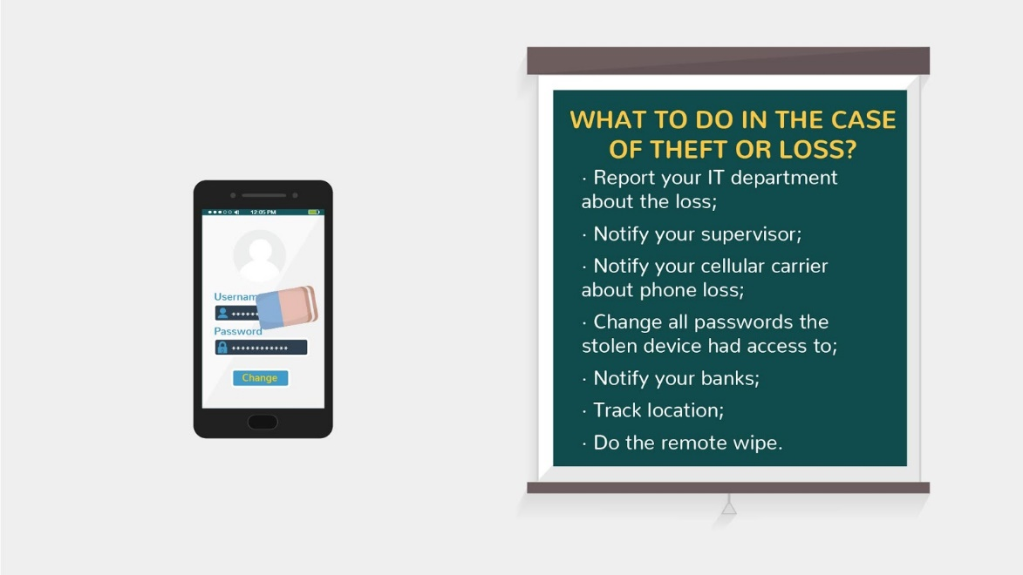
21 | THANKS FOR WATCHING  Should you have questions, do ask your colleagues or the responsible department. They will be happy to help you. | Characters appear in the left | 