Movie Storyboard “Password Security Awareness Video”

Introduction: Each LUCY Video is split up in different scenes / animations. This video script covers the awareness video under:

https://www.youtube.com/watch?v=VqEMlofu47k

If you want only a few selected scenes to be altered choose the according scene and provide us with the customized text and a draft of the desired animation. Within the field “animation description” you can specify the details of the animation.

Price calculation: A modification costs about around 100 USD per scene (depends on the complexity of the desired animation). So if you only want to change the logo at the beginning and the end with the intro voice change it will cost 200 USD. The creation of a customized new video of about 2 mins length with a voice of your choice starts from USD 2’000 (includes voice & image/animation design).

# | Voice-over | Animation | Storyboard
1 | This is a LUCY password security video | - Usual logo animation | 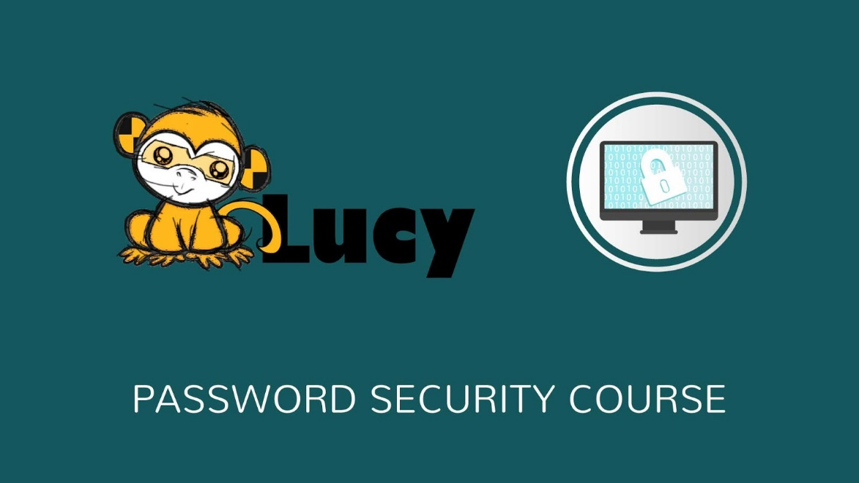
2 | So let’s talk about passwords.  Passwords are like keys to your home...but online. You should do everything you can to prevent people from gaining access to your password. You can also further secure your accounts by using additional authentication methods. | - Text appears on the note  - Gadgets slide in from the left  - Password icons appear on the screens  - Bunch of keys appears above | 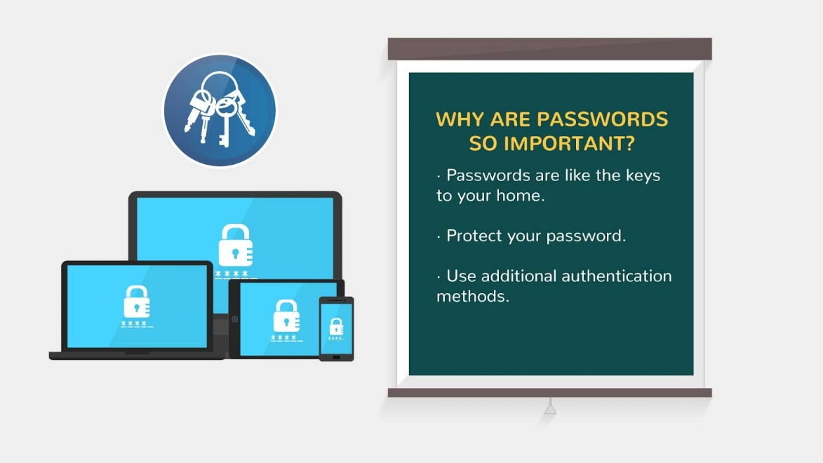
3 | Dictionary programs are one of many tools frequently used to crack passwords. A hacker will launch a dictionary attack by passing every word through a dictionary (which can contain foreign languages in addition to the entire English language), to a login program hoping that a word will eventually match the correct password. | - We see animation like in the reference | 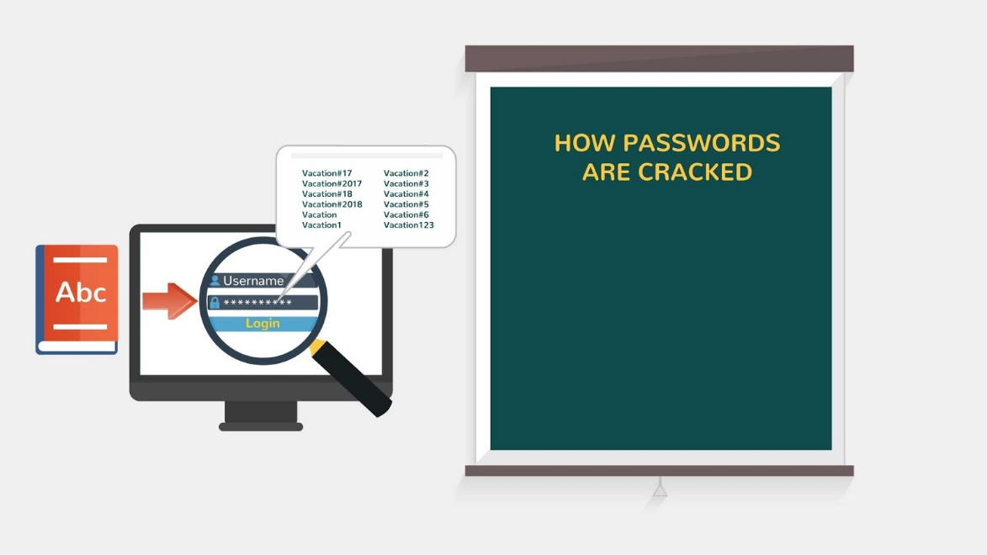
4 | Some passwords can be cracked instantly by computer software, here is a list of the top 10 worst passwords. All of these passwords would be cracked instantly: | - Text appears  - Passwords are highlighted 1 by 1 | 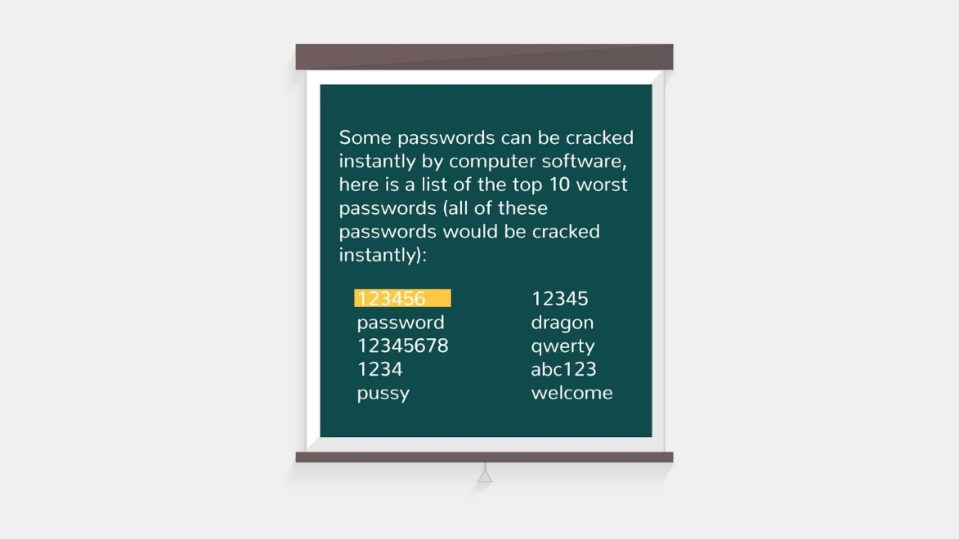
5 | Passwords become more secure as you add more layers of security to them. For example, if you use a password like “Mankato”, it would take about 4 minutes to be cracked. If we add an extra layer of security to our password such as numbers or special characters, we get passwords that take much longer to crack. | - Text on the top is animated  - Two different passwords appear(red and green)  - Icons appear below (the right clock is ticking faster and faster)  - Text is animated below the icons | 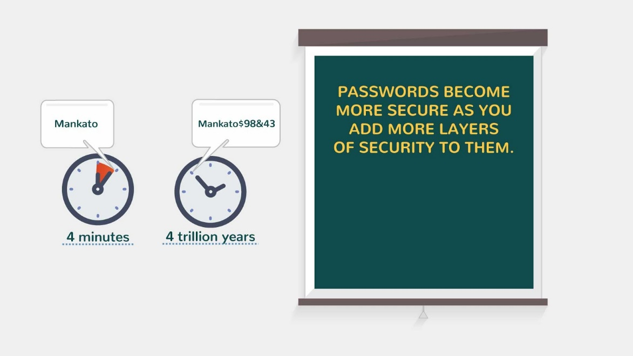
6 | Want to know how to make your password secure? | - Image appears and new text appears | 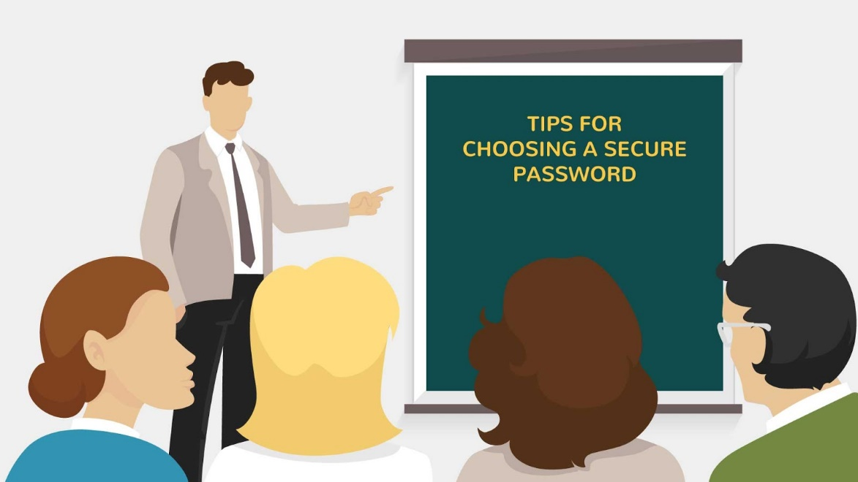
7 | TIP1: Don’t Use the Same Password Over and Over Again.  Passwords should be changed on a regular basis, at least twice a year. The primary reason is that if someone has cracked your password without you being aware of it, it makes them have to start all over again. A strong password is one that's never reused. | - New text appears on the note  - Calendar appears  - Text *180* is animated  - Bell rings  - Text animated above | 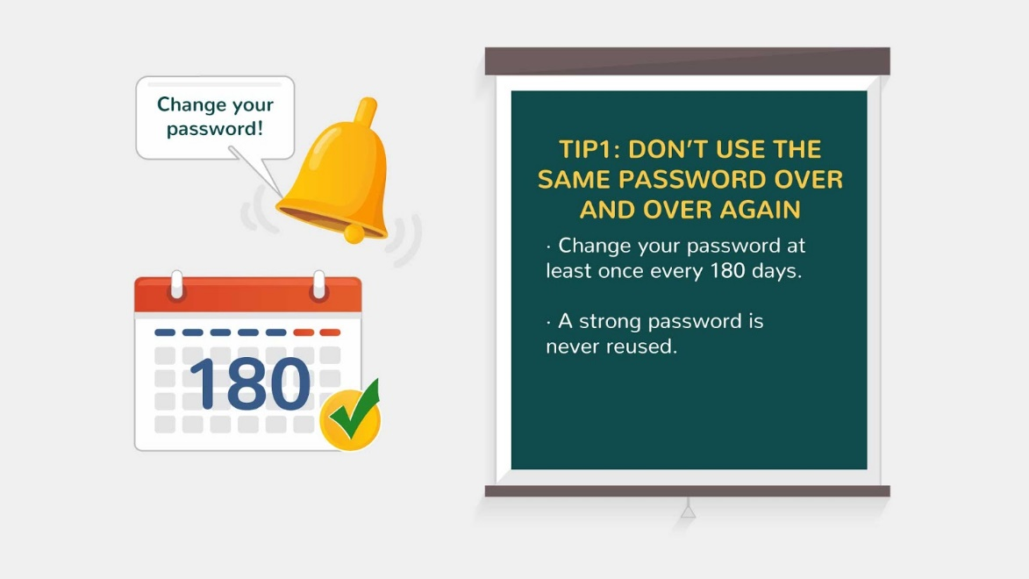
8 | TIP2: Categorize your passwords in order to minimize the number of passwords you have to remember but also to provide a barrier between systems with sensitive information and those with non-sensitive information. For example, you can use the same password for Gmail and Hotmail, but you should not use the same password for your online banking program. The password you have for your Hotmail (or other Internet email services) should be different than the passwords you use on any work-related systems. | - New text appears on the note  - Picture appears and animated | 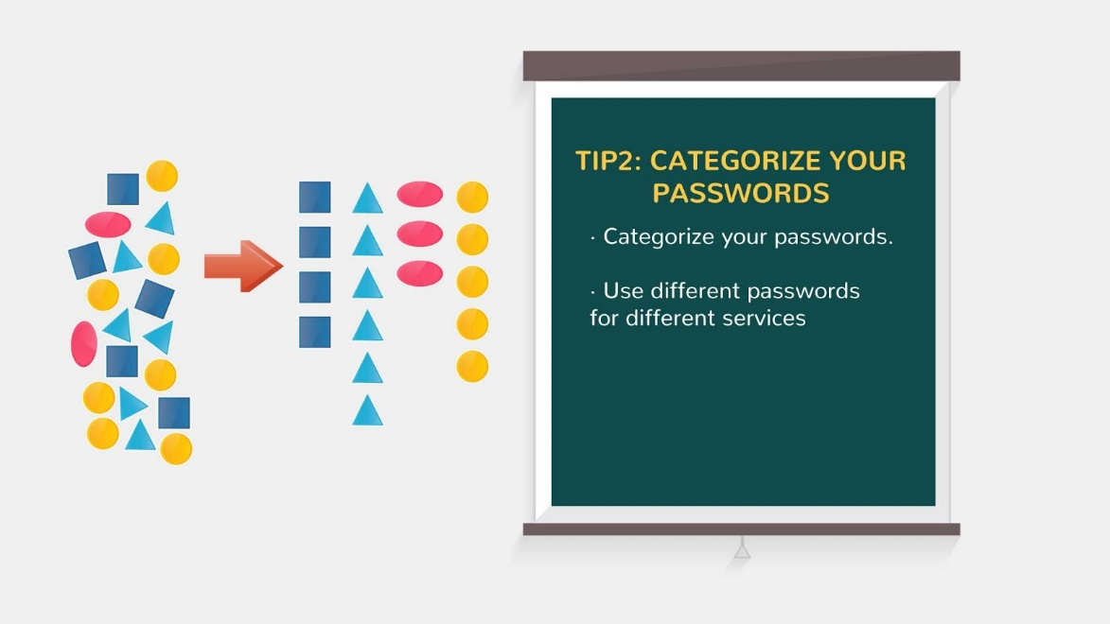
9 | TIP3: It is important not to reuse passwords and to change your passwords on a regular basis. | - New text appears on the note  - Lock appears on the PC screen  - The color of the lock changes (showing the change of password) | 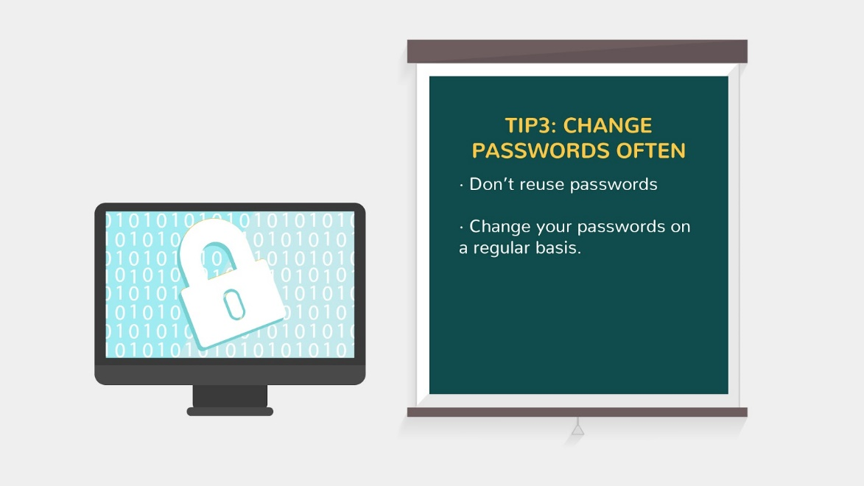  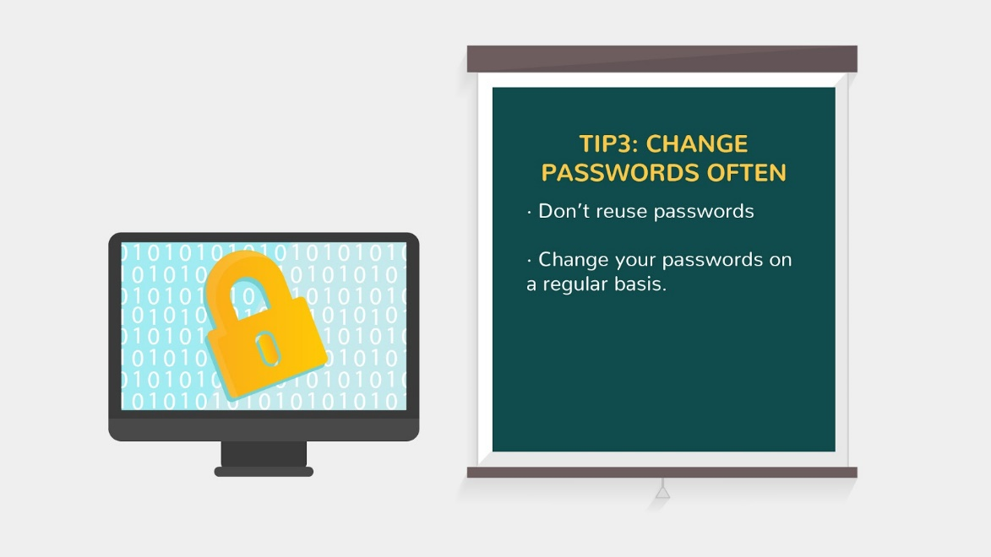
10 | TIP4: Instead of people guessing passwords, now computers are guessing passwords. For this reason, if your password is made up of words found in a dictionary, it is very easy for a computer to guess it and gain access to your account. | - New text appears on the note  - Password is typing on the PC screen  - Speech bubble and book in it appear  - *HACKED* is stamped on the password | 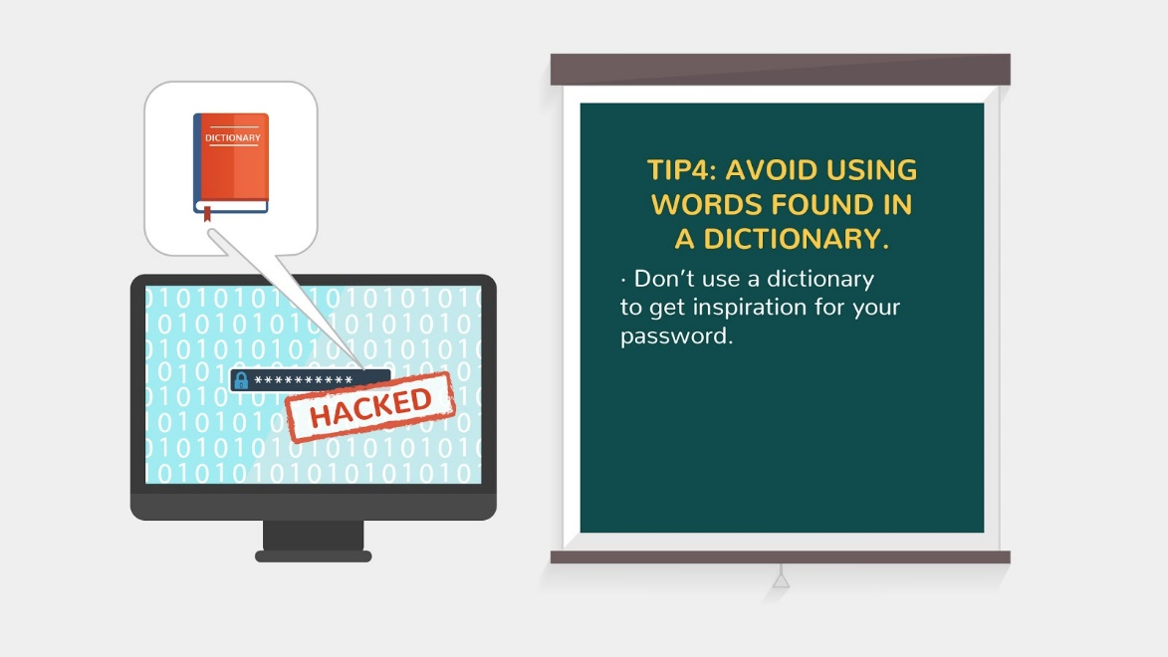
11 | TIP5: A password should be at least eight characters long. | - New text appears on the note  - Locks appear 1 by 1 | 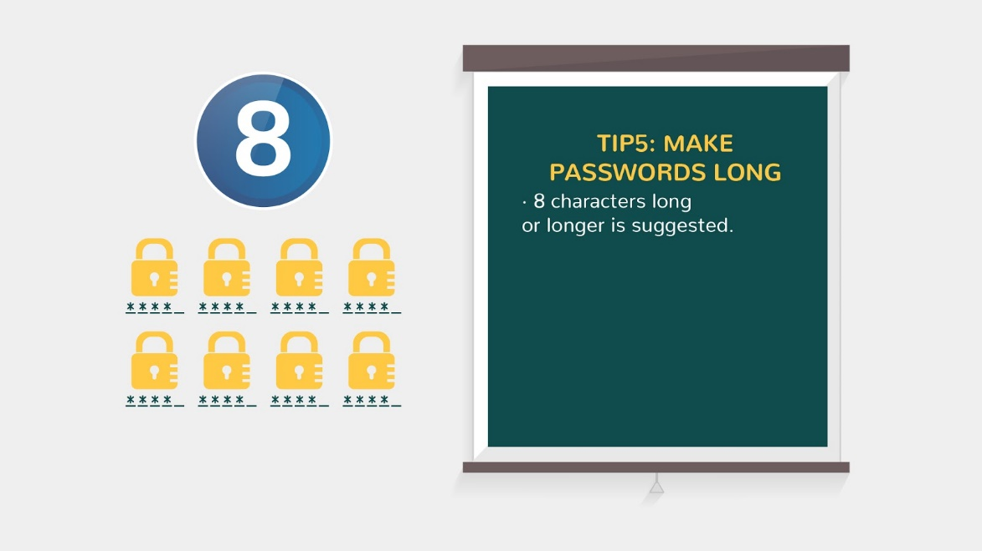
12 | Tip 6: Moreover, use uppercase, lowercase, special characters, and numbers in your password. | - New text appears on the note  - Text appear 1 by 1 synchronised with V/O | 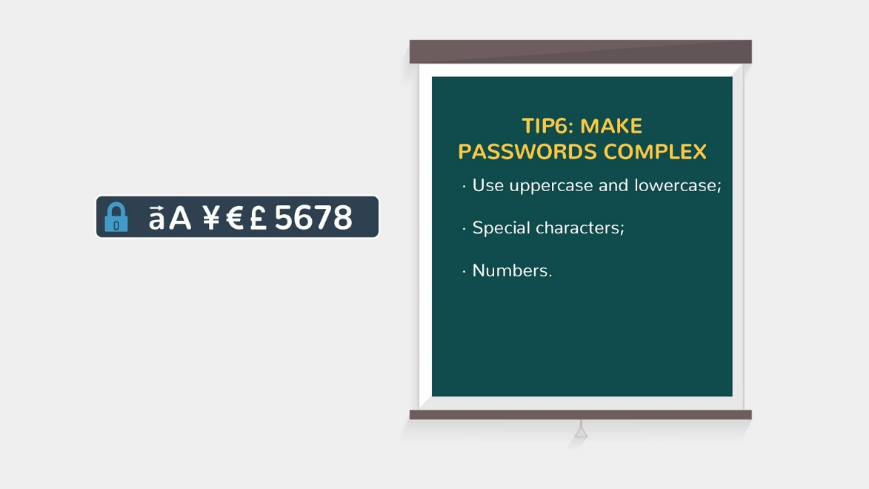
13 | TIP7: Try not to re-use one of your last five passwords in any form of iteration. See examples on the screen. | - New text appears on the note  - Icon and text in it appear  - Red cross flies on it | 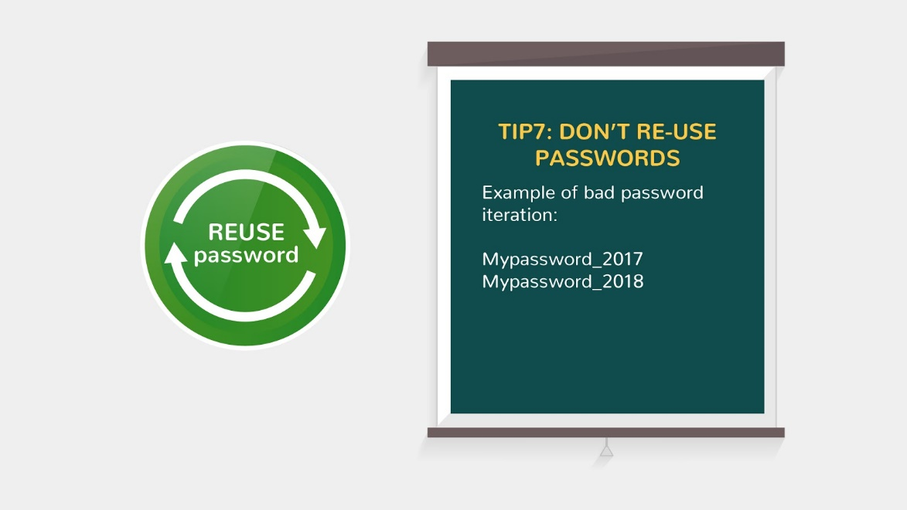  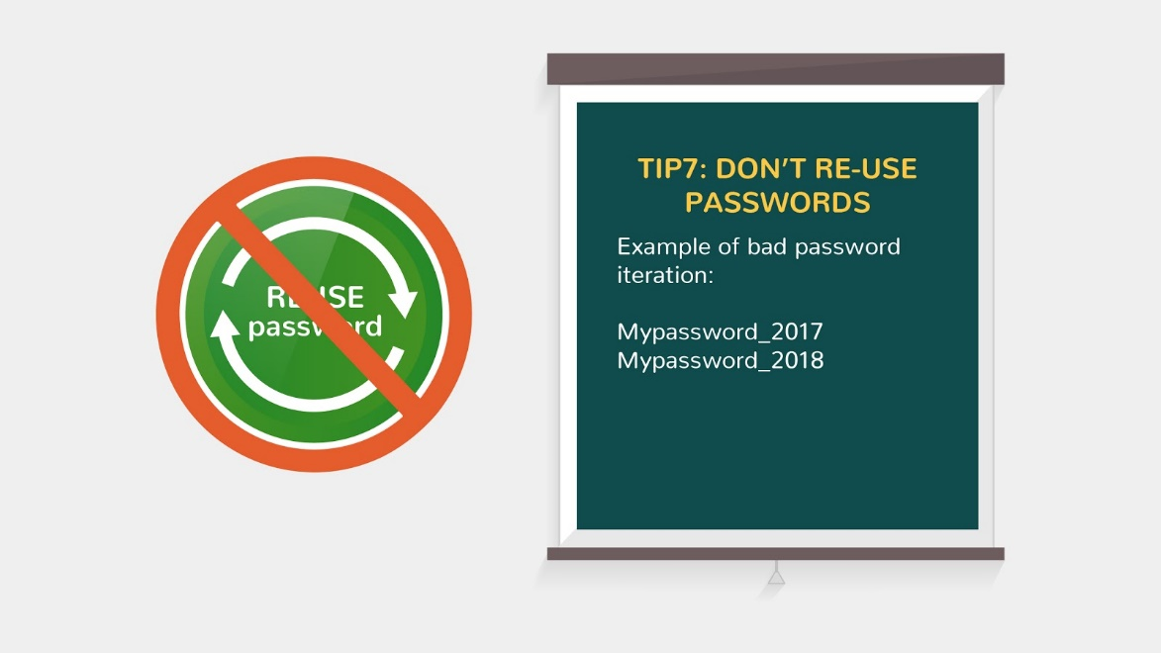
14 | TIP8: Avoid using things like your name, birthday, current year, current season, address, phone number, pet’s name, or other information that may be on social networking profiles, public records, or otherwise easily found or guessed. | - New text appears on the note | 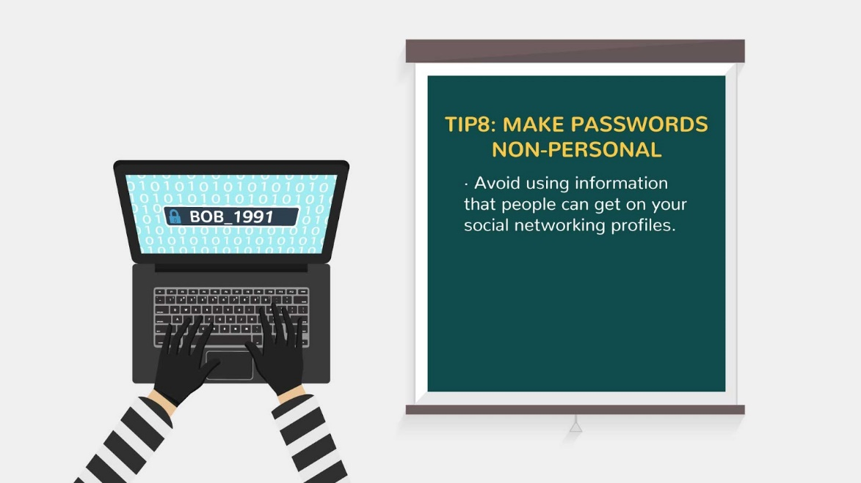
15 | TIP9: If you absolutely need to write down a password, never store it in obvious places, such as address books, Rolodex files, under drawers or keyboards, or behind pictures. The worst, but all too common location, is a Post-it note near the computer. Better locations are a safety deposit box or a locked file cabinet. Software is available for popular hand-held computers that can store passwords for numerous accounts in encrypted form. | - New text appears on the note  - Two pictures slide in  - *YES* and *NO* icons appear nearby | 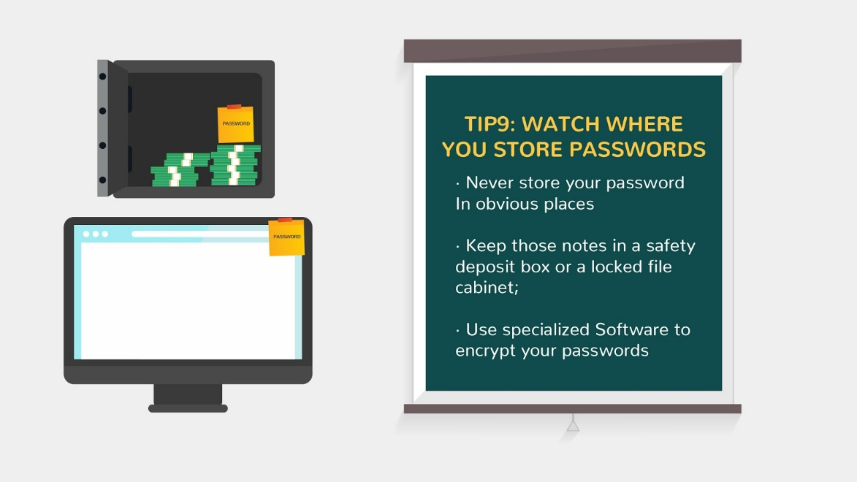  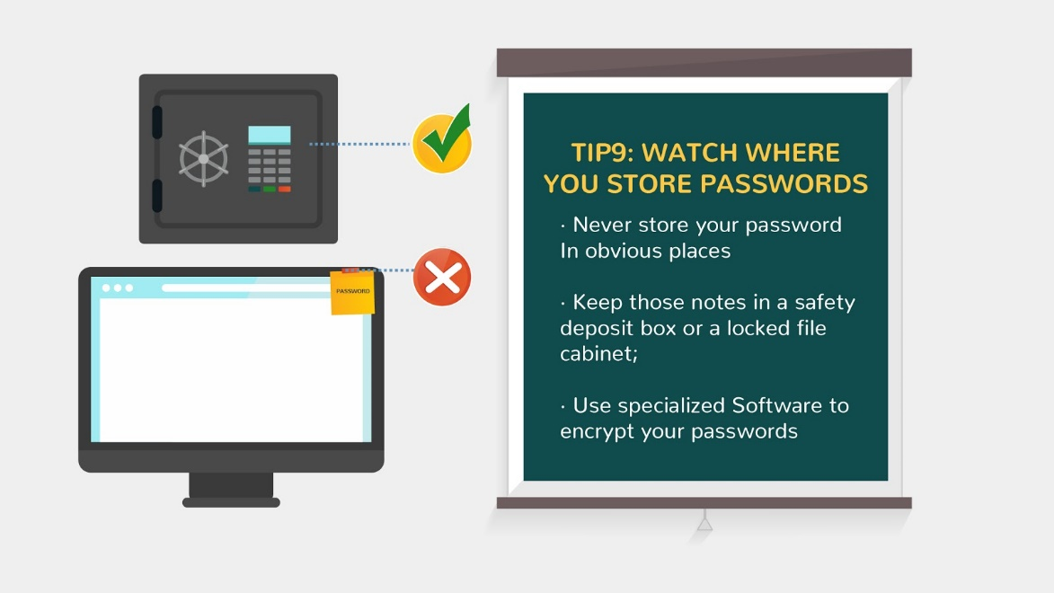
16 | TIP10: Public computers may not always be securely configured, and can pose a threat to your privacy by storing your password or web cookies. Think twice about going to a secure site if you cannot verify the security of the computer. | - New text appears on the note  - We see several computers with users  - Icon of opened lock appears above | 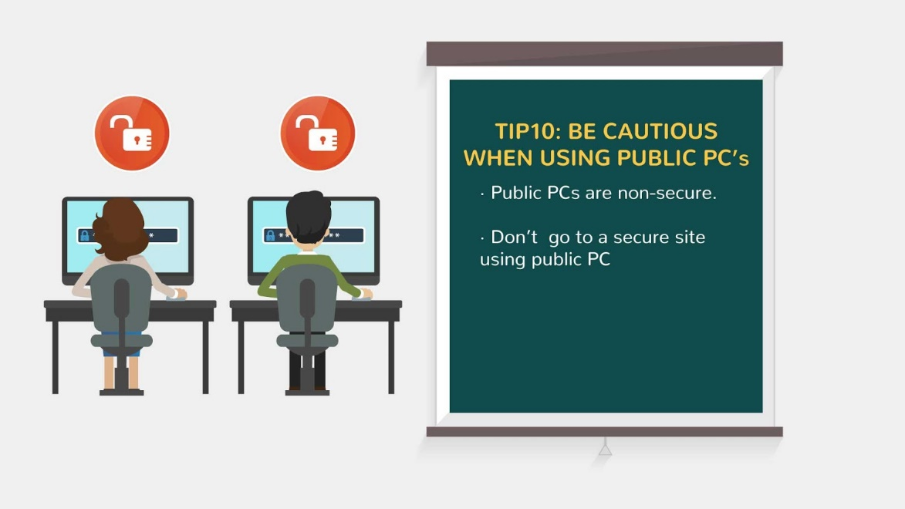
17 | TIP11: Don't forget that getting passwords by manipulation of users is an example of social engineering. An attacker might telephone a user and say, "Hi. OIT here. We're doing a security test. Can we have your password so we can proceed?" Know that any reputable company you do business with will never ask for your password, and rarely, if ever, need to know your password in order to perform the work. | - New text appears on the note  - Icon of whispering man appears  - Speech bubble pops up and text is animated in it | 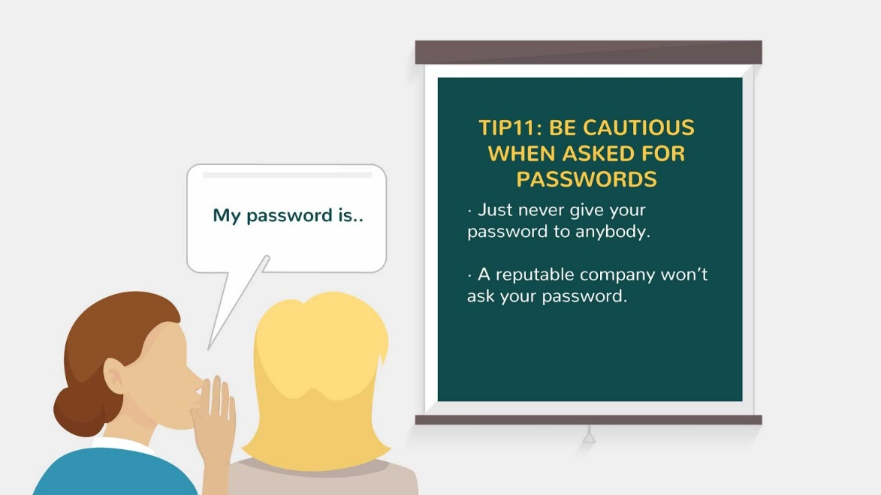
18 | Keep your data safe and be cautious. | - Image appears  - Text is animated  - Logo animation at the end | 