SAMPLE Lucy Movie Storyboard “Ransomware Video”

Introduction: Each LUCY Video is split up in different scenes / animations. This video script covers the awareness video under: https://www.youtube.com/watch?v=995lZmQI-2E

If you want only a few selected scenes to be altered choose the according scene and provide us with the customized text and a draft of the desired animation. Within the field “animation description” you can specify the details of the animation.

Price calculation: A modification costs about around 100 USD per scene (depends on the complexity of the desired animation). So, if you only want to change the logo at the beginning and the end with the intro voice change it will cost 200 USD. The creation of a customized new video of about 2 mins length with a voice of your choice starts from USD 2’000 (includes voice & image/animation design).

# | Voice-over | Animation Plan | Storyboard
1 | This is a LUCY awareness video | - Logo animation | 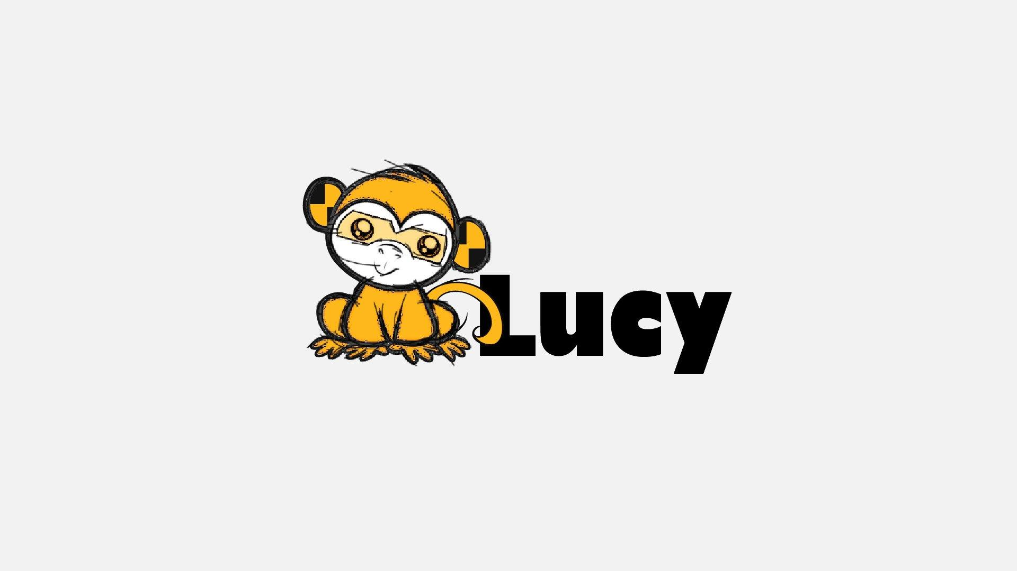
2 | You have already heard of malware... | - Text animation | 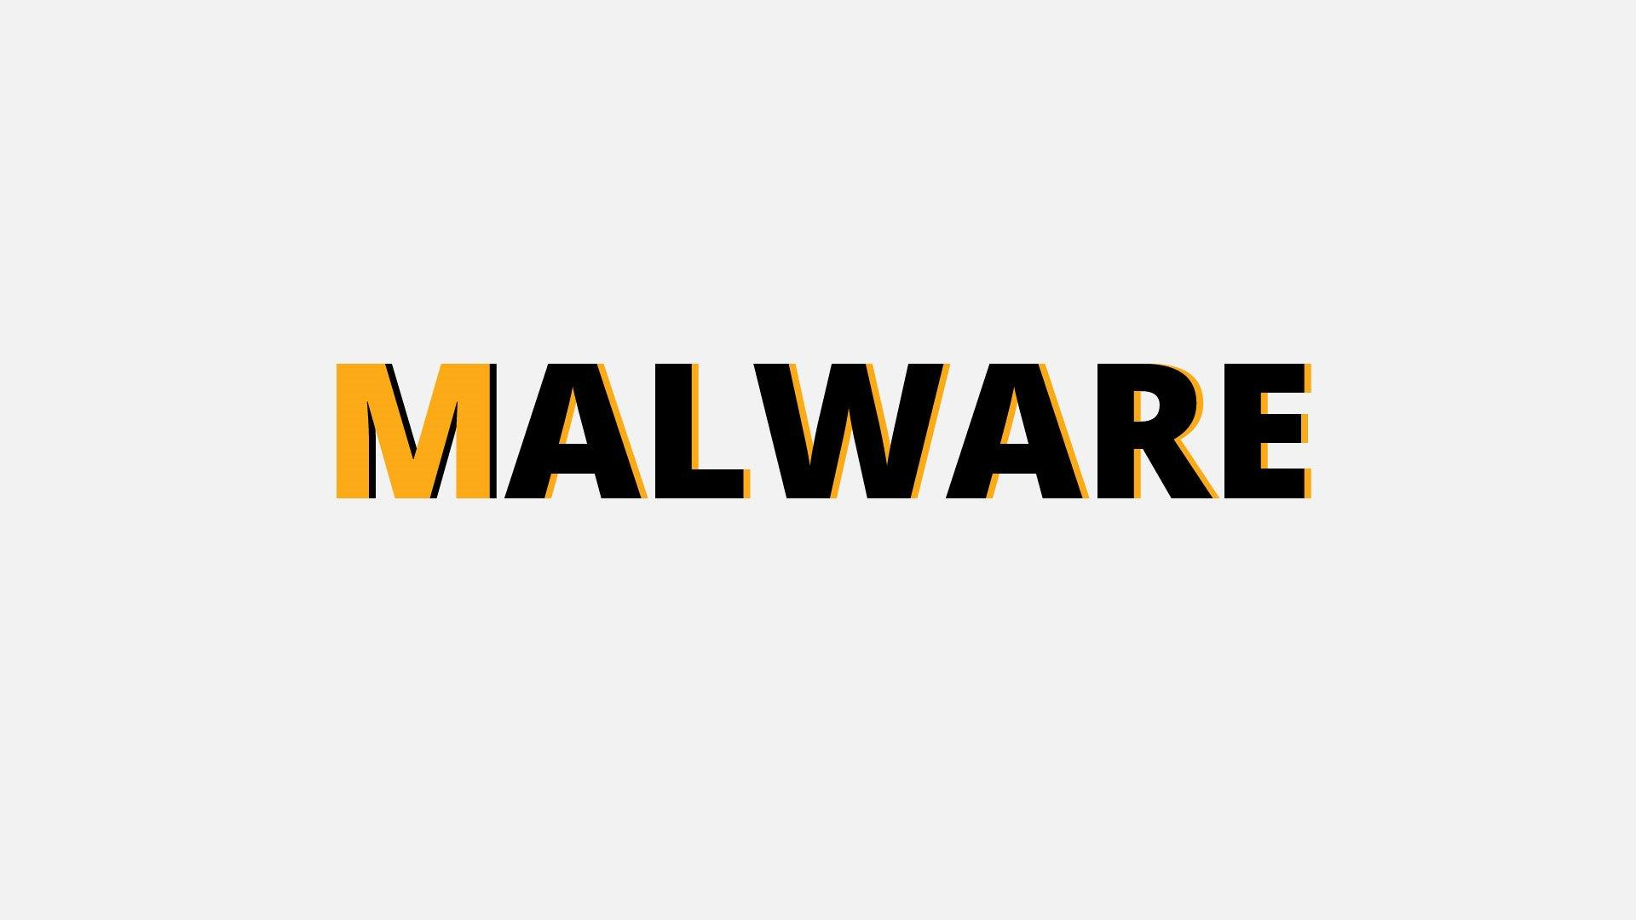
3 | Hiding within downloads of  websites... | - PC Screen with website full of ads appears  - The page is scrolled down | 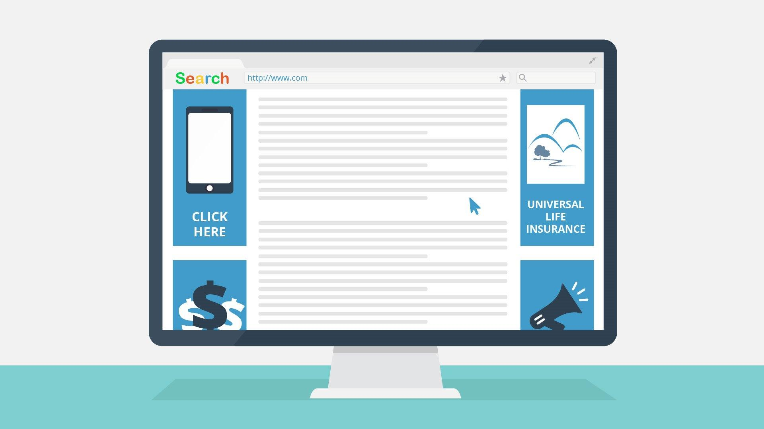
4 | Or appearing in your inbox as a harmless looking email attachment | - Closed mail appears  - Mail opens and we see malware inside it | 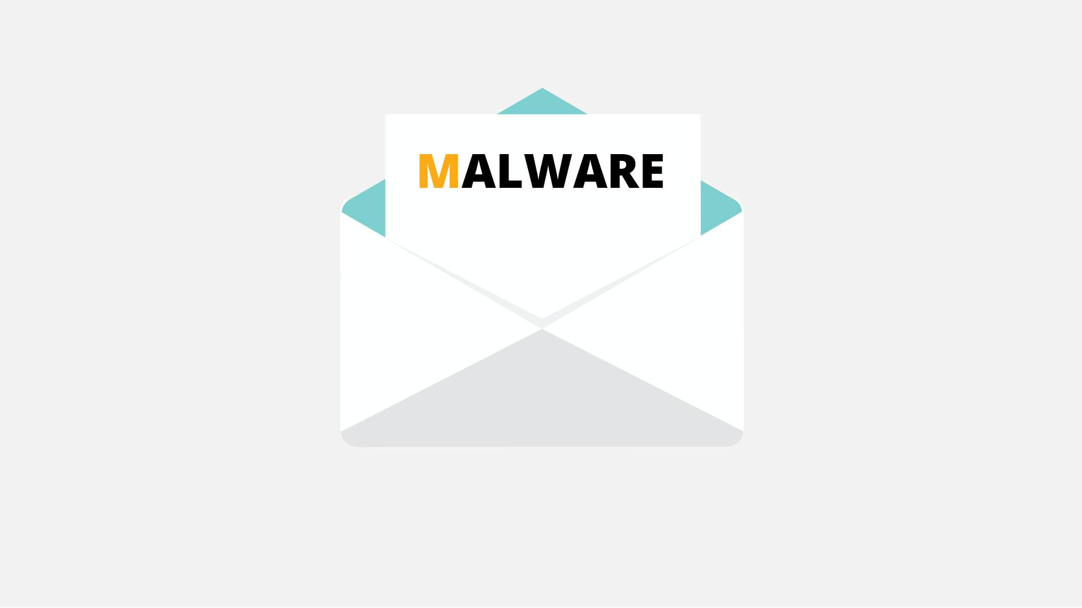
5 | While most malware are designed to steal your confidential data... | - PC screen appears  - thief stealing data from a windows desktop | 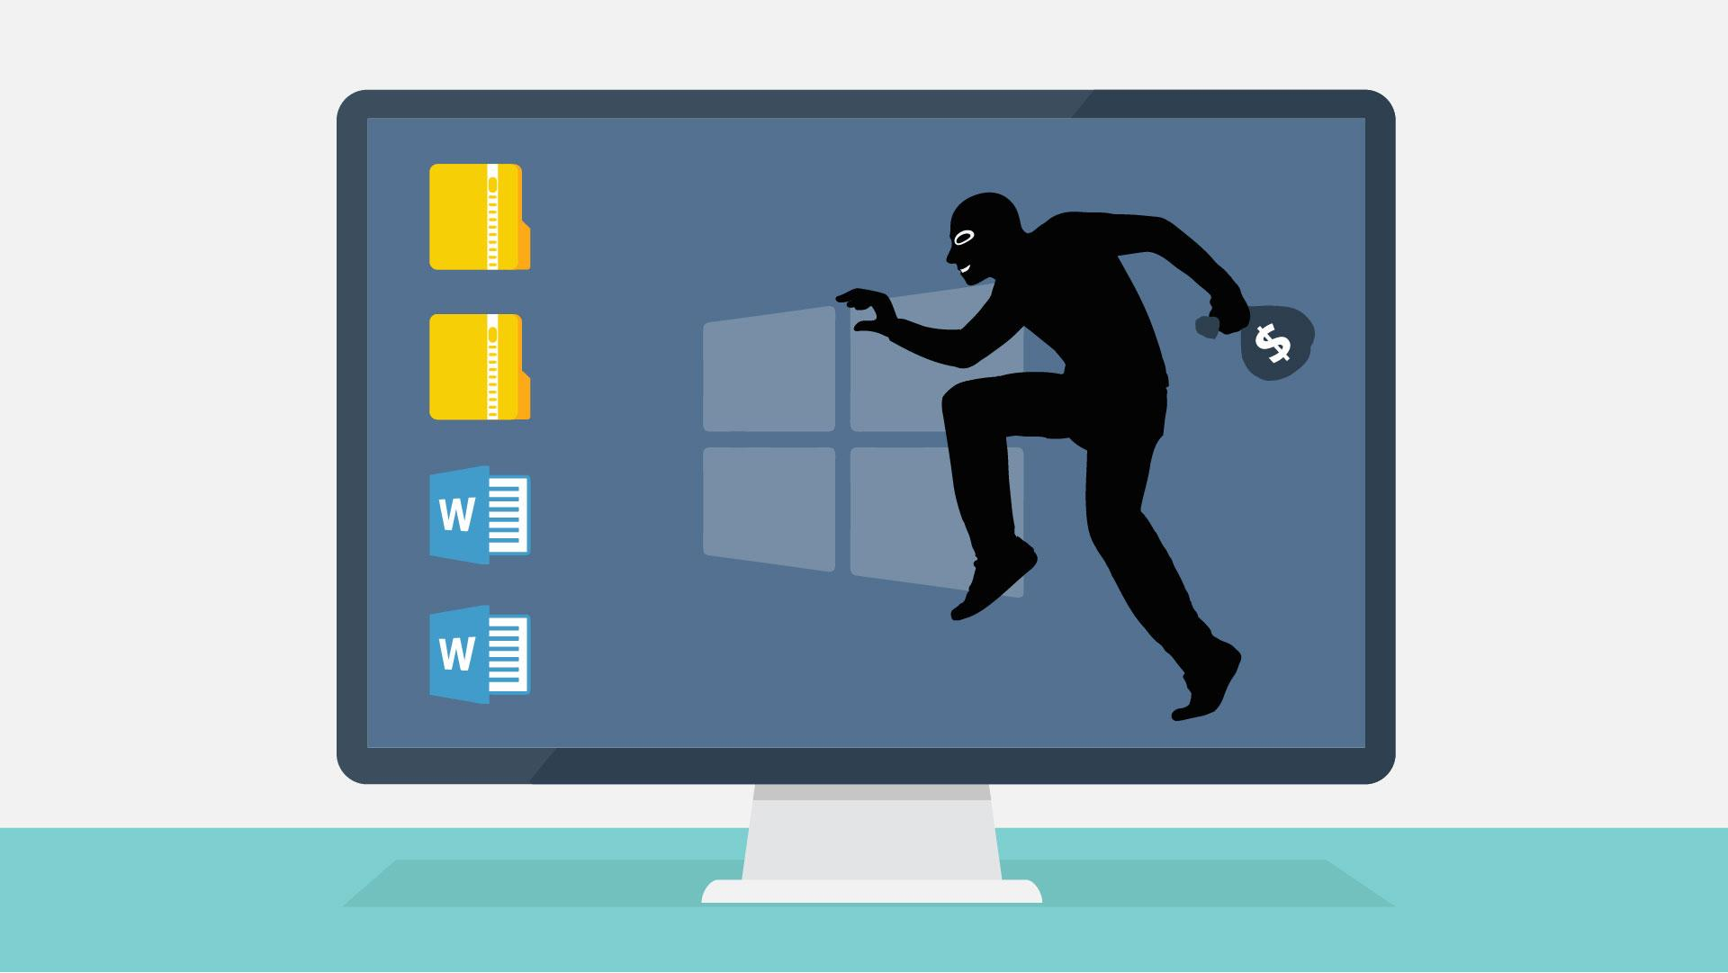
6 | there is a new, even more dangerous attack out there:  Ransomware! | - Image appears  - Text appears | 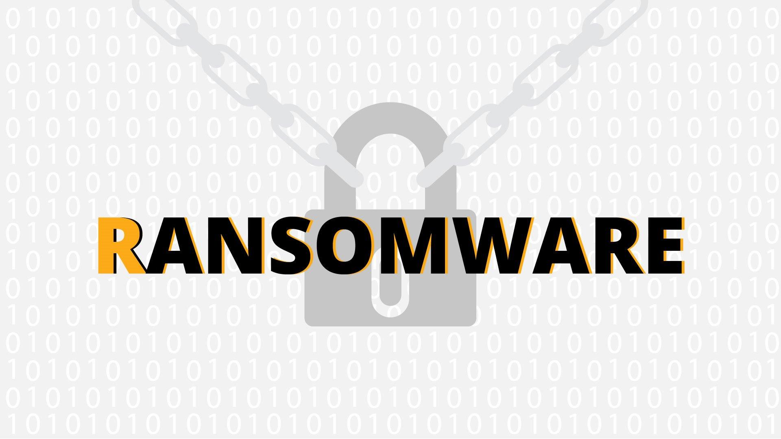
7 | Ransomware encrypt files or holds a computer hostage by restricting the access. | - PC screen appears with some information on it  - Screen locks | 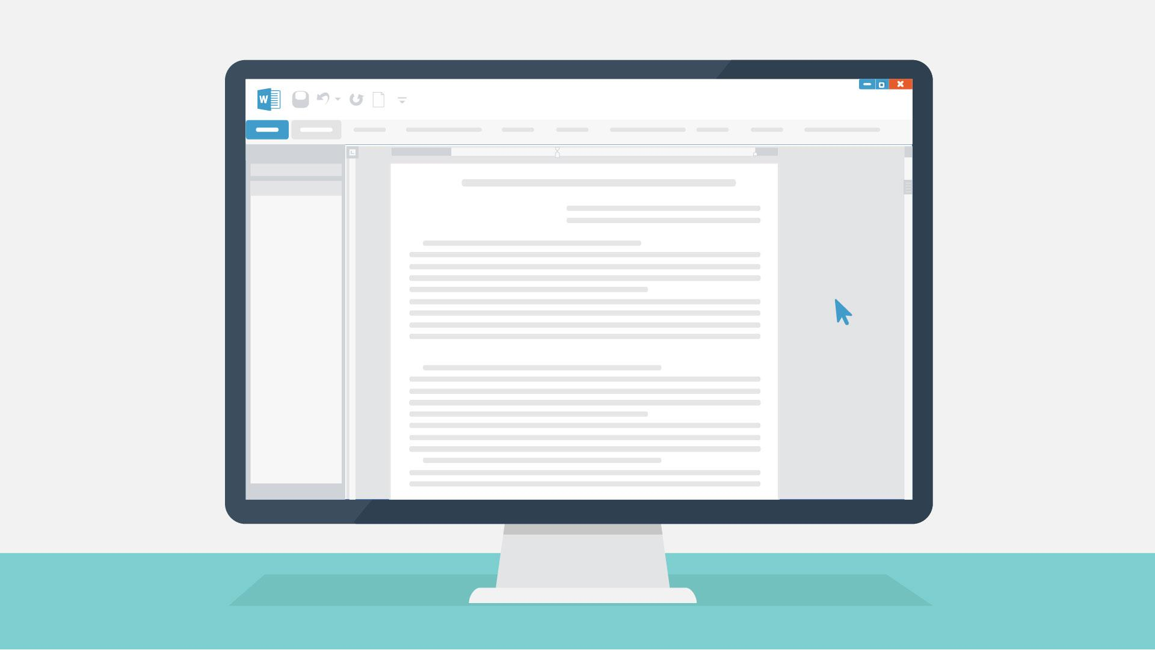  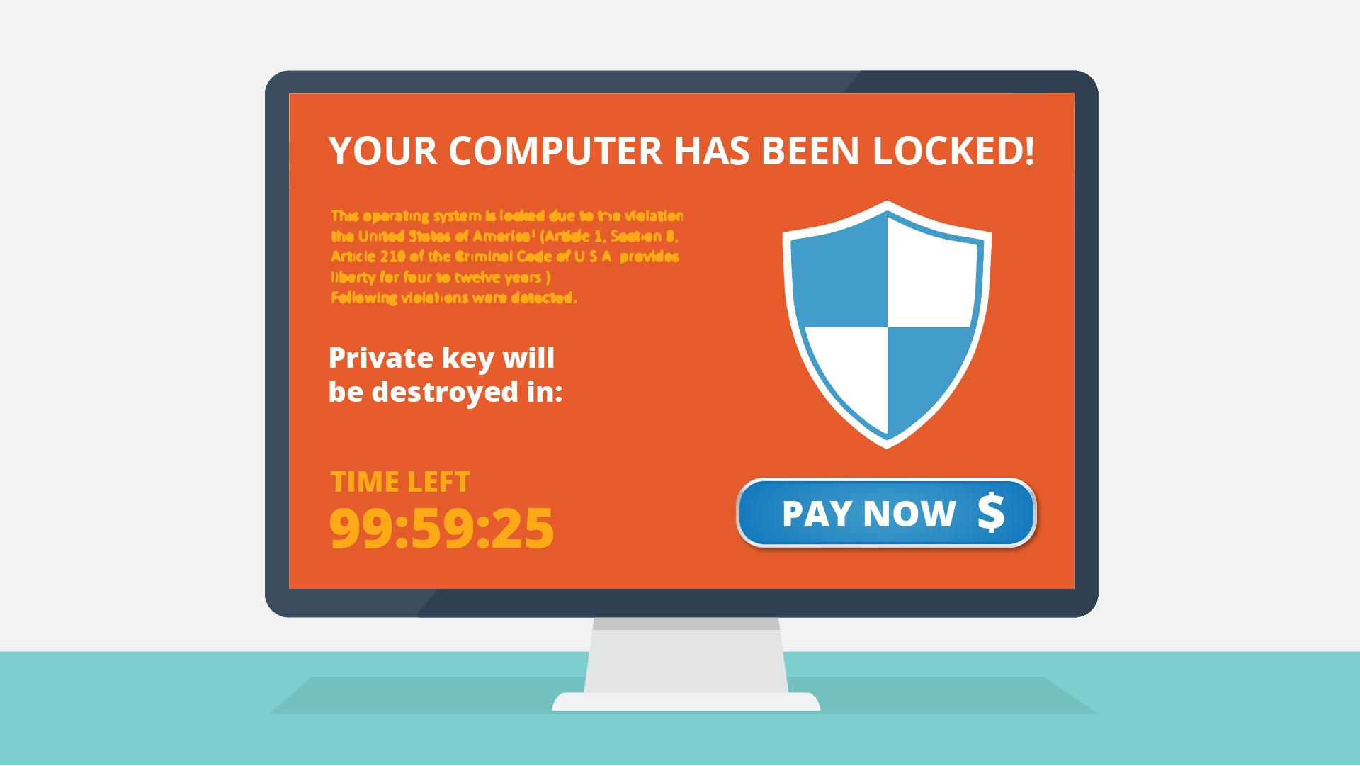
8 | After the system is  kidnapped, the  cybercriminals demand ransom money to restore  the files or unlock the  computer | - We see the same locked screen  - A hand with money appears  - Second hand with key appears  - Screen is unlocked | 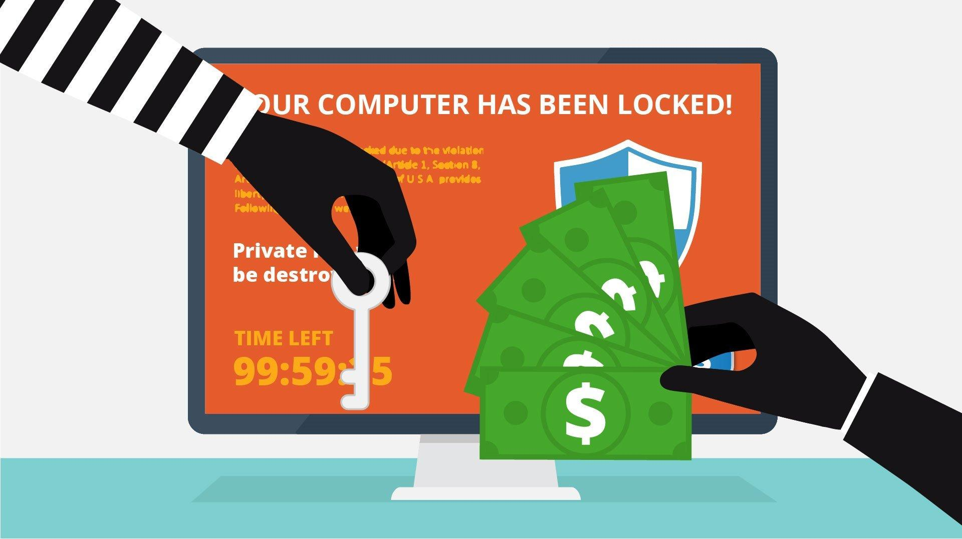
9 | So how do hackers pull this off? | - Question marks appear
10 | Quite simple: by exploiting the most vulnerable part of  the organization…  You and your fellow  employees | - 3 characters appear 1 by 1  - Central character is highlighted
11 | When paying, the ransom is not an option: what can you  do? | - Hand out of the screen appears  - Pay bill flies to the hand  - Block sign appears | 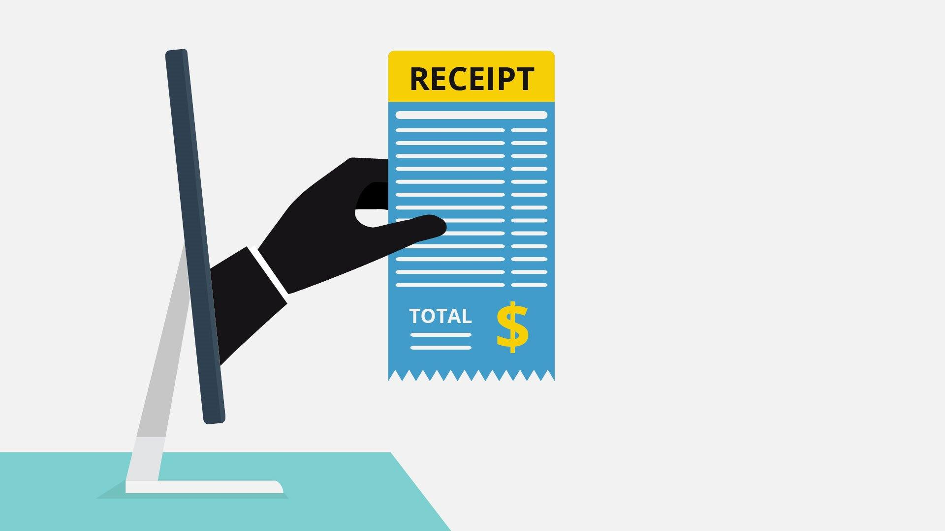  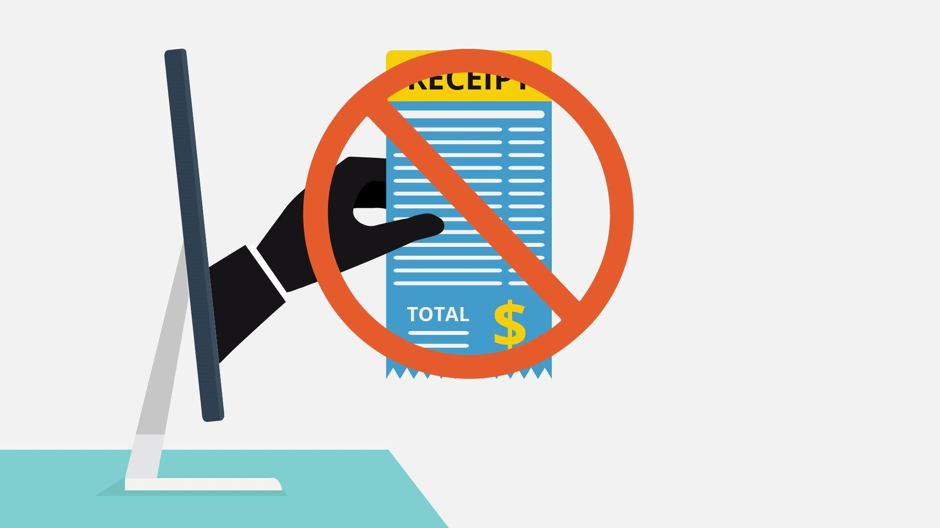
12 | Prevention is the key: think before you click! | - Hand is moving to the mouse and suddenly stops  - Bulb appears
13 | Be a little skeptical when you see download links or  advertisements...  A hacker could have created them! | - We show a website with different banners, ads. etc.
14 | Don’t open mail  attachments from  unidentified senders or someone you don’t trust | - We see inbox letter with attachment  - Attachment is blinking and attracting the attention  Can we replace the word “normal” with Harmless? | 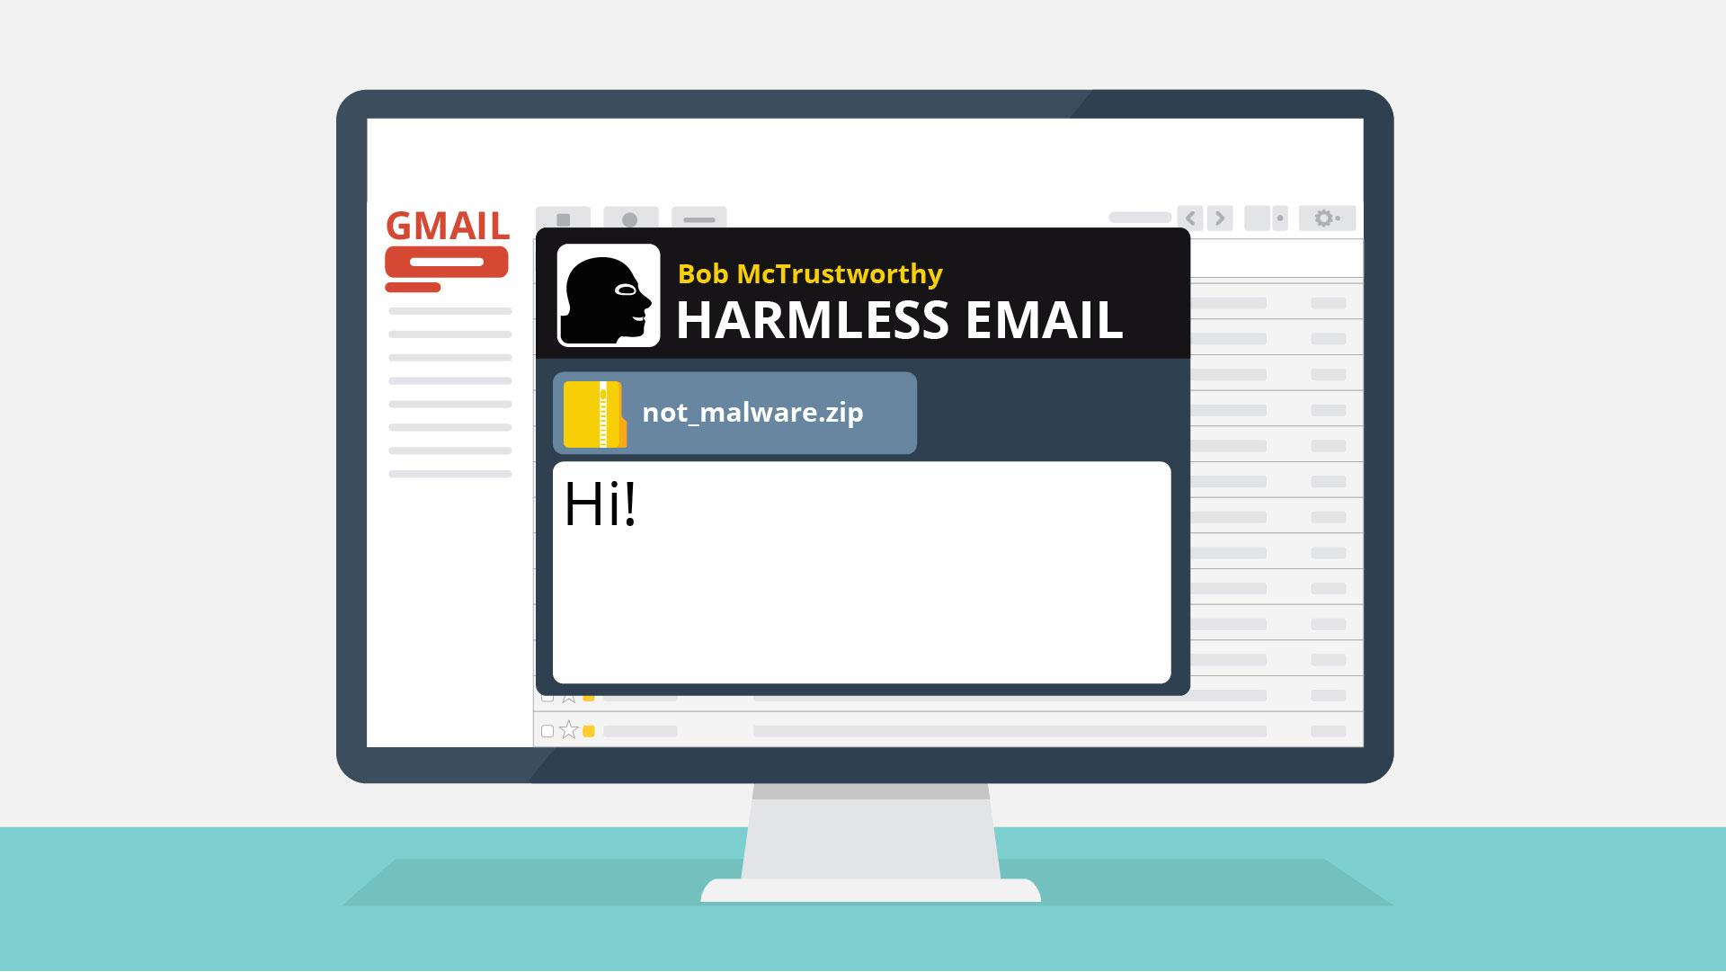
15 | Never enable macros in office documents if you are not absolutely sure you know the sender. | - We show a document  - Macros appear  - Block sign appears | 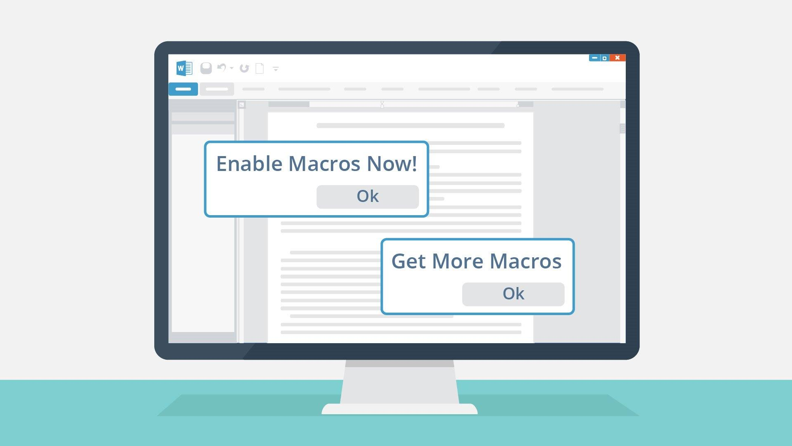  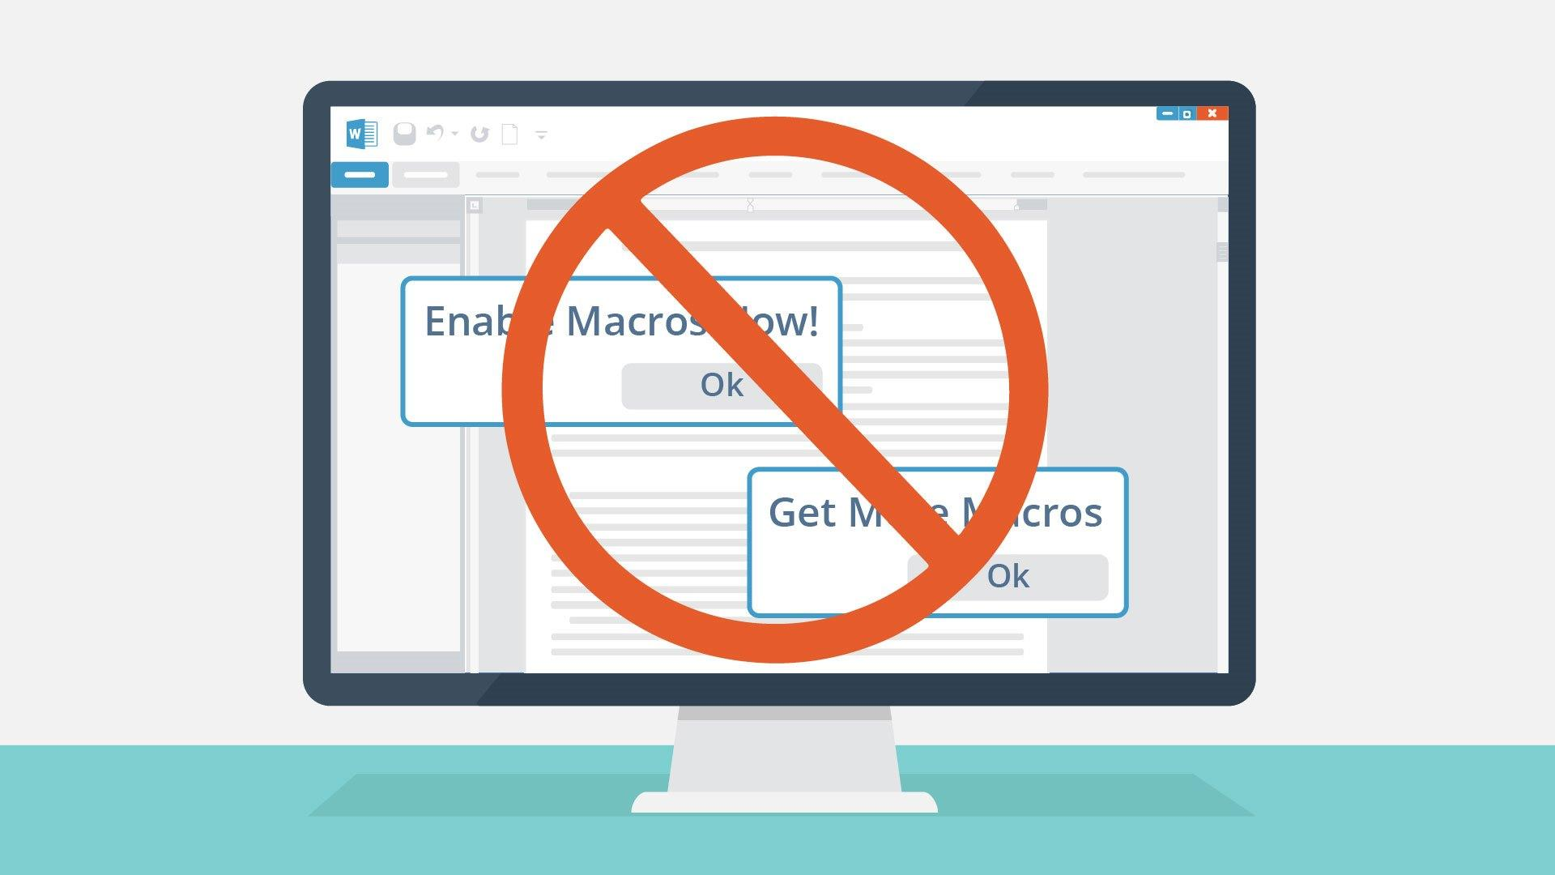
16 | Never plug in USB devices from untrusted sources. | - Laptop appears  - Hand appears and USB is plugged in. | 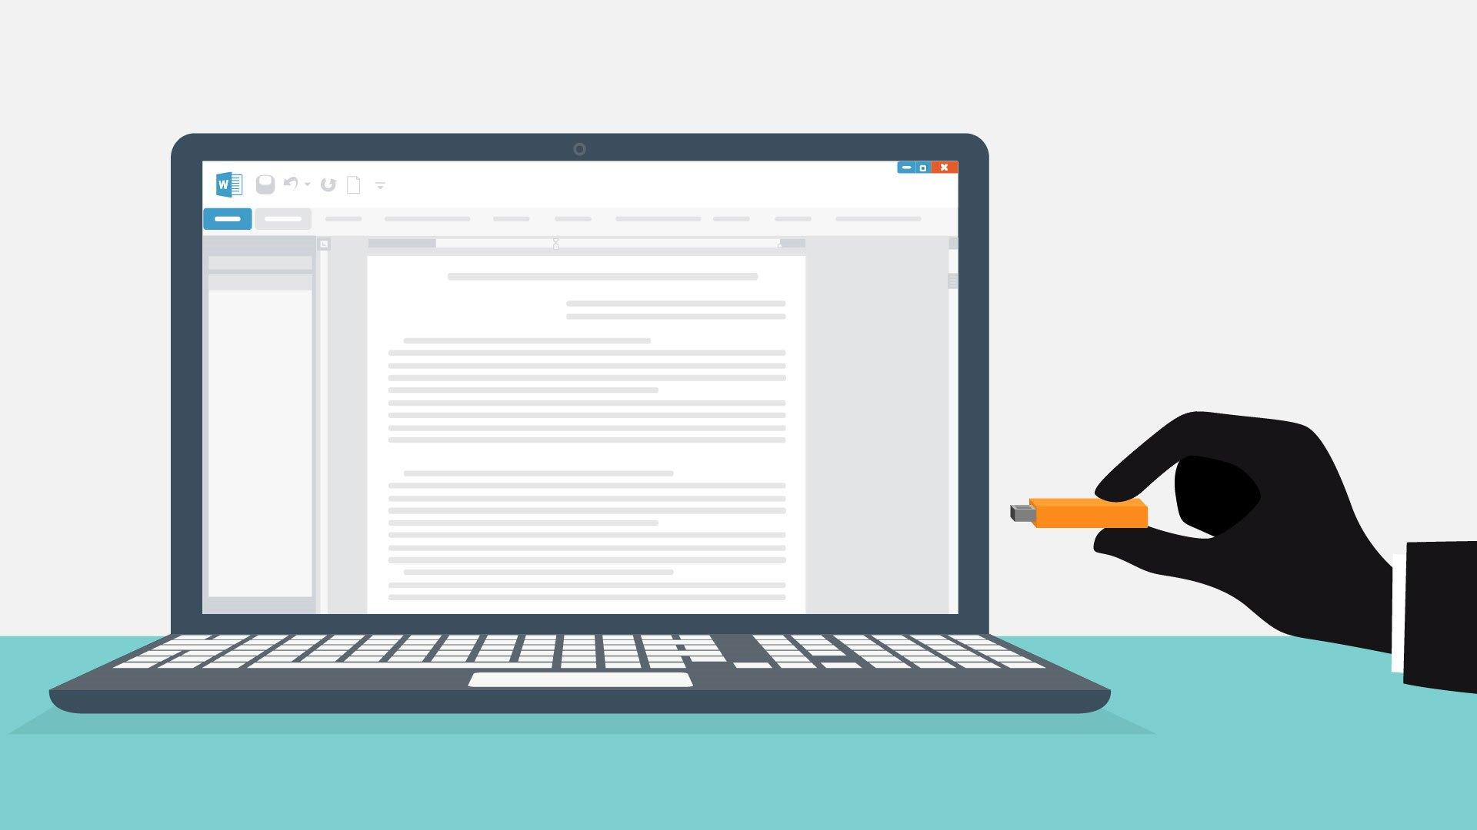  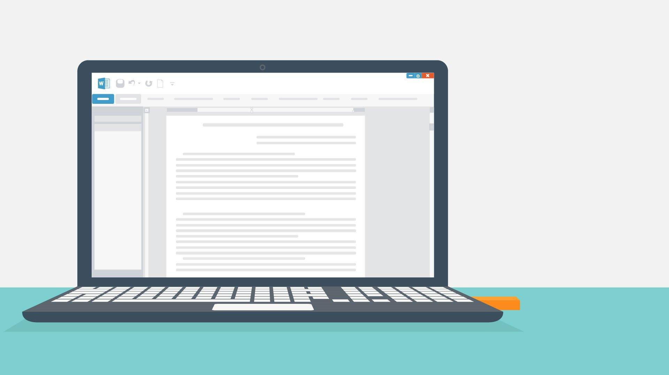
17 | Create regular backups of your data... | - Character in front of PC  - Backup icons appear 1 by 1 | 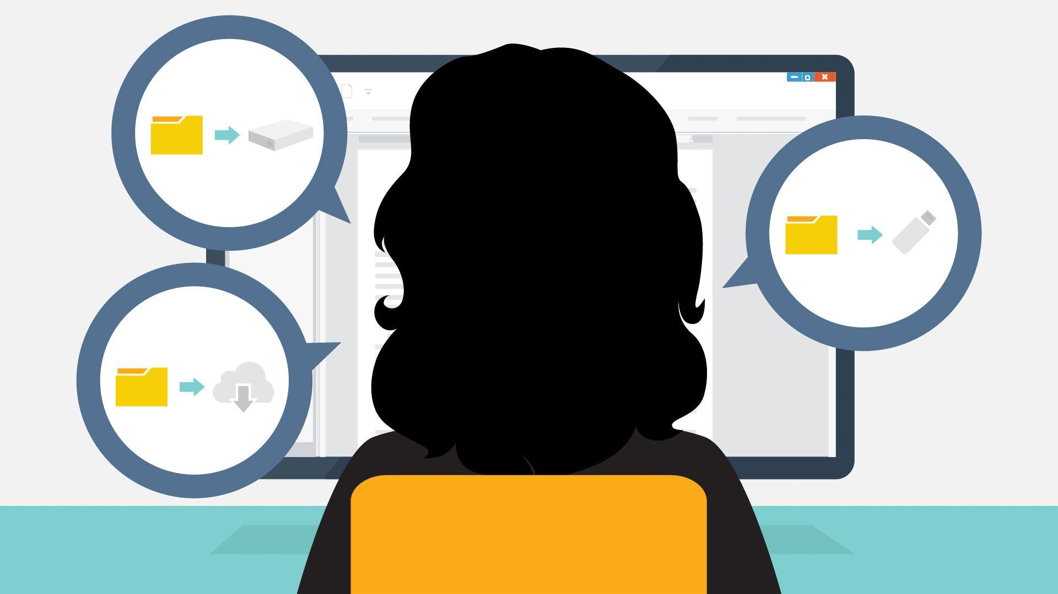
18 | ...but make sure you  disconnect your external storage devices when not in  use | - USB is disconnected from the device
19 | If you follow these  safeguards and report  anything suspicious to your it department right away... | - Image appears  - Email flies from worker to the IT department  I cannot see what is user/helpdesk...both look same…...  Still wish you could see what the helpdesk is and what the user is... | 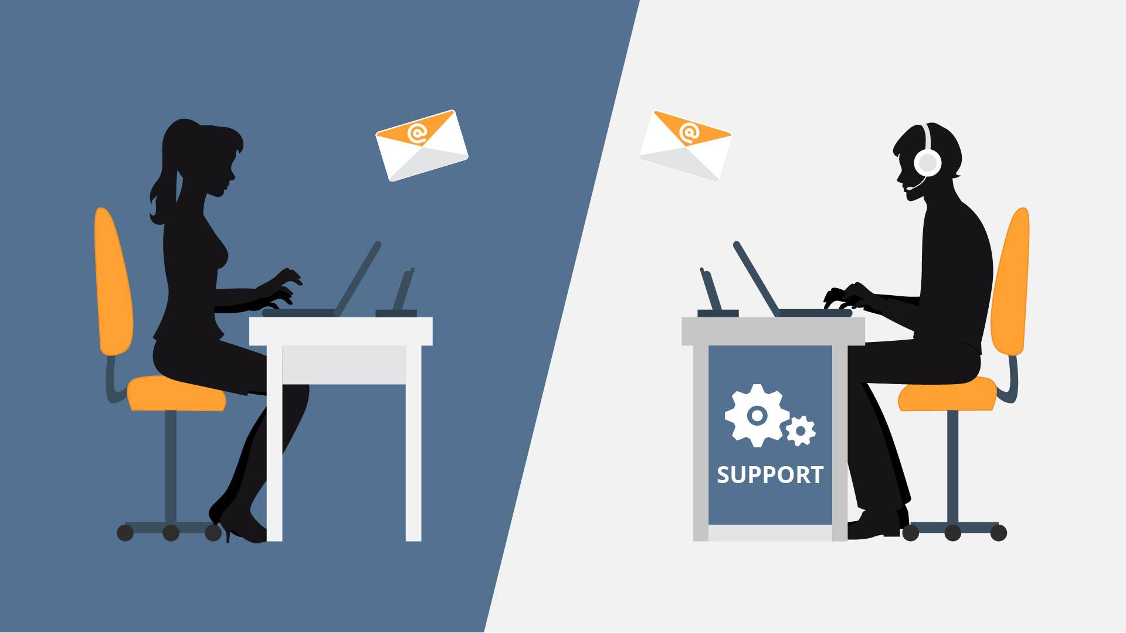
20 | ...YOU do your part to  protect US from ransomware | - Text appears  - Block sign appears | 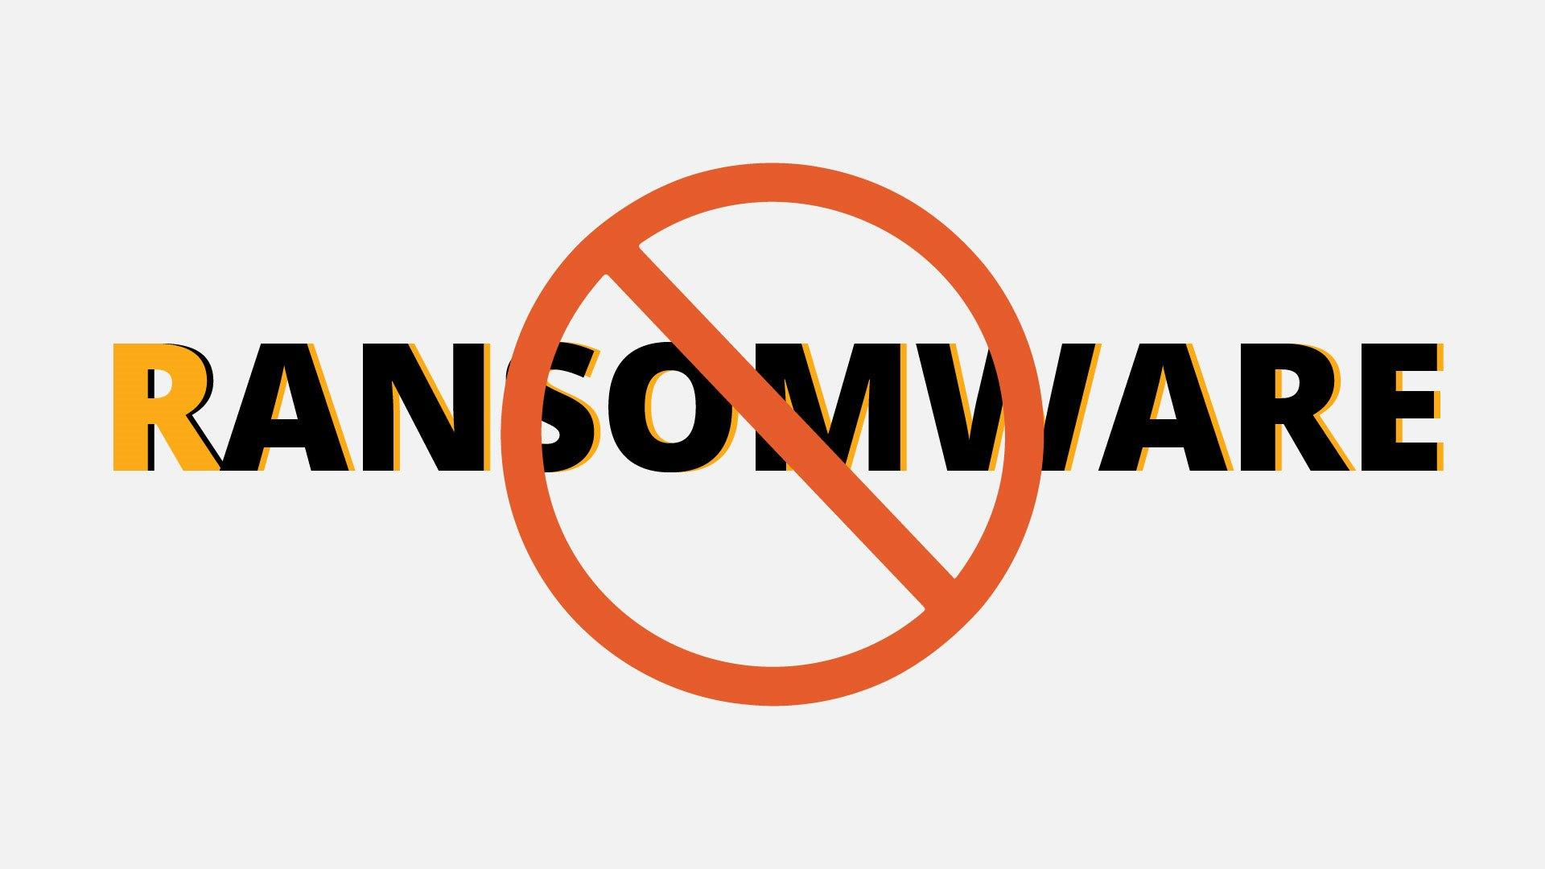
21 | Thank you and be safe! | - Logo and contact animation | 