Data Privacy & GDPR Video - Script

Graphic | English Text
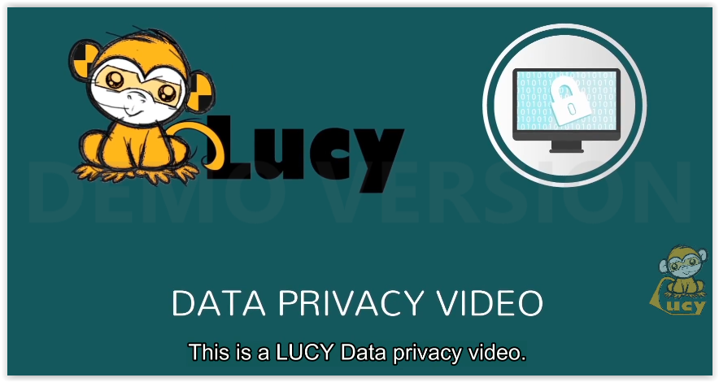 | This is a LUCY Data privacy video.
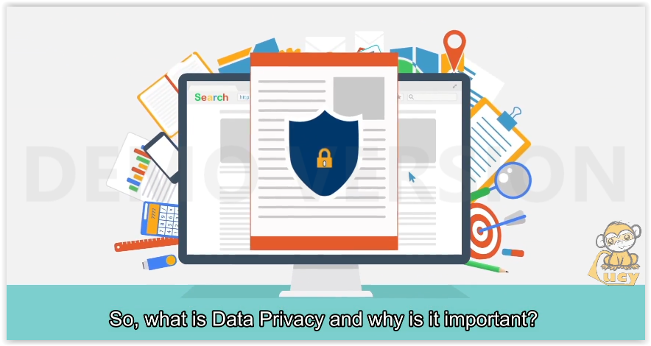 | So, what is Data Privacy and why is it important?
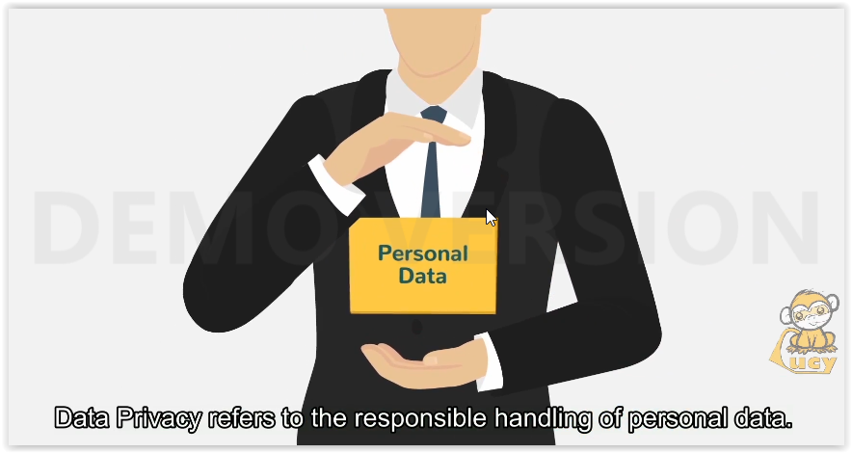 | Data Privacy refers to the responsible handling of personal data.
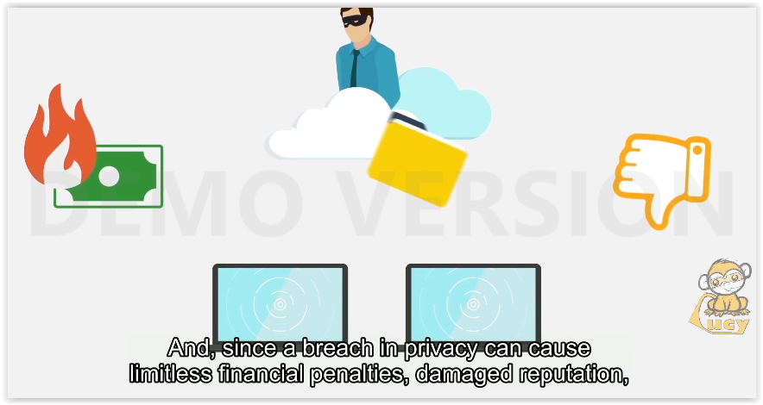 | And, since a breach in privacy can cause limitless financial penalties, damaged reputation,
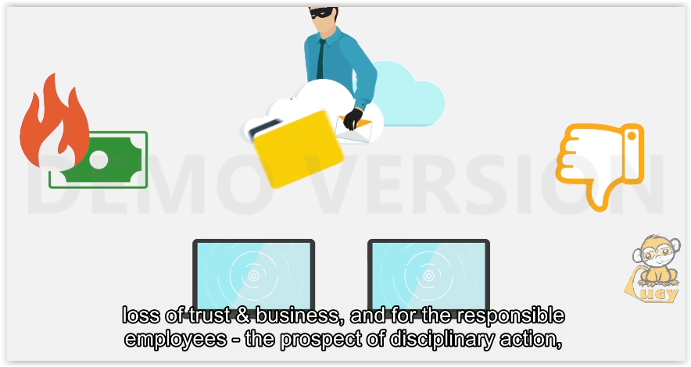 | loss of trust & business, and for the responsible employees – the prospect of disciplinary action,
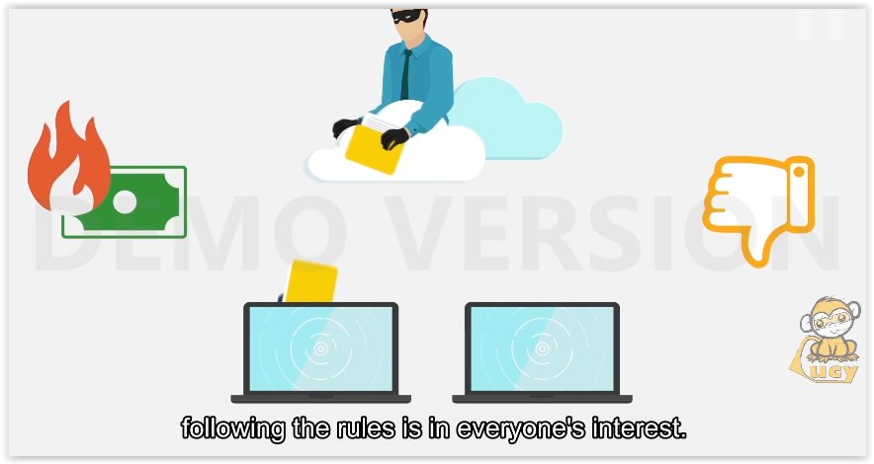 | following the rules is in everyone’s interest.
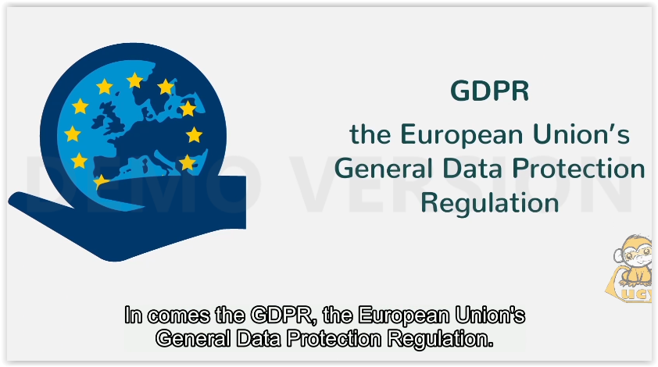 | In comes the GDPR, the European Union’s General Data Protection Regulation.
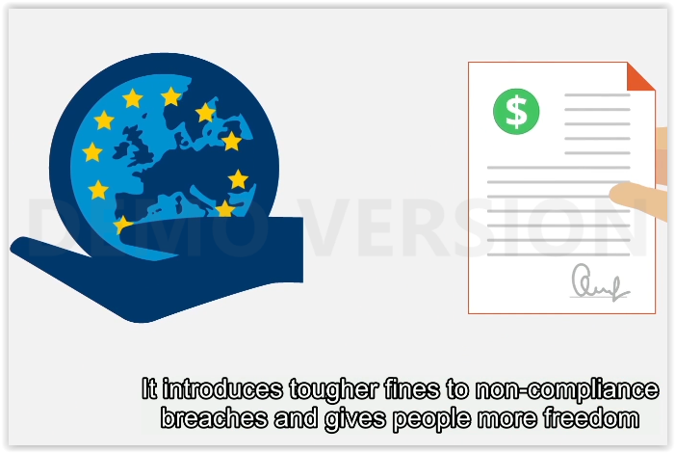 | It introduces tougher fines to non-compliance breaches and gives people more freedom
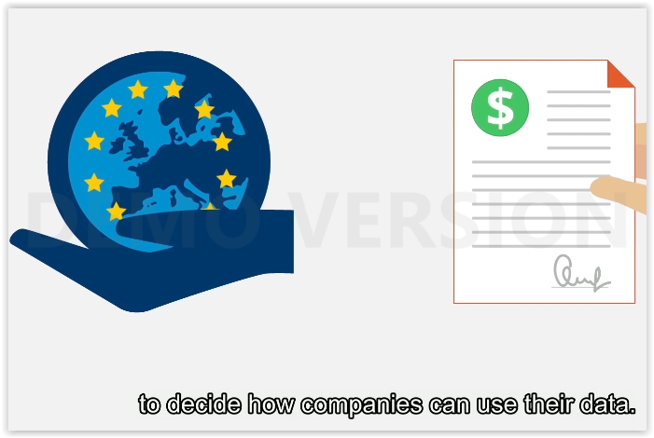 | to decide how companies can use their data.
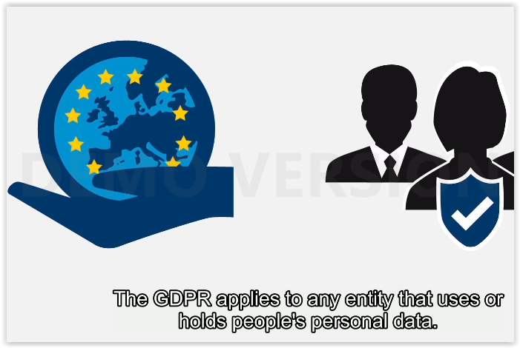 | The GDPR applies to any entity that uses or holds people’s personal data.
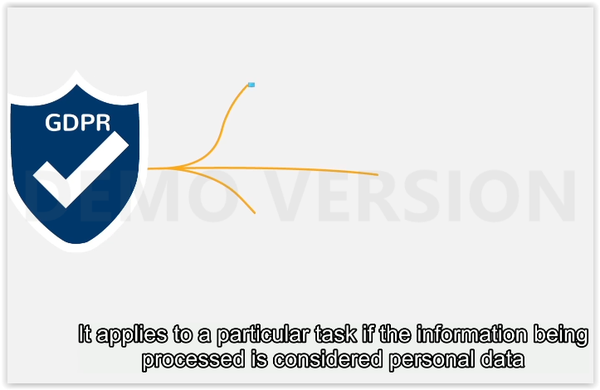 | It applies to a particular task if the information being processed is considered personal data
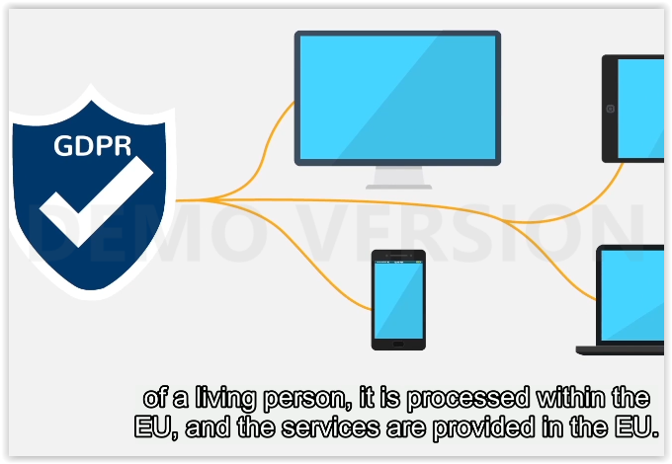 | of a living person, it is processed within the EU, and the services are provided in the EU.
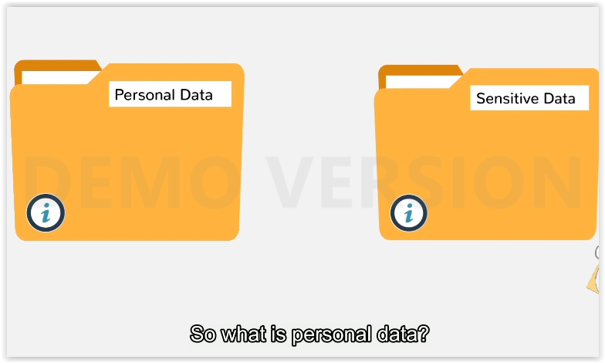 | So what is personal data?
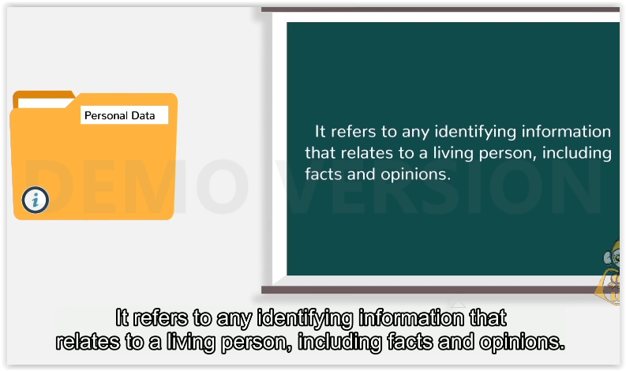 | It refers to any identifying information that relates to a living person, including facts and opinions.
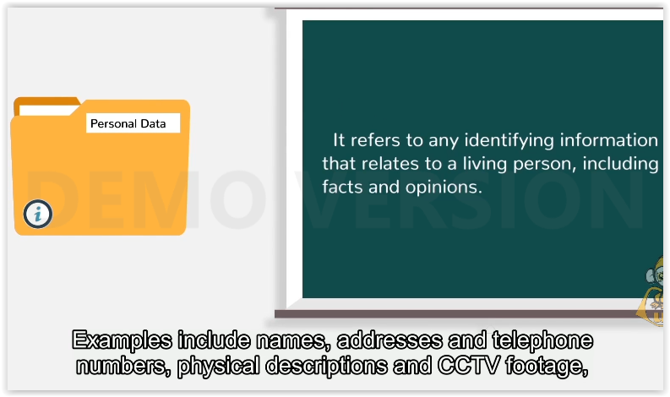 | Examples include names, addresses and telephone number, physical descriptions and CCTV footage,
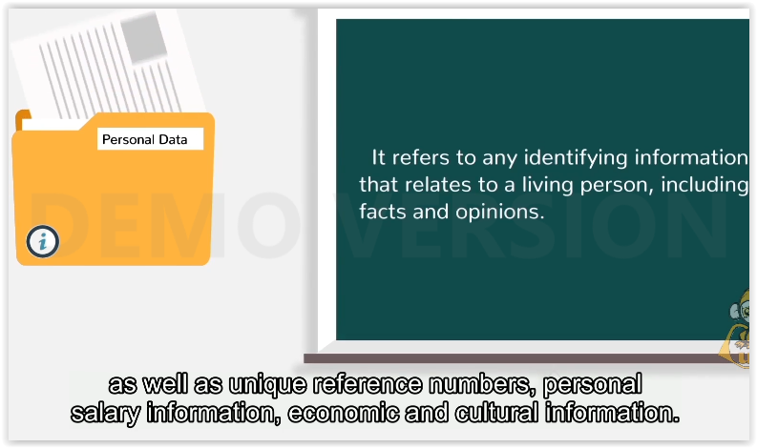 | as well as unique reference numbers, personal salary information, economic and cultural information.
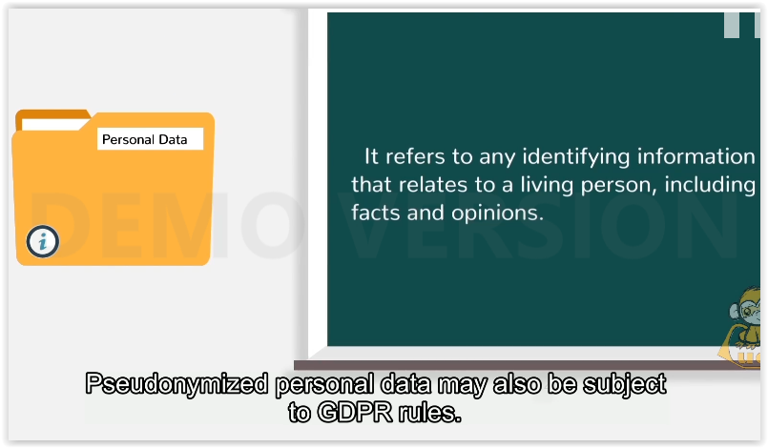 | Pseudonymized personal data may also be subject to GDPR rules.
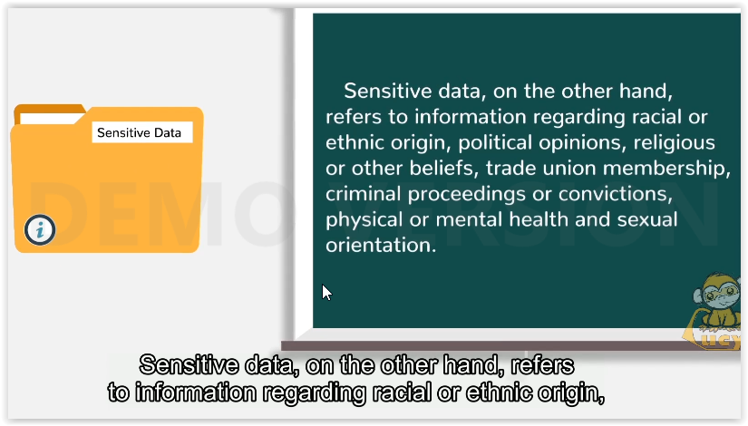 | Sensitive data, on the other hand, refers to information regarding racial or ethnic origin,
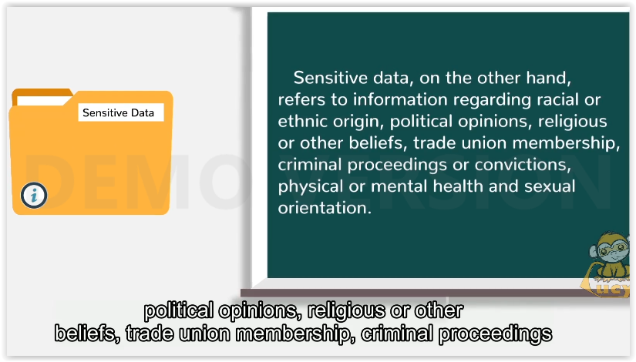 | political opinions, religious or other beliefs, trade union membership, criminal proceedings
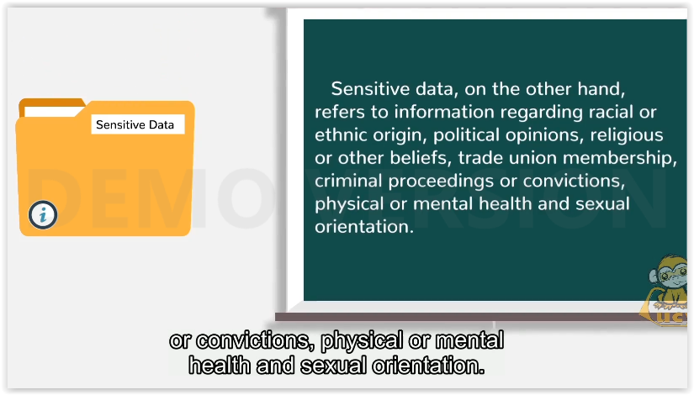 | or convictions, physical or mental health and sexual orientaion.
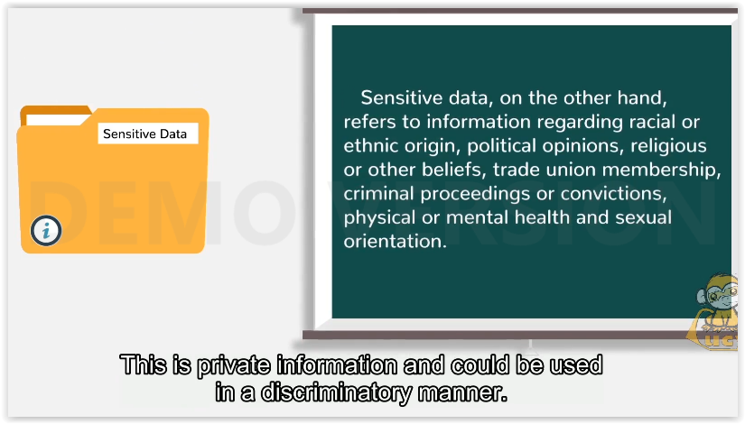 | This is private information and could be used in a discriminatory manner.
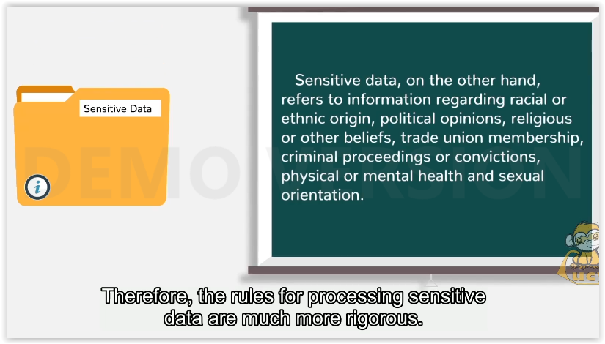 | Therefore, the rules for processing sensitive data are much more rigorous.
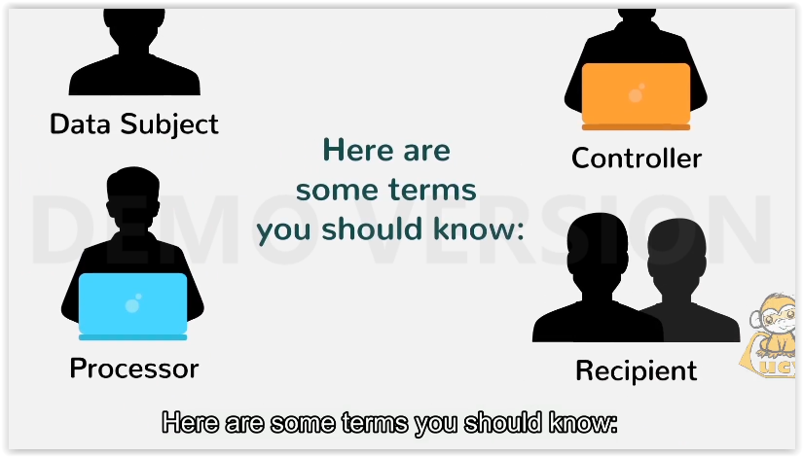 | Here are some terms you should know:
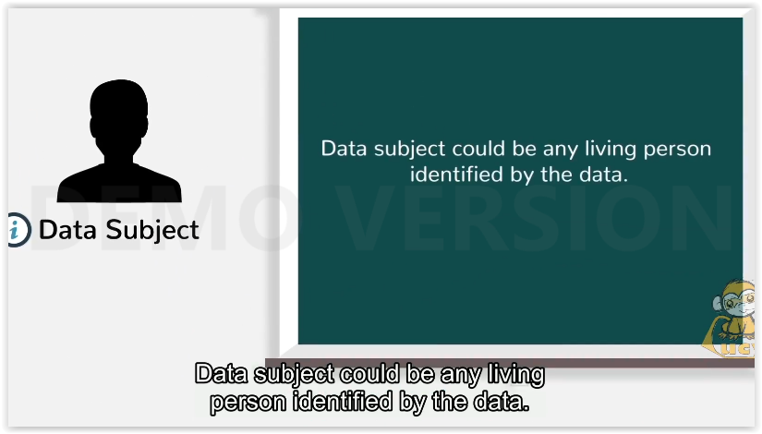 | Data subject could be any living person identified by the data.
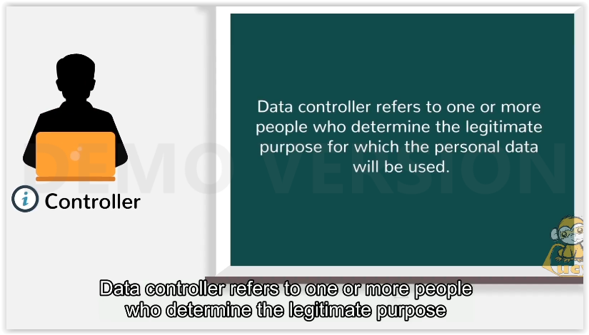 | Data controller refers to one or more people who determine the legitimate purpose
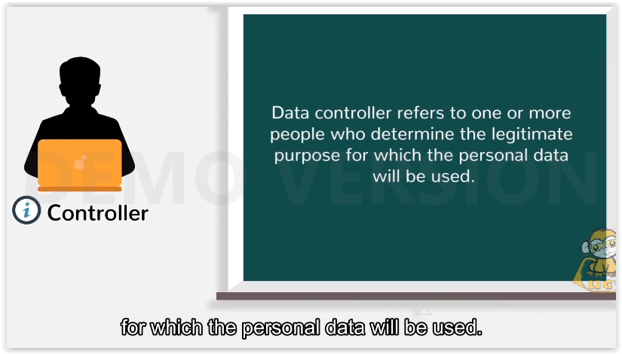 | for which the personal data will be used.
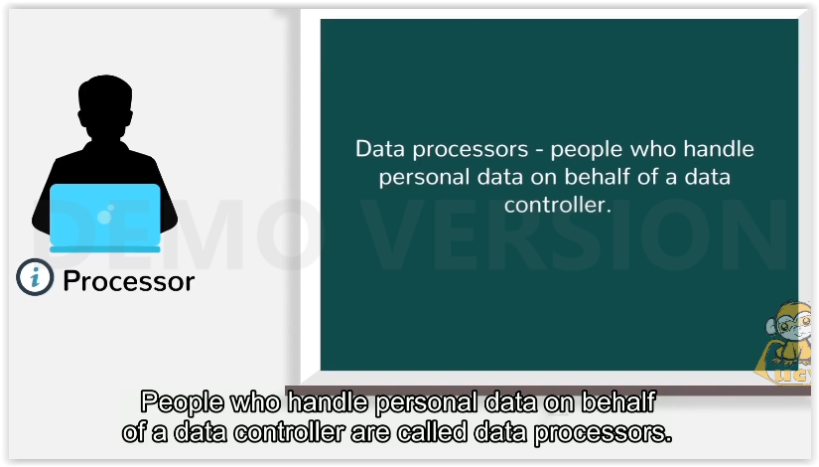 | People who handle personal data on behalf of a data controller are called data processors.
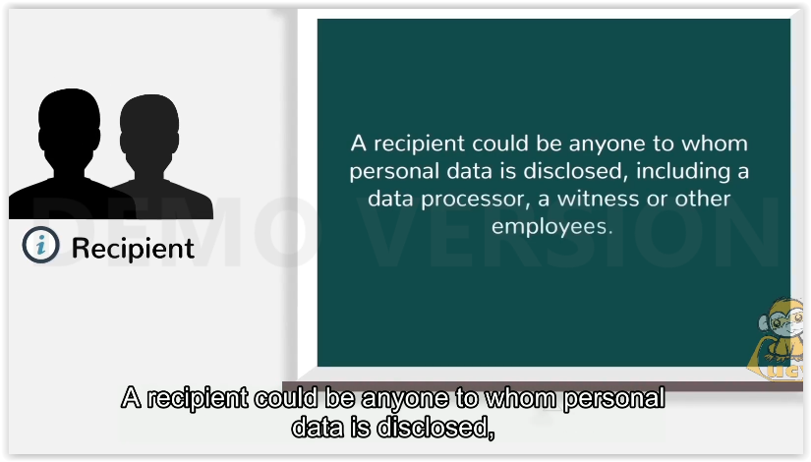 | A recipient could be anyone to whom personal data is disclosed,
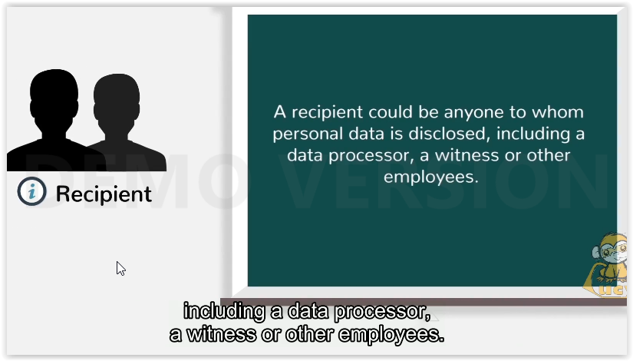 | including a data processor, a witness or other employees.
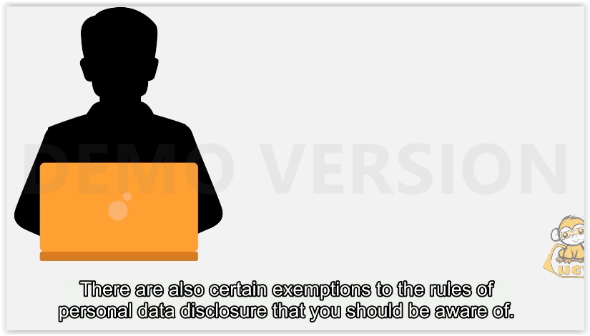 | There are also certain exemptions to the rules of personal data disclosure that you should be aware of.
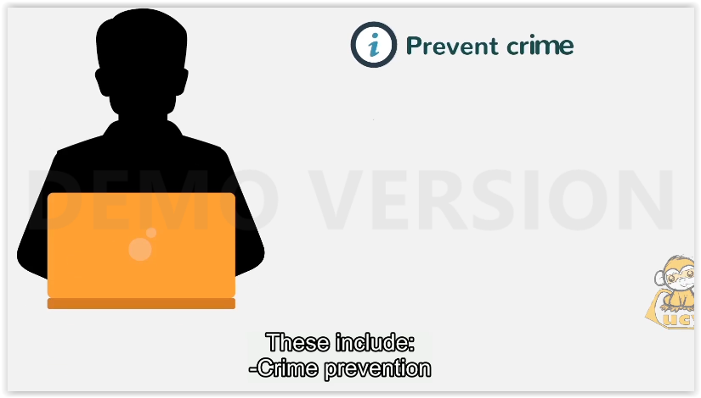 | These include:  -Crime prevention
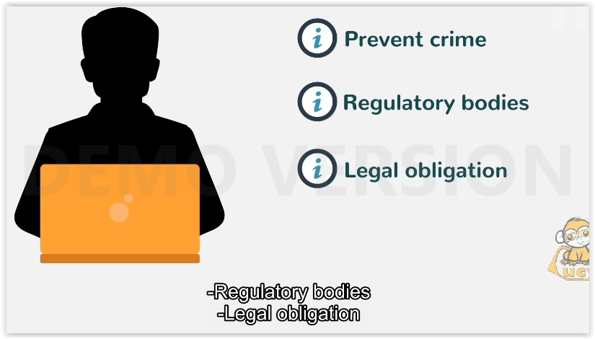 | -Regulatory bodies  -Legal obligation
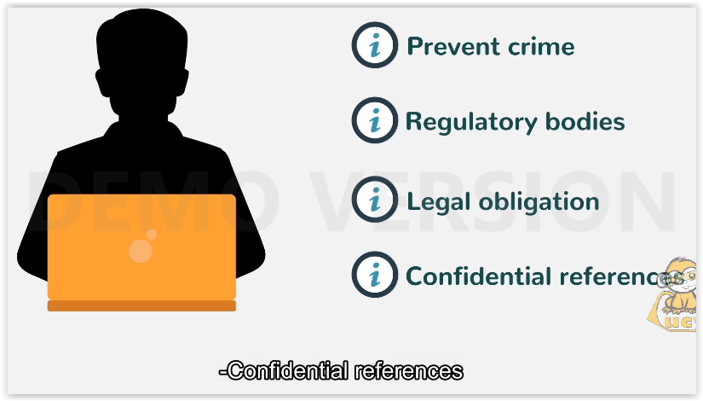 | -Confidential references
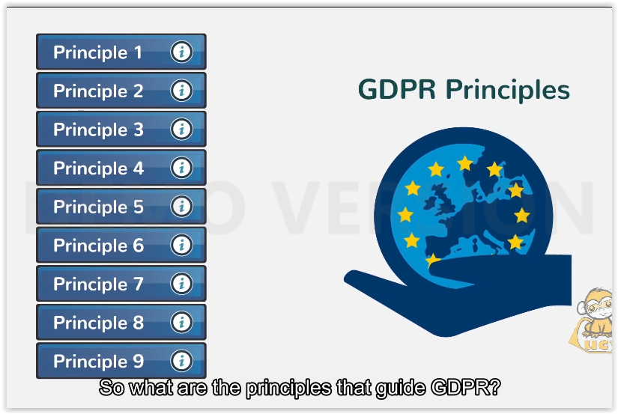 | So what are the principles that guide GDPR?
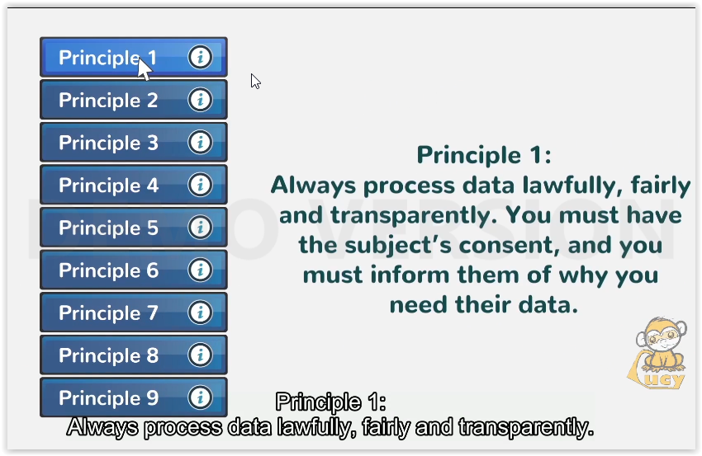 | Always process data lawfully, fairly and transparently.
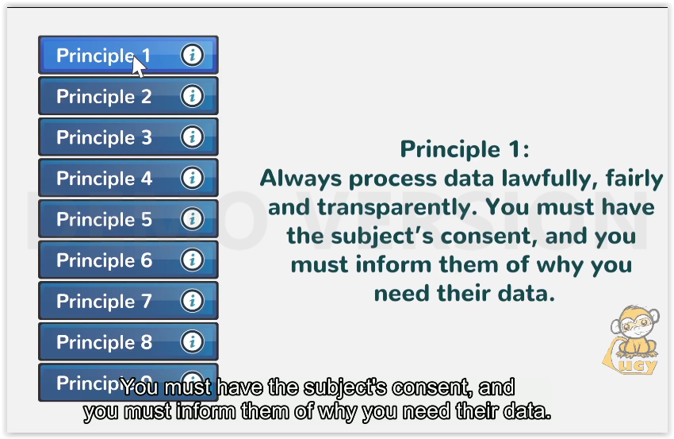 | You must have the subject’s consent, and you must inform them of why you need their data.
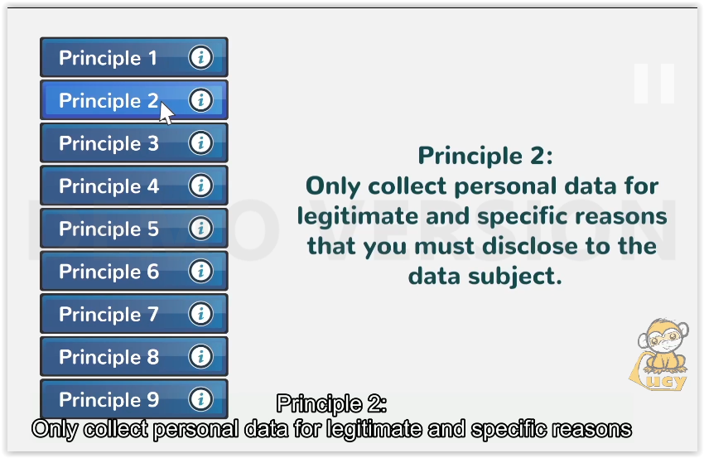 | Only collect personal data for legitimate and specific reasons
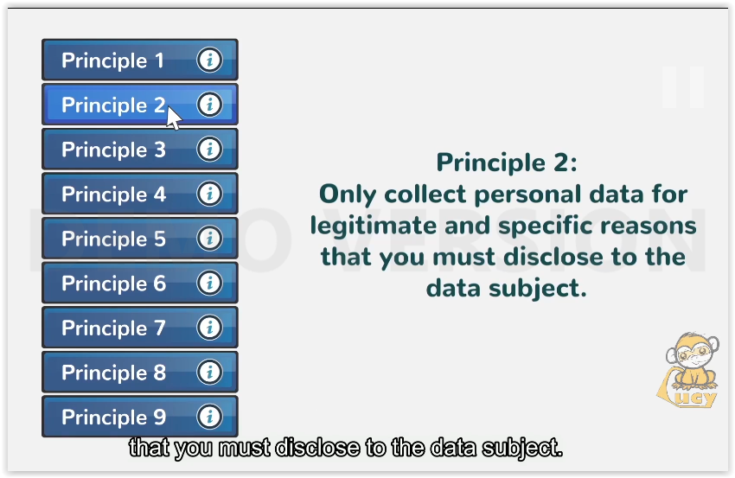 | that you must disclose to the data subject.
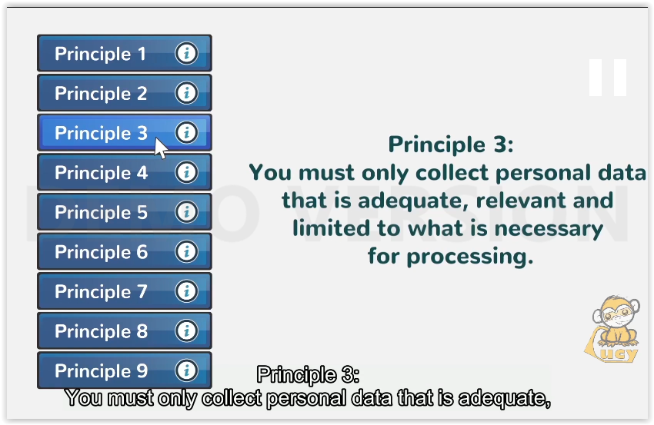 | You must only collect personal data that is adequate,
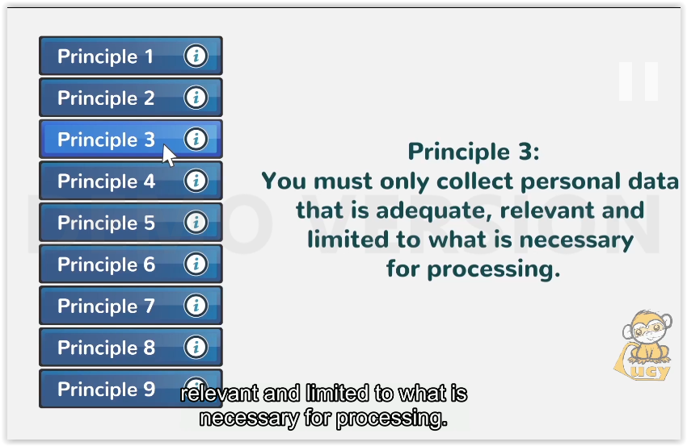 | relevant and limited to what is necessary for processing.
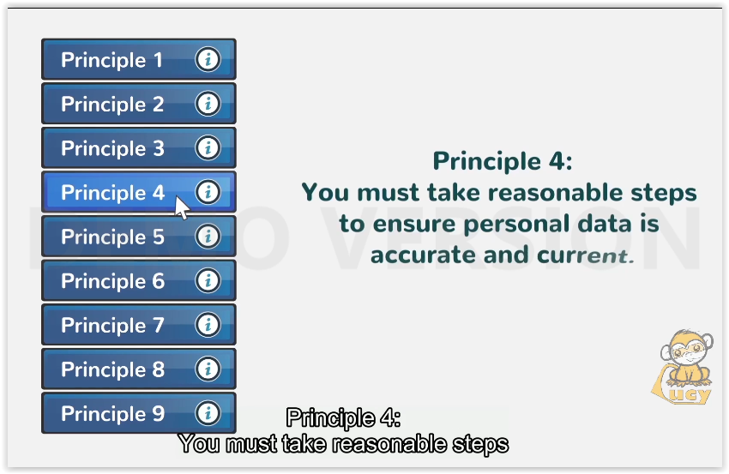 | You must take reasonable steps
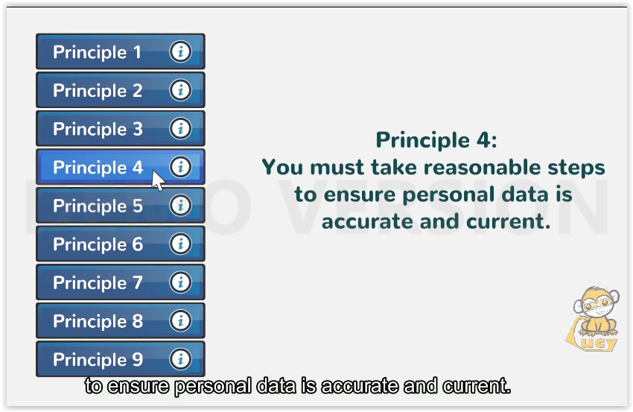 | to ensure personal data is accurate and current.
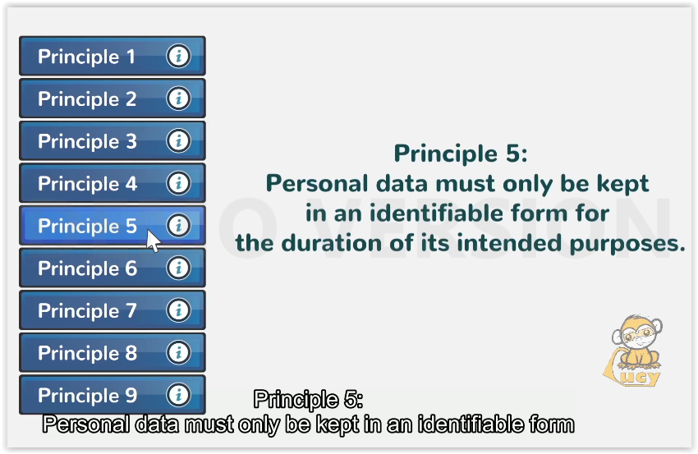 | Personal data must only be kept in an identifiable form
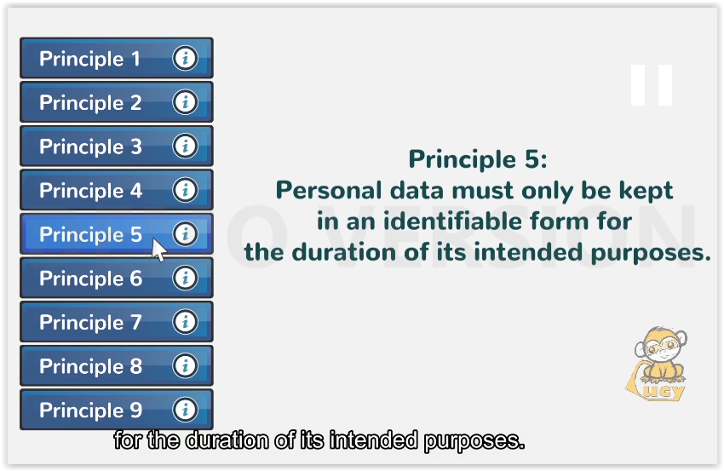 | for the duration of its intended purposes.
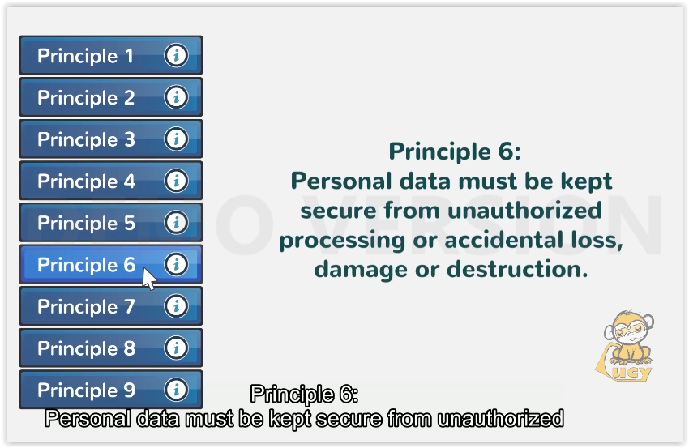 | Personal data must be kept secure from unauthorized
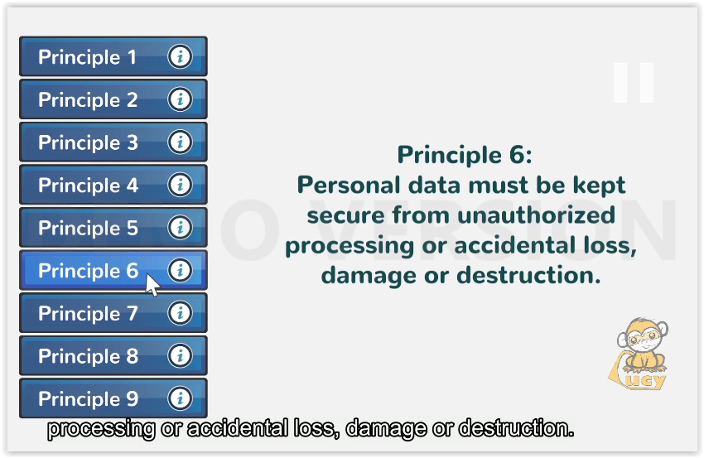 | processing or accidental loss, damage or destruction.
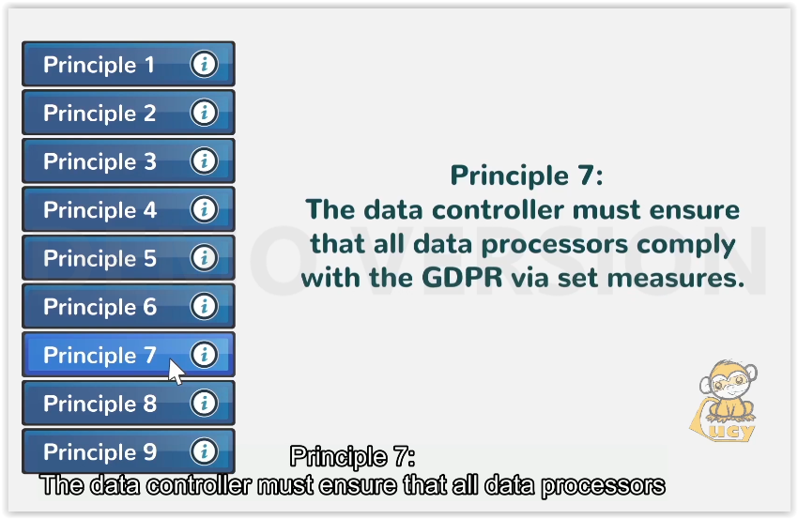 | The data controller must ensure that all data processors
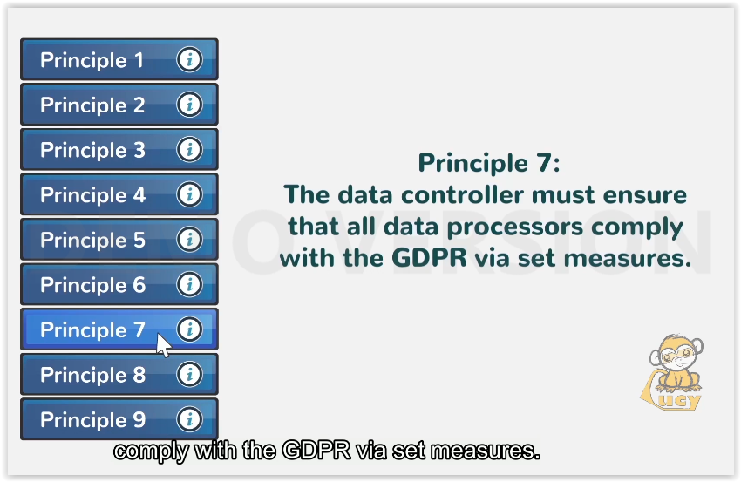 | comply with the GDPR via set measures.
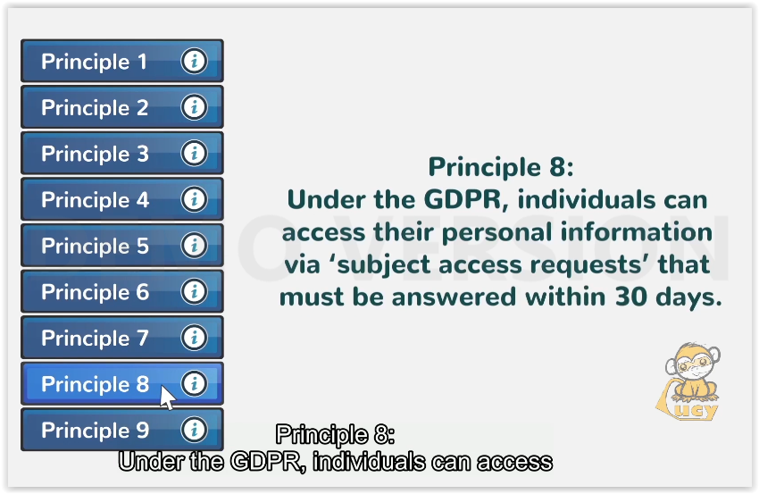 | Under the GDPR, individuals can access
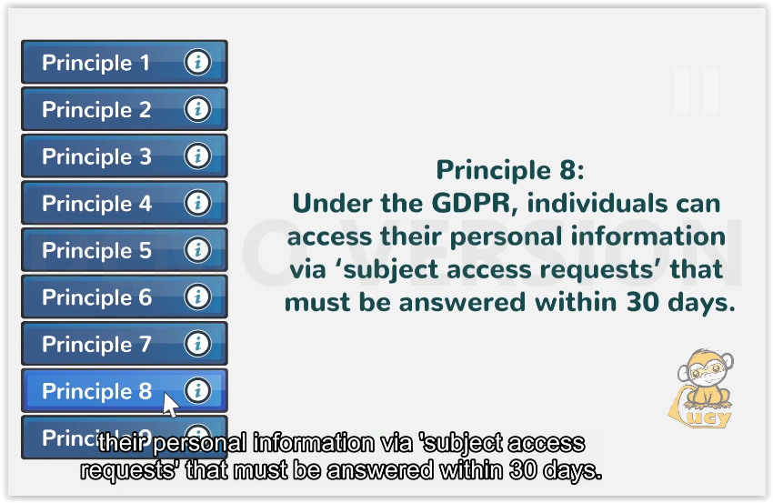 | their personal information via ’subject access requests’ that must be answered within 30 days.
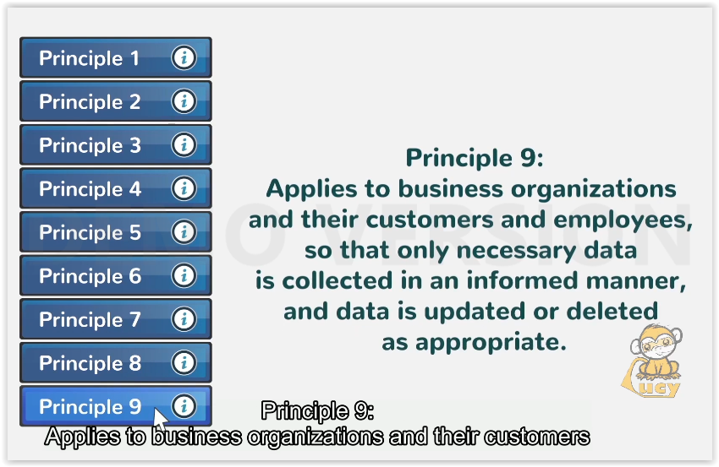 | Applies to business organizations and their customers
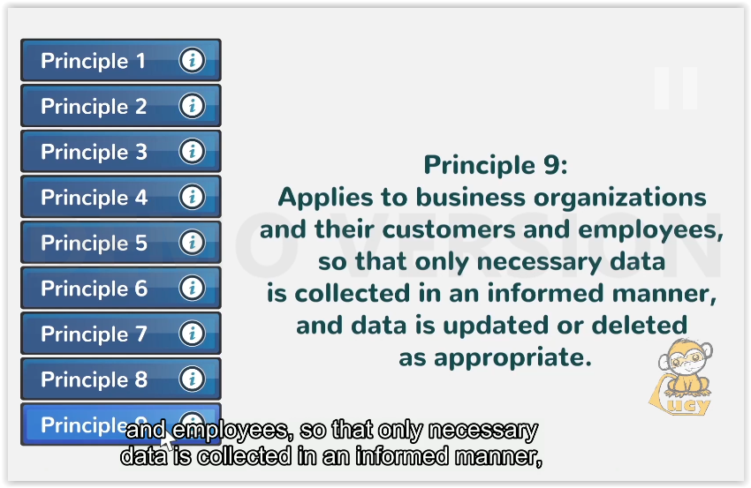 | and employees, so that only necessary data is collected in an informed manner,
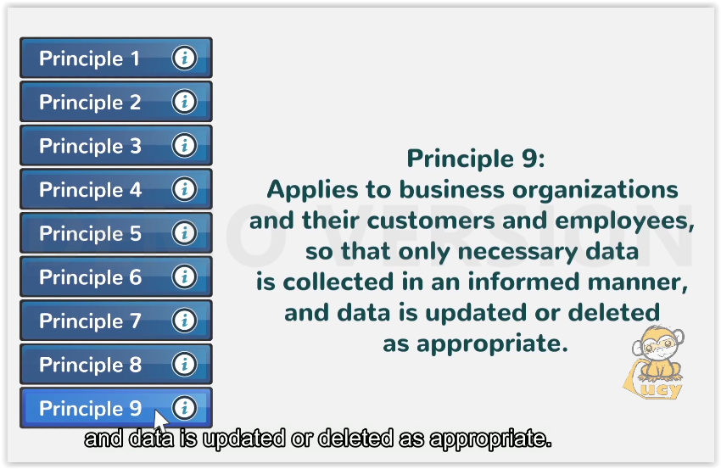 | and data is updated or deleted as appropriate.
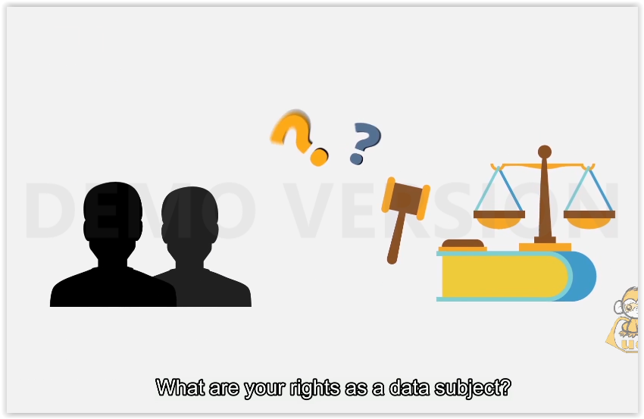 | What are your rights as a data subject?
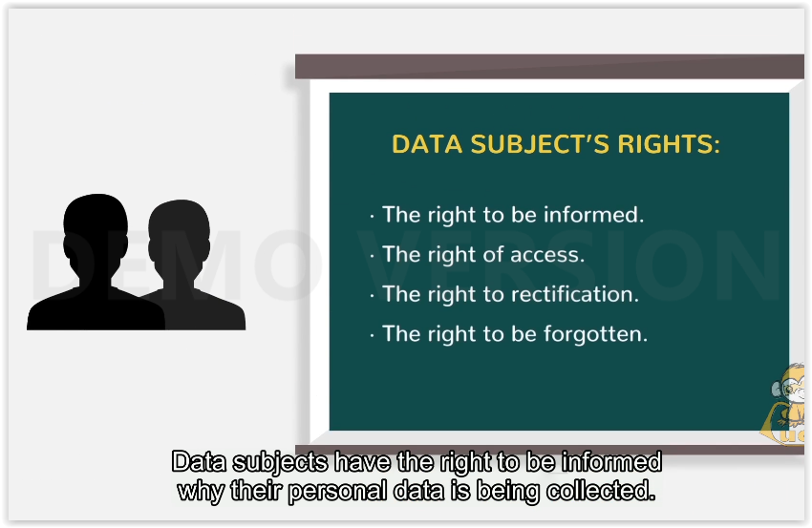 | *DATA SUBJECT’S RIGHTS:  - The right to be informed.  - The right of access.  - The right to recertification.  - The right to be forgotten.  Data subjects have the right to be informed why their personal data is being collected.
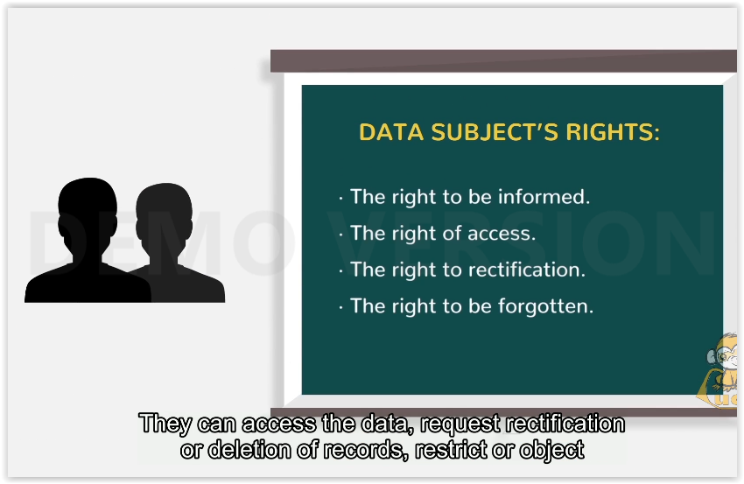 | They can access the data, request rectification or deletion of records, restrict or object
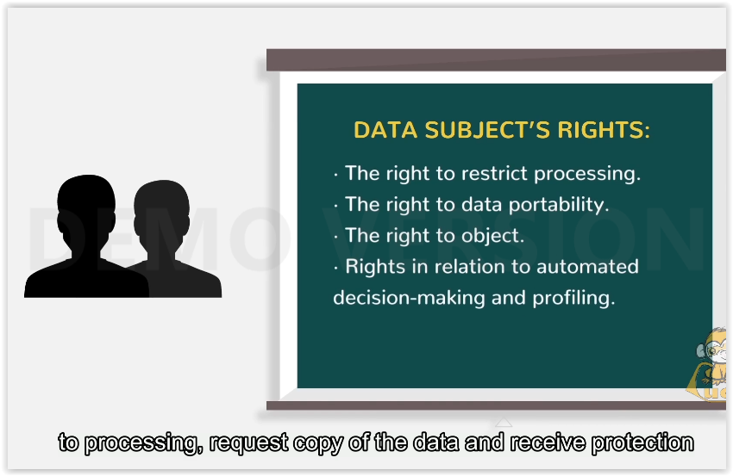 | to processing, request copy of the data and receive protection
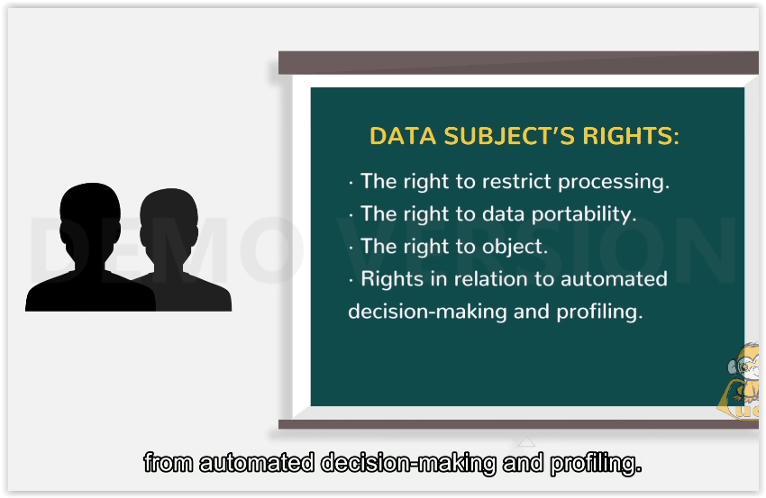 | from automated decision-making and profiling.
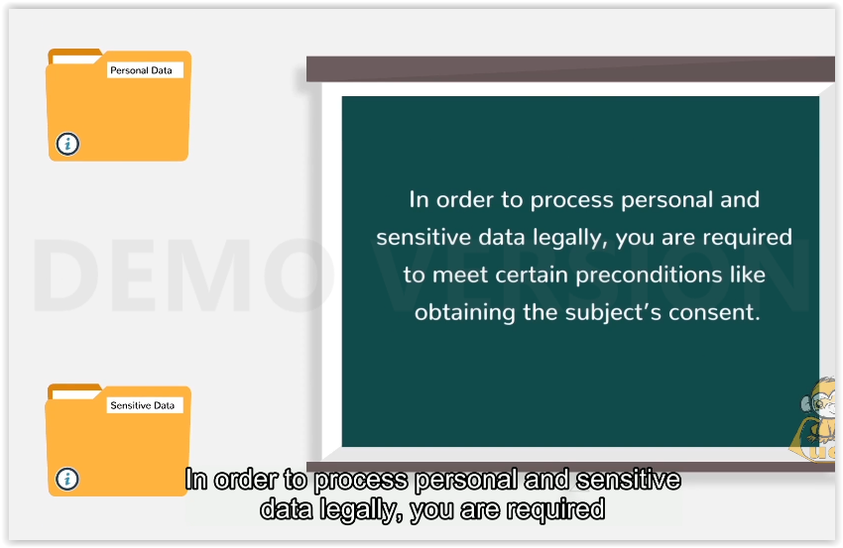 | In order to process personal and sensitive data legally, you are required to meet certain preconditions like obtaining the subject’s consent or explicit consent in the case of sensitive data.
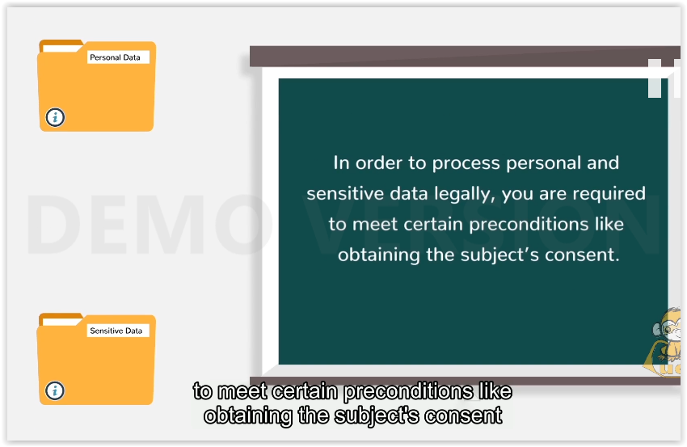
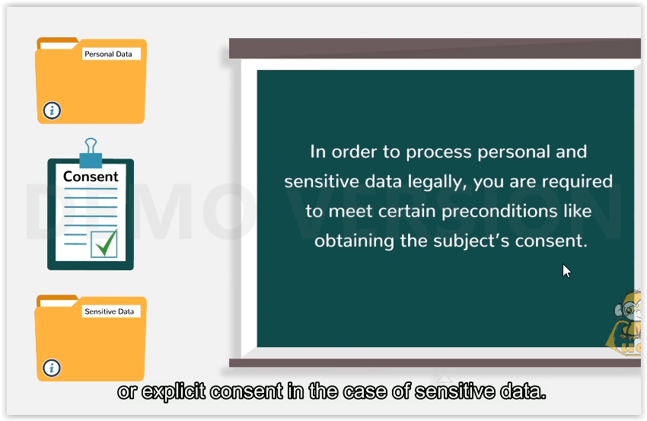
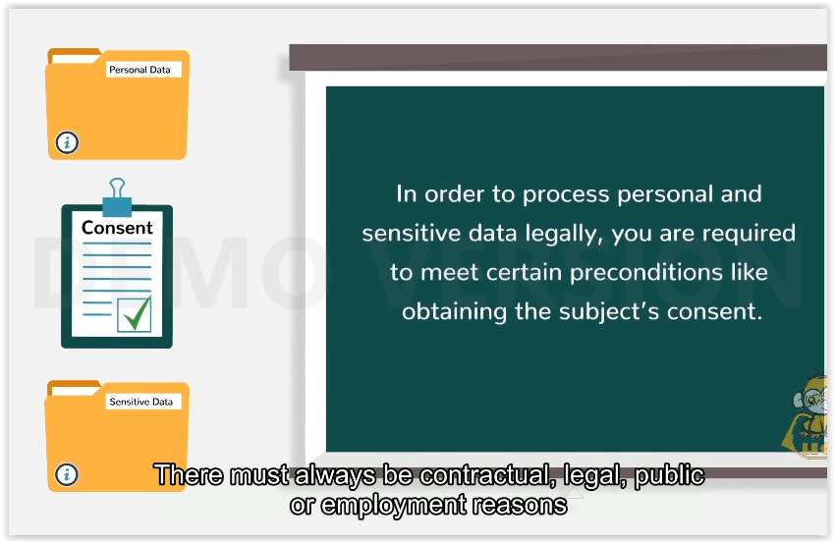 | There must always be contractual, legal, public or employment reasons for obtaining the subject’s personal or sensitive data.
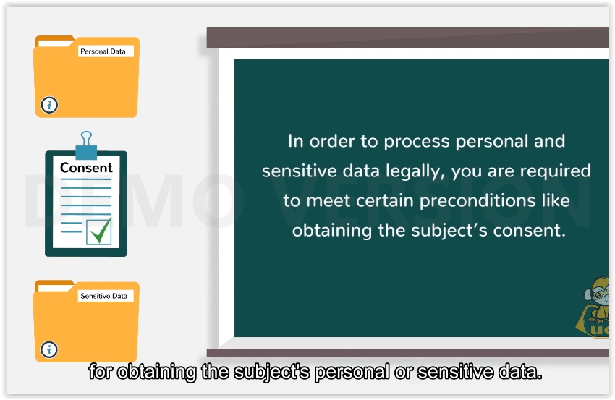
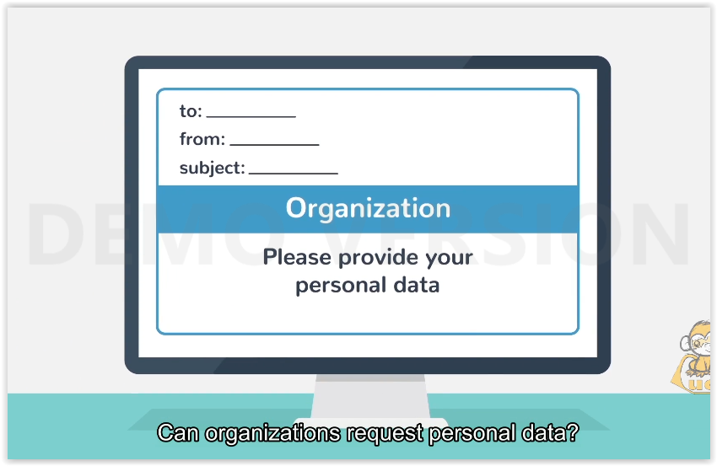 | Can organizations request personal data?
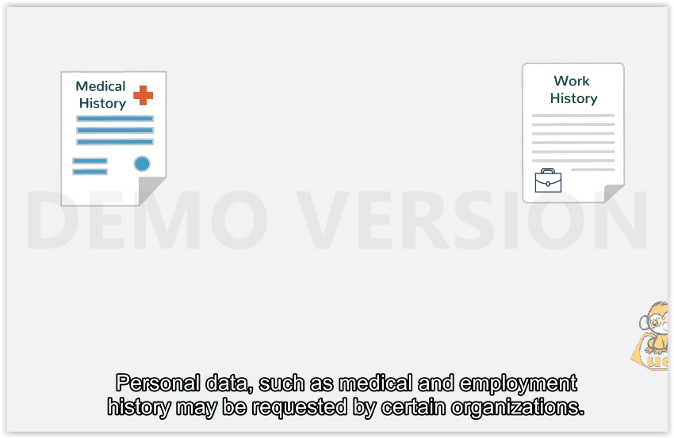 | Personal data, such as medical and employment history may be requested by certain organizations.
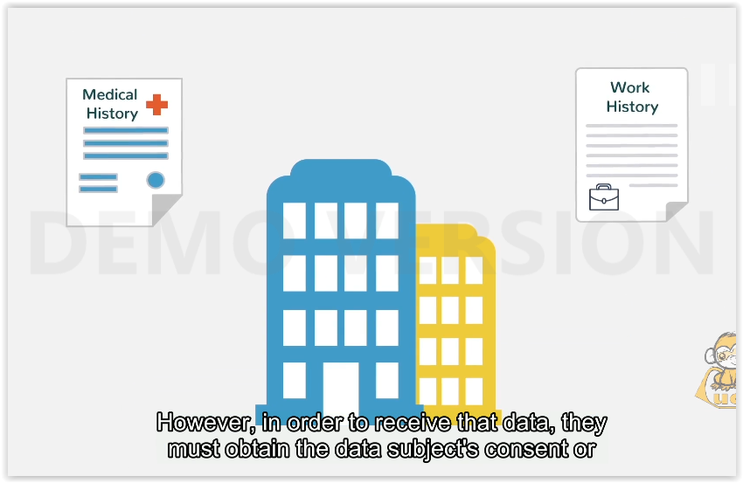 | However, in order to receive that data, they must obtain the data subject’s consent or require the information for contractual reasons or protection of legitimate interest.
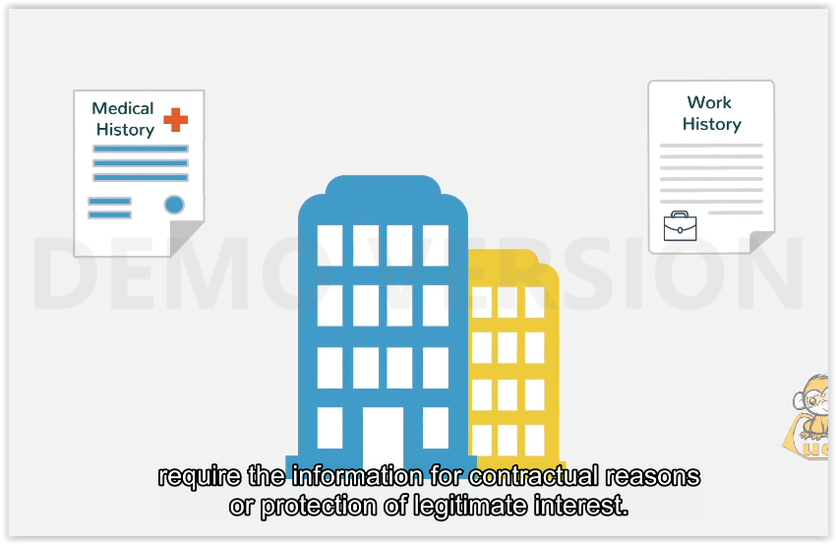
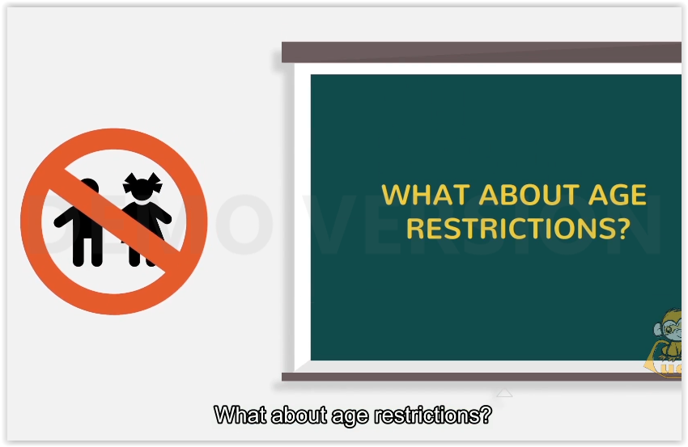 | What about age restrictions?
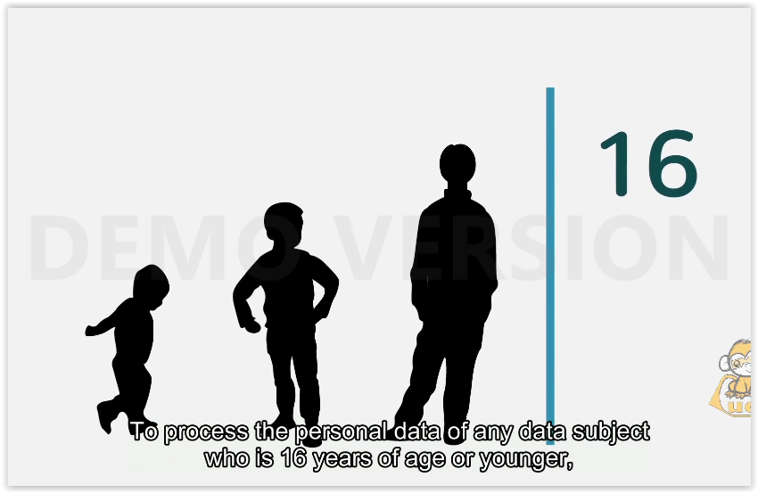 | To process the personal data of any data subject who is 16 years of age or younger, you will need to obtain consent from their parent or legal guardian.
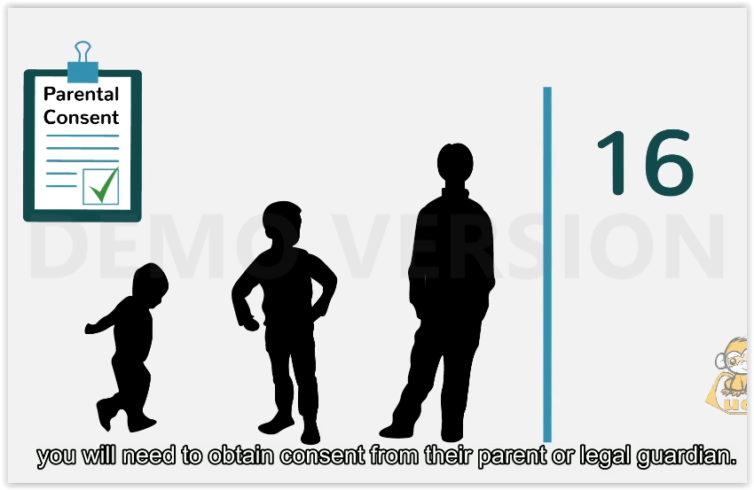
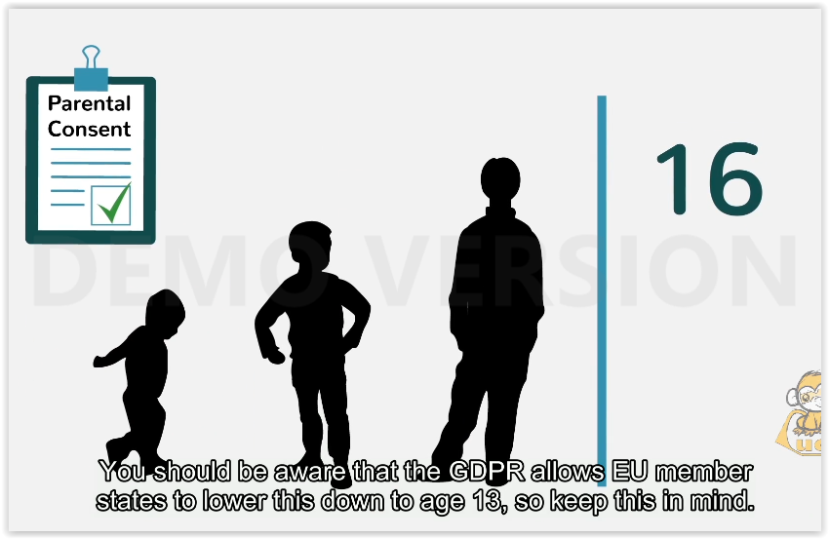 | You should be aware that the GDPR allows EU member states to lower this down to age 13, so keep this in mind.
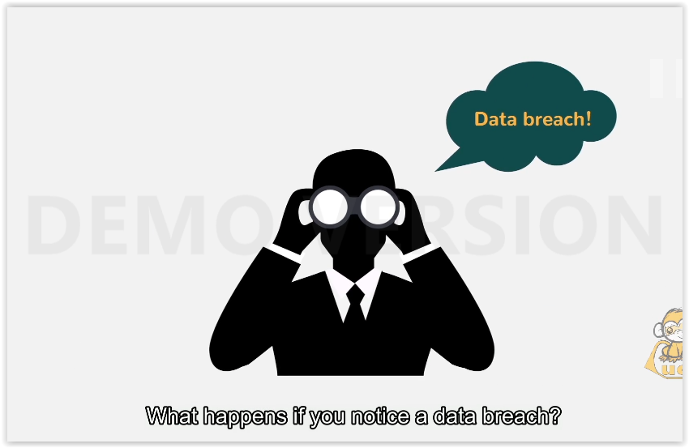 | What happens if you notice a data breach?
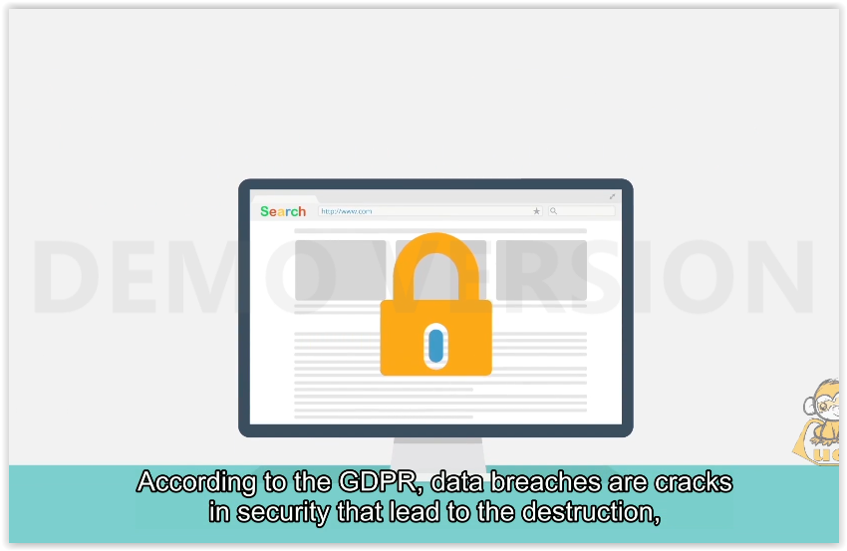 | According to the GDPR, data breaches are cracks in security that lead to the destruction, loss, alteration, unauthorized disclosure of, or access to personal data.
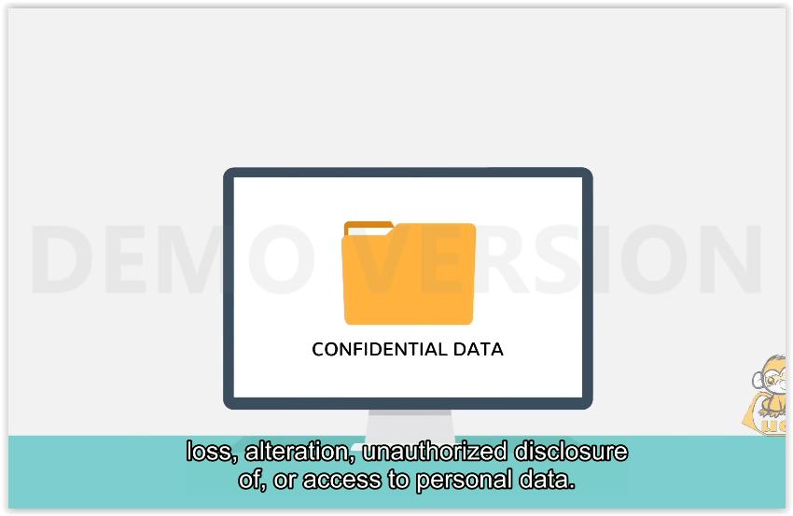
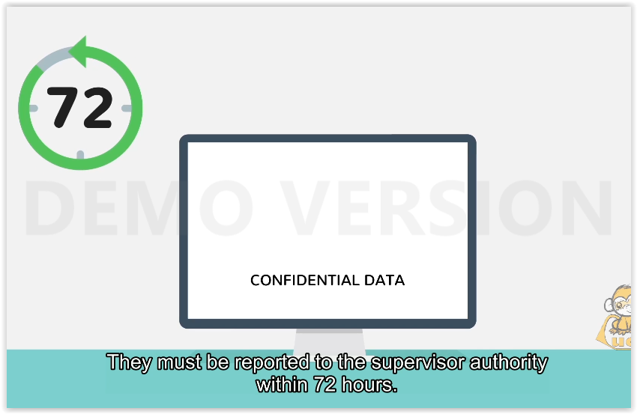 | They must be reported to the supervisor authority within 72 hours.
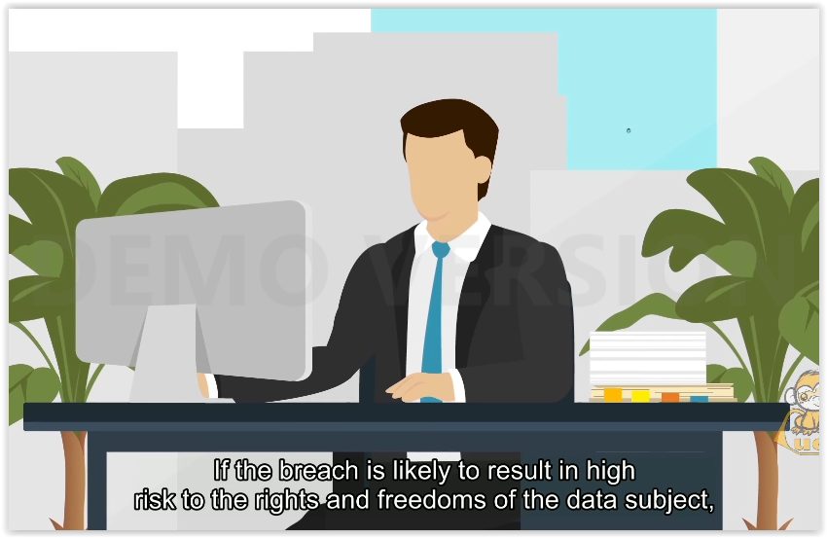 | If the breach is likely to result in high risk to the rights and freedoms of the data subject, he or she must be informed of the breach without delay.
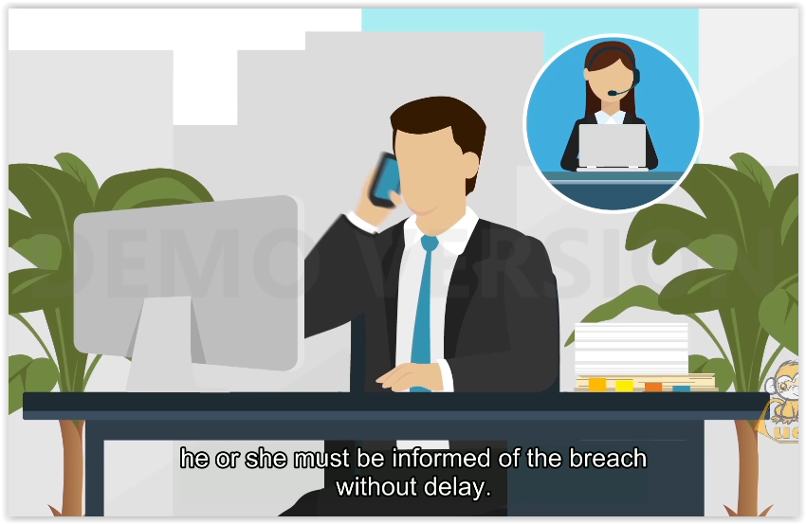
 | Thank you for watching, and remember, always be attentive and careful when handling personal or sensitive data.

